Cultural Grants 2024
Application Form

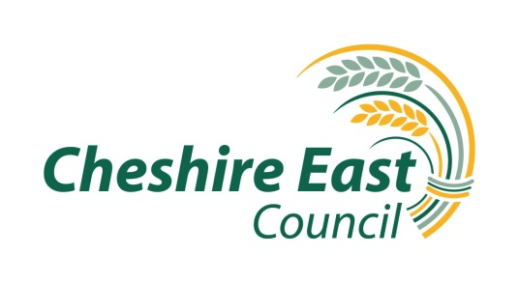

This application form asks you for information about your organisation and your project including quality, engagement, outcomes and finance.

This gives us information about the project you are applying for, management of it, the budget and timescales. We will use the information you give us in the application form to decide whether we are able to offer funds towards supporting your project.

Please refer to the Cultural Grants 2024 Guidance Notes for assistance in completing this form.

Contact Details

Name & Address of Organisation:
Name of Applicant:
Position:
Telephone Number:
Email address:
Website: |  | Instagram:
Facebook: |  | Twitter:

About your organisation

What type of organisation are you? | Limited Company ☐  Social Enterprise ☐  Community Interest Company ☐  Voluntary, Community or Faith Sector Organisation ☐  Registered Charity ☐  Community Group ☐  Unincorporated Association ☐  Society ☐  Other ☐ please state:
If applicable | Company Number:  Charity Number:  VAT Number:
Area of Cheshire East that the project will take place
Please tell us about your organisation, its aims and the work you undertake and any other organisations that you work with (in 200 words or less).

Project information

Please give a concise description of the project you are applying for:

Activity Dates and Outputs:

Please provide clear timescales for your project.

- This should include planning, promotion, delivery and evaluation – example table below to include specific ages or target groups

- For grants over £5000 please attach a detailed project plan with clear milestones and deliverable outcomes

Date | Activity | Outputs
Example  Apr-Jun | Deliver 12 weeks of music making with young people not in Education, Training or Employment | 10 people aged 11-19 engage in the activity  Minimum of 10 people per class attend each week

Please detail who will deliver this activity (named artist / staff) and relevant experience
If not known, please state the process by which you will recruit these roles

How does your project meet UK Governments objectives for Shared Prosperity Funding? (See Application Guidance Notes- Appendix A)

How does your project meet Cheshire East Council’s Cultural Priorities?
Refer to Cultural Framework and specifically how your project will address the target groups and / or priorities identified

Please describe the outcomes that you will achieve with this project and how you will evidence this?

Please describe how you will ensure high quality is achieved?

Please outline how you have considered environmental responsibility and sustainability in your planning and/or how you will promote this in your activity. This will help the Council to achieve its Carbon Neutral target.

Please give details of data capture methods for monitoring this project and expected evaluation format to demonstrate how your project will benefit the Cheshire East Cultural Economy.

For example this might include number of volunteers, volunteer hours, case study, audience / visitor numbers, participant experience, satisfaction survey.

Please give details of marketing, press and promotional activity that will be undertaken to ensure that this project is accessible and raises the profile of Cultural Activity in Cheshire East

Project Costs and Finances

Please give a full breakdown of the overall budget including how the proposed funds will be spent and include any match funding / leverage for this project, both in kind and cash. In Kind costs should be calculated as a cash amount e.g. volunteer support at an appropriate rate to the role, venue costs if the space was hired.

- Organisations may apply for up to 80% of project costs up to a maximum of £10,000.
- Organisations are expected to provide 20% of project costs either through cash match funding or in kind support.

If preferred, you can attach your own spreadsheet or use the format below. If using your own spreadsheet please include the breakdown of Council funding allocation.

How much is the overall cost of your activity / project?  Please detail (in section A) all associated costs. | £

Item | Total Costs (A) £0.0 | Amount requested (B) £0.0
Grand Totals | £ | £

Please detail match funding or in kind contribution you will include in this project, whether confirmed or under application

Match funding | Total
In kind contribution funding (eg. Space hire, volunteer hours, equipment hire)

Finally, please provide details of how this project may be scaled accordingly should all funding requested not be available?

For queries and submission contact: culturaleconomy@cheshireeast.gov.uk

