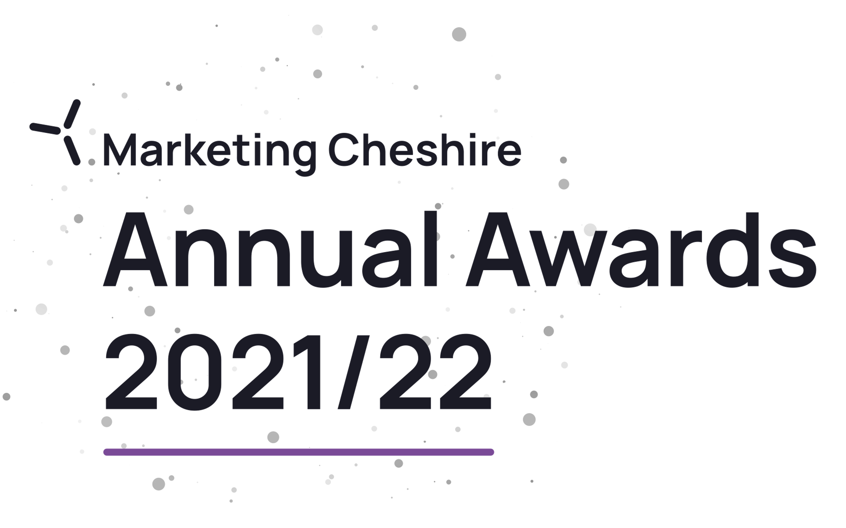

Best Tourism Marketing Project of the Year

Eligibility Criteria
- Must have produced a tourism marketing initiative or campaign to promote Cheshire since July 2020.

- Directly involved in tourism, making a contribution to the visitor economy with a significant proportion of business generated by people visiting from outside the local area.

- If you have any questions, please email awards@marketingcheshire.co.uk
The judging will be based on this entry form, your website (viewed on desktop, mobile and tablet), and any other online presence that you might have, including social media. The judges will also look at your online customer reviews.
If there is any other information (not available online) that you would like to include to illustrate points made in your entry, for example, regional or national press coverage, please upload one pdf document no larger than 5mb. If more than one document is sent or it is larger than 5mb it cannot be sent on to the judges. Please ensure each piece of evidence is indexed to the relevant question.
Please try to answer all questions as fully as possible, but within the word limit. At the end of each question, you may include web links, if you have them, to support your answer. These can be in addition to the word count.

Please give details of the person we should contact in regard to this entry. The email given here will be the email address we will use for all future correspondence
Applicant & Business Details
Applicant’s Name

Applicant’s Job Title

Applicant’s Phone Number

Applicant’s Email

Business Name
Give the name you use when promoting your business, as you wish it to appear in all publicity materials, on certificates, in presentations etc.

Business Address

Name of Tourism Marketing Project being nominated
Promotional description
Provide a promotional description of your business.
- Focus on its strengths and stand out features
- Write your description with regard to this category
- This wording will be used in PR and awards literature if you are short listed as a finalist
- Wording provided is subject to edit
- 120 word maximum
Promotional images
Provide up to three landscape high resolution photos.
- Photos should relate to this category
- Photos should not be edited in any way e.g. embedded text or logos, a collage
- Only include photos that you own the copyright for
- If the photo requires a credit e.g. photographer, please provide details
- These photos will be used in PR and awards literature if you are short listed as a finalist

Background
Briefly outline the story of your business (250 words maximum).

Judges will be looking for:
- Length of time business has been under current ownership
- Target market(s) and typical customer profile
- Key milestones in developing the business
- Indication of size of business
- Number of staff employed, if any

List any awards, ratings and accolades received in the last two years that relate to the marketing project. Include the title, awarding body, level and date achieved.

For example:
- Successes in this competition and the VisitEngland Awards for Excellence
- TripAdvisor Certificate of Excellence

There is no requirement for your business to be quality assessed. However, if you have an independent quality assessment/mystery shopping report from the last two years, you might wish to attach it when emailing your completed application form /upload it here (optional).

Online Presence & Reviews
Provide links to your online presence, which will be reviewed and scored by judges in addition to your answers to the four questions.

Website
Social Media Platforms

Provide links to any business pages/profiles on Facebook, Instagram etc. and Twitter handles

Online Review Sites

Provide specific links to any customer review listings for your business e.g. TripAdvisor, Google.

- Outline the brief for the marketing project
For Example
• What was the aim of the campaign?
• What was the target market?

(200 words maximum).

- What marketing channels did the campaign use
For Example
• Print, digital etc.
• How did you reach the target market?
• Have you noticed any industry trends that influenced the campaign?

Maximum 200 words

Links to relevant supporting evidence online (optional):

3: Project budget
Budget for the whole campaign | £
Media spend for the campaign | £

4. Results of the project

Give an overview of the results, how did you measure success and assess return on investment?
For Example
• How did you measure the success of the project?
• Did you achieve the aim of the project

Maximum 500 words
Links to relevant supporting evidence online (optional):

Terms & Conditions of Entry
Marketing Cheshire Annual Awards 2021/22
TERMS & CONDITIONS

“Competition” means Marketing Cheshire Annual Awards and the VisitEngland Awards for Excellence
“Organiser” means Marketing Cheshire
“Platform” means the online system that the applicant must use to complete their application.

By submitting an application to the Competition, you agree to be bound by the following terms and conditions:

• Applications for the Competition must be submitted within the time and date ranges specified at Marketing Cheshire Annual Awards 2021-22

• Applications must be submitted via the Marketing Cheshire Annual Awards Online Portal

• It is free to apply to all of the competition categories.

• You must be open for business at some point between 1 and 30 November 2021, so the judges can visit if required. If you are closed for any part of this period, please ensure this is highlighted in the ‘closures’ box on your application. Should the Government require your business to close due to COVID-19, alternative judging arrangements may be made.

• Applications may be submitted by any individual representing the business applying and the individual who submits the application will also become the contact whom all correspondence from the Organiser and VisitEngland concerning the Competition will be addressed to.

• You must inform the Organiser immediately of any changes to the contact information relating to you or the business applying during the Competition.

• Employees or representatives/agents of the Organiser and VisitEngland are not eligible to submit an application to the Competition except for categories in which third party nominations are publicly invited.

• You must ensure that your business complies with all current and relevant legal and licensing obligations before submitting an application. The judges reserve the right to not consider an application if this is in doubt and cannot be confirmed.

• You can apply for more than one category, except where specified within the eligibility criteria, but separate applications must be completed for each.

• Applications will only be considered if they are deemed to meet the eligibility criteria for the category.

• Applications will only be considered if they are submitted via the Platform and completed in full and do not exceed the maximum word counts.

• The Organiser reserves the right to move an application into a different category, if deemed more appropriate and should this occur the business affected will be informed.

• You must be willing to reimburse the judge and his/her partner (or family/companions in the case of some visitor attractions or experiences on departure for the cost of the mystery visit/overnight stay, any meals taken (alcoholic drinks only for restaurant and hotel categories), or any admission or ticket cost as appropriate to the category. The Judge will produce a Marketing Cheshire signed letter on departure as proof of mystery visit.

• You agree to be part of any publicity undertaken in association with the Competition. If selected as a finalist, you accept and agree that the Organiser and VisitEngland may use or publish any photographs, comments or evidence submitted at any stage of the Competition in any media, waiving any rights to payment or to inspect and approve a finished product.
- The Organiser and VisitEngland may send you communications via email in relation to your application to the Competition e.g. reminders of the deadline and to submit your application, notification of successful application submission, judging feedback, applicant survey, event invitation.

• The Organiser and VisitBritain/VisitEngland may store your contact information within databases to send you marketing communications including newsletters, future events and promotions unrelated to the Competition.

• Competition judges may decline to award winners at any level in some or all categories, if in their opinion there are insufficient entries of a winning standard.

• The prize provided by the Organiser for each winner will be a certificate and/ or a trophy. There is no cash alternative.

• Competition winners may publicise their success indefinitely provided the placing, category and year are specified in all publicity and materials.

• Competition winners may only use the specific logo issued by the Organiser or VisitEngland and not modify it in any way, nor use, or adapt for use, any other logo connected with the Organiser or VisitEngland.

• The logo may only be used alongside the location or part of the business that has won an award e.g. a self-catering provider with multiple properties across different locations must only use the logo alongside the winning location.

• You confirm that you or the business applying own the copyright to any photographs included with your application and permit the Organiser and VisitEngland to use these photographs in PR and awards literature.

• The Organiser and VisitEngland will not accept responsibility for applications delayed or lost as a result of any network, computer hardware or software failure.

• In the event of any dispute regarding the Competition eligibility criteria, application forms, judging process, choice of finalists/winners or any other matter relating to the Competition, the decisions of the Organiser and VisitEngland shall be final and no correspondence or discussion shall be entered into.

National Judging
• Should you win an award in your local/regional Competition you may be automatically put forward for national judging by VisitEngland for the VisitEngland Awards for Excellence 2022.

• You must notify the Organiser in writing at the time of application if you do not wish to be put forward for national judging.

• In rare circumstances VisitEngland may deem that an application does not meet the eligibility criteria and reserves the right not to consider the application for national judging.

• It is not possible to revisit your application prior to being put forward for national judging.
• VisitEngland reserves the right to move an application into a different category, if deemed more appropriate.

• The prize provided by VisitEngland for each winner will be a certificate and/ or a trophy. There is no cash alternative.

• Any queries in relation to national judging should be directed to VEAwards@visitengland.org.

- Any data you provide will be handled in accordance with the Organiser’s privacy policy, VisitEngland’s privacy policy and the privacy policy of the organisation contracted to provide the Platform, available on their websites.

