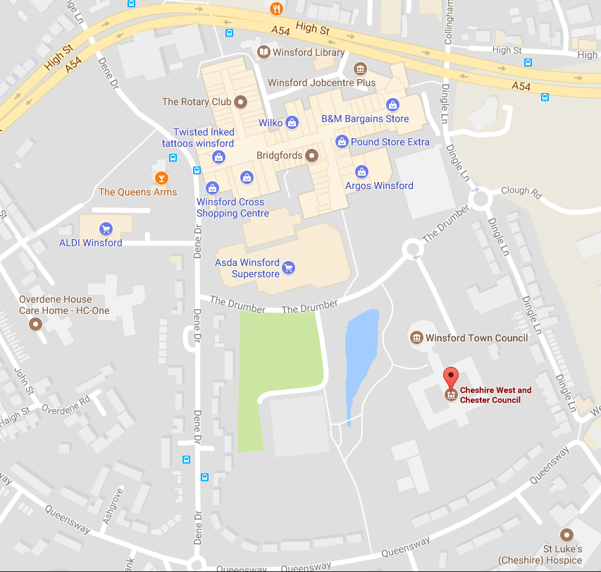



**Cheshire & Warrington LEP**

**1st Floor, Wyvern House (Cheshire West and Chester Council)**

**The Drumber**

**Winsford**

**Cheshire CW7 1AH**

**Tel: 01606 812280**

Turn off the A54 onto Dingle Lane. Turn right at the first mini roundabout into The Drumber and left at the second mini roundabout.

Visitors parking is on the left before you reach the barrier.

Please sign in at reception and ask the receptionist to let us know you have arrived.