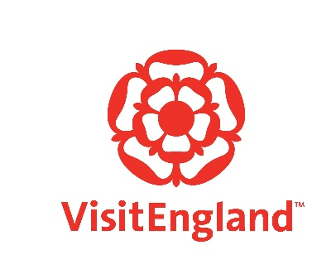
VisitEngland’s Tourism Superstar
2024 submission form
Please remember to attach a photo
Nomination for Tourism Superstar 2024 – name or names, job title or job titles, email or emails, telephone number or numbers and details of social media channels and X formerly known as Twitter handles etc.

Destination Management Organisation (DMO)/Local Visitor Economy Partnership (LVEP)

DMO/LVEP contact details - name, email and telephone number, including details of social media channels

Employer name and contact details - email and telephone number, including details of social media channels

Place of work and description of job

Why should this person or team win Tourism Superstar 2024 and how does your nominee represent your destination (800 words or less)

Details of channels that will be used to support the nominated Superstar to gather votes. This should also include details of the employer’s and DMO’s/LVEP’s channels

What activity will the employer and DMO undertake to drum up interest and votes?

How will your Local Economy Visitor Partnership be involved in promoting your Superstar if they are selected?
What would it mean to the employer to have a member of their team or a team recognised through this national award?
Please return to charlotte.sanders@visitengland.org

