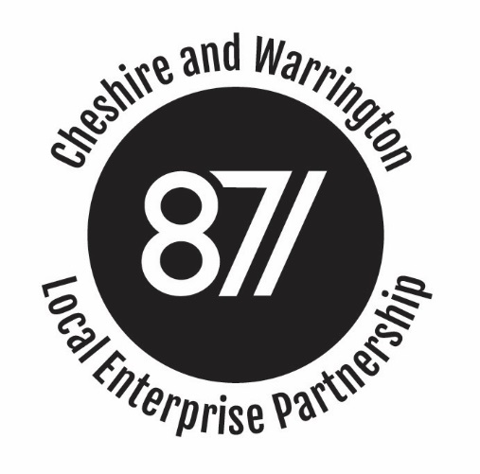

BOARD MEETING

Minutes of the Cheshire and Warrington Local Enterprise Partnership Board Meeting
held on 23rd January, Wyvern House, The Drumber, Winsford CW7 IAH

Present:
Christine Gaskell Cllr Rachel Bailey Cllr Samantha Dixon
Chris Hindley John Downes Meredydd David
Graeme Bristow Ged Barlow Robert Mee
Clare Hayward

Apologies:
Prof Tim Wheeler Cllr Russ Bowden Stephen Kinsey

Attending / Observing:
Philip Cox Mark Livesey Frank Jordan
Steve Park Charlie Seward Andy Hulme
Ian Brooks

Agenda Item 1: Apologies and Introductions

1.1 Christine Gaskell welcomed Board Members and extended a warm welcome to Ian Brooks, the LEP’s new Financial Director who was attending his first Board meeting. Apologies were received from Prof Tim Wheeler, Cllr Russ Bowden and Stephen Kinsey.

Agenda Item 2: Conflicts of Interest

2.1 No conflicts of interest were declared.
Agenda Item 3: Public Presentation
3.1 No members of the public were present.
Agenda Item 4: Minutes of the Meeting held on 14 November 2018
4.1 The minutes were agreed as a true and accurate record.
Agenda Item 5: Deputy Chief Executive's report
5.1 The Board noted the report and additional comments from the Deputy Chief Executive and:
- Recognised that Cheshire and Warrington is unlikely to receive a significant amount of the £281m that had been directly allocated to the North West through the Stronger Towns Fund. The metrics used to determine allocations relied on productivity, skill levels, deprivation and income and so Cheshire and Warrington, as a region, performed well against these metrics. However, the remaining £600m would be made available to those more prosperous regions which also had pockets of deprivation. This would present an opportunity to Cheshire and Warrington, should it wish to bid for funding.
- Expressed concern over the recent release of funding from Government and the lack of strategic direction. Most recently funding had been made available to tidy high streets, but this was given without notice, to be spent within days and could impact on future funding allocations.
- Welcomed the results of the Annual Appraisal which saw the LEP maintain its position as a LEP rated outstanding for governance, outstanding for strategy and good for delivery. The Board also welcomed the deep dive that had been carried out on governance. Officials had spent two days in the LEP reviewing the governance processes and procedures and at the end of the visit had concluded that the LEP was outstanding in this area.
- Noted that the LEP Board would need to improve its gender balance, but that could be remedied through the current recruitment exercise. The Chair had done a good deal of work to stimulate interest, hosting lunches and would also be hosting a LEP network event in London, again to stimulate intertest from potential women Board members.
- Noted that three investments were now proceeding on the Enterprise Zone in Ellesmere Port and another in Warrington would follow shortly.

Agenda Item 6: MIPIM
6.1 The Chief Executive reported back on last week’s attendance at MIPIM and explained that a more detailed report, including evidence of coverage attained would be brought to the next Board meeting. The Board noted that:
- This had been the largest delegation to represent Cheshire and Warrington and comprised over 70 delegates.
- Clean growth had emerged as a key feature and opportunity, which Manchester and Liverpool and already expressed an interest in joining forces with Cheshire and Warrington in developing a low carbon cluster.
- The young people’s event had proven a great success an should be considered as a feature for next year.
- In terms of next year’s MIPIM presence, discussions were beginning around a potential NP11 cluster. While logistically these may be challenge there would be obvious synergies in presenting alongside other northern areas.

  - In discussion, it was agreed that the LEP would continue to work with regional partners to identify potential opportunities around clean growth and would begin thinking around next year’s MIPIM attendance.

Agenda Item 7: Use of EZ Income

7.1 The Chief Executive took the Board through the EZ income paper explaining that the LEP held around £1m in its EZ account. After taking account of EZ and LEP running costs an additional £600k was due to be received on average each year. A range of options existed for deploying that money and the Board was asked to consider how it might want to utilise that income for the wider benefit of the sub-region. Following discussion, the Board agreed:

- That a proportion of the income (£400k) should be used to develop business cases, to ensure the region had fully developed pipeline of potential development projects. This would include transport projects already identified in the Transport Strategy but would not be restricted to transport. The Board recognised that the absence of such a project pipeline had impacted on the LEPs delivery score and suggested P&I have a role in taking final decisions.
- A further £200k should be used to cover the running costs of the Evergreen loan fund. This fund would release up to £20m to support development loans. We had already seen the success of this fund in supporting the development of Alderley Park, Protos and City Place Chester.
- An additional sum of £100k would be put aside to potentially support the delivery of an inward investment strategy. The LEP would work with local authority partners to shape proposals which would come back to the Board and Leaders for approval.

Agenda Item 8: Local Assurance Framework

8.1 The Deputy Chief Executive took the Board through the covering paper explaining that the government had published its revised National Assurance Framework in January this year. This required LEP’s to update Local Assurance Frameworks and to secure Board approval by 31st March. The changes to the current Local Assurance Framework had been light touch and comprised:

- A commitment to respecting GDPR requirements
- A new Annex setting out the relationship between S151 officer and LEP
- An agreement to conform to govt branding guidelines
- An ability to seek Board approval by correspondence, but then to be ratified at full Board
- Insertion of policy on non-compliance of projects and potential recovery of funding

The Board welcomed the revisions and were happy to sign off the revised Local Assurance Framework. This will now be published on the LEP Website.

Agenda Item 9: Local Industrial Strategy Update

9.1 Andy Hulme took the Board through a short presentation updating the Board on the Local Industrial Strategy work. In discussion is was noted that:

- The evidence base was showing clear disparities in productivity across the region and more work was needed to understand why this was the case.
- More work around the productivity of particular jobs (e.g. logistics, financial services) was needed. While the numbers were presenting a stark picture, this may be due to structural shifts in the nature of the jobs being created in specific sectors ie more low paid jobs and more part-time working.
- A specific piece of work with Cardiff University was already underway, to better understand the logistics sector and what was happening in the region.
- Clean energy was emerging as a clear opportunity for the region and work would continue around developing this as a key feature of our Local Industrial Strategy.
- Engagement around the work was progressing well, with over 20 events already being held involving around 400 attendees.

9.2 The Board welcomed the work that had been undertaken to date and were particularly keen to explore the productivity and pay of sectors, and roles within them. It would be important to consider how productivity gains might deliver benefits more widely and to ensure the agenda was truly inclusive.

Agenda Item 10: Board Sub-Committee Reports

10.1 In reporting sub-committee updates:

- Noted that Performance & Investment Committee had met this day and approved the EZ development proposals in Warrington. Final approval had been given to Centre Park Link and we were on target to spend against the agreed profile by year end.
- In relation to skills, the Pledge initiative had received final approval and had now been contracted with DWP. The Skills for Growth initiative had submitted a full application and was now awaiting the appointment of an assessor.
- Agreement was given the issue the Skills capital funding consultation and the Board agreed that its focus should be on the purchase of equipment and technology, not new buildings.
- The Strategy Committee reported that Quality of Place strategy and Housing Strategy had now been published. The Digital Strategy was almost ready for publication and would follow shortly.

Agenda Item 11: AOB

11.1 A short discussion around Brexit planning took place, with the Board expressing its concern over the continued lack of clarity. Work was underway within the local authorities to ensure the region was as prepared as it could be.

11.2 The Chair closed by explaining that this was Meredydd David’s last meeting and thanked him for the excellent work he had taken forward. He had been a great ambassador for the region and had been instrumental in driving forward the skills work.

Date and Time of Next Meeting:
Wednesday April 17th 4:30pm.
Action points:
Action: None arising

