Cheshire & Warrington Local Enterprise Partnership
Performance and Investment Committee

Title: A51 Tarvin Road |  | Agenda item: 4
Prepared by: Rachel Brosnahan |  | Date of Meeting: 24th January 2018

- Executive Summary
The Tarvin Road scheme seeks to address transport problems between the M53/A55/A51 junction and the Tarvin roundabout, which is prone to congestion and travel delay, through a series of highway capacity improvements at key points along the corridor. The project is a priority for Cheshire West and Chester Council (CWAC) and was put forward as part of the LGF round 3 bidding process. The project is expected to improve travel times in and around the area and thereby indirectly support regeneration of the neighbouring areas, such as Chester Northgate. The scheme is also expected to increase air quality through better movement of traffic and reduce the number of accidents on this stretch of road.

- Recommendations /Actions / Decisions required:

The Performance and Investment Committee is asked to:
    - Note the contents of the Outline Business Case (OBC);
    - Give conditional Approval of the project subject to the satisfactory completion of an independent appraisal which supports the project.
    - Authorise the LEP executive to issue a conditional offer letter for up to £3.663m Local Growth Fund grant or 67.5% of the final project costs, whichever is lower.
    - Approve 100% funding of any eligible project costs to the end of 17/18 at which time the claims should fall back in line with the adjusted intervention rate, taking into account all the funding claimed to date. (the maximum grant will remain at £3.633m)
    - Request the following before the final business case is submitted:
      - Confirmation of the costs of works.
      - Clarification of the timescales
      - Confirmation of the breakdown of match funding.
      - Clarification of any outputs associated with the project.

- Background
Currently the stretch of road subject to this application is considered the UK’s 5th most congested in terms of average journey waiting time, outside London with a delay of 26.44 hours (total delay in year) in 2014 (DfT traffic counts 2014). The slow traffic is negatively affecting air quality and the stop start traffic has been the cause of many accident, especially around the junctions.

- Scheme Proposal
The scheme is broken down into five main elements detailed below:
- An additional left turn lane at Tarvin roundabout from the A51 South to the A51 West;
- Signal and line marking changes at Stamford Bridge to provide 2 lanes straight ahead for eastbound traffic;
- Provision of an extra westbound lane through the Stamford Bridge junction, with a long merge for westbound traffic exiting the junction;
- Removal of some of the existing right turn movements at the Hare Lane/Littleton Lane junction;
- Modifications to the westbound approach and eastbound merge on the A51 at the A51/ A55 junction; and
- New crossing points and footpath provision for pedestrians, bus users and cyclists along the A51 corridor.
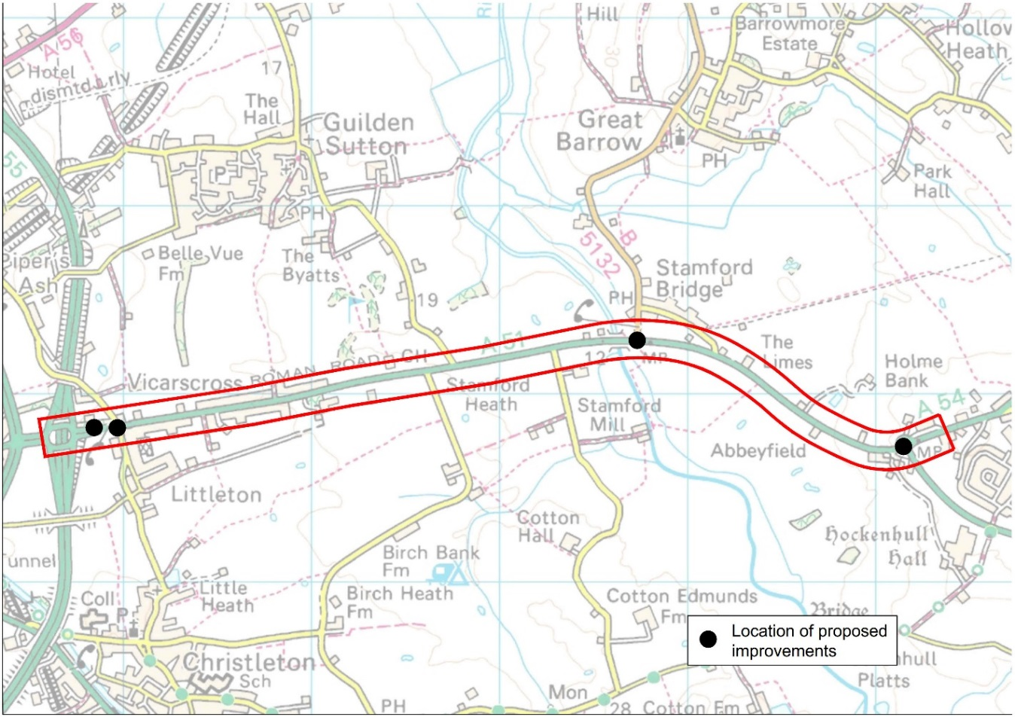

  - The main objectives of the scheme are:
- Economic growth- To achieve improved accessibility to facilitate economic growth and job creation;
- Strategic connectivity- To deliver transport network improvements which deliver enhanced connectivity between Chester and Tarvin, and key regional centres such as Crewe, Northwich, Winsford and Manchester Airport;
- Local connectivity- To reduce levels of highway congestion and secure enhanced local connectivity between Chester and Tarvin, current and future local housing sites, employment and mixed-use developments; and
- Wider social impacts- To ensure local residents enjoy a good quality of life and that the area between Tarvin and Chester remains an attractive place to live, work and play.

- Timescales
The key milestones for the project are:

Key Milestones | Timescale
Appointment of preferred developer / contractor | Q2 2018
Planning and other statutory approvals | Q3 2018
Work commences | Q3 2018
Work complete | Q3 2021
Final financial claim date | Q4 2021
Proposed project completion date – date by which outputs/outcomes will be achieved | Q4 2021

- Financial Summary
The estimated total costs of the works is £4,488,926 and includes base construction costs, preliminaries, design and supervision costs, statutory undertakers works and land acquisition costs. A Quantified Risk Assessment has been applied to the total cost of the scheme and totals £633,183, therefore, the total amount of funding required for the scheme is £5,122,109.

The total estimated costs are less than those identified in the LGF3 submission. Usually where the costs are reduced we reduce the LGF grant pro-rata. In this case the original application requested £3.663m of LGF grant which represented 67.5% of the project costs. If we apply this intervention rate to the updated costs it would reduce the grant by £205k to £3.457m. It is suggested that the offer of grant remains at £3.663m but it is clear the maximum grant that can be claimed will be 67.5% of the final costs. This therefore provides time and scope to firm up costs before seeking final approval for the project and shouldn’t cause unnecessary funding issues at this stage.

- Value for Money
The BCR for the scheme is 3.1 which represents High Value for Money according to the DfT.

- Outputs
The business case states that the following outputs will be achieved:

- An additional left turn lane at Tarvin roundabout from the A51 South to the A51 West;
- Signal and line marking changes at Stamford Bridge to provide 2 lanes straight ahead for eastbound traffic;
- Provision of an extra westbound lane through the Stamford Bridge junction, with a long merge for westbound traffic exiting the junction;
- Removal of some of the existing right turn movements at the Hare Lane/Littleton Lane junction; and
- Modifications to the westbound approach and eastbound merge on the A51 at the A51/ A55 junction.

While these are all elements we expect to be delivered they are not the economic outputs we would typically look for on a scheme. At the very least we should be able to record the match funding for the scheme but should ask the applicant to explore whether there are any other direct or indirect outputs associated with the scheme. If the scheme is going to take three years to deliver as stated, then there should be construction jobs that could be delivered.

- Independent Appraisal
Due to an oversight by the project team the appraisal hasn’t been completed yet. Rather than delay the presentation of the project, it has been suggested subject to P&I approval that the project team go ahead with the presentation to P&I as planned and that the appraisal will be completed in the next month.

- Appendices

Outline business case

