Engagement Board - Candidate Information Pack

Introduction from the Chair and Chief Executive
Thank you for your interest in becoming a member of the Cheshire & Warrington Local Enterprise Partnership (C&WLEP) Engagement Board.
The Engagement Board, comprising of 4 current members, formed in 2020 to provide an opportunity for the voice of young people to contribute to shaping the future of the economic region of Cheshire & Warrington: covering aspects of housing, transport / public transport network, digital infrastructure & skills.
The purpose of the Engagement Board is to provide a forum for views / opinions to be shared, an opportunity to scrutinise / influence the LEP’s plans; & to engage with other young people in our region and to assist the LEP to achieve its’ ambitions for inclusivity.
Your involvement as a member of the Engagement Board is to act as a representative on each of the LEP sub-boards, to communicate what is important for young people, to ensure everyone is included in the prosperity the LEP generates.
In return for your time and commitment to the Engagement Board, we will provide you with opportunities to develop your skills, by linking you up with a Mentor from one of the Sub Boards, who will provide coaching & feedback on your performance as part of your role as Non-Executive Director.
This is an exciting and challenging time for Cheshire and Warrington as we enter recovery from the pandemic and inflationary pressures. Our role is about supporting the development of the local economy and making our area an even greater place to live, work, study or invest. Cheshire and Warrington are already home to about 1 million people and as we make our plans, we want to ensure that the voice of young people contributes to shaping the future.
In consideration of the governments Levelling Up agenda & the UK Shared Prosperity Fund to boost productivity, pay, jobs & living standards; and spread opportunities & improve public services, we want to know what is important for young people; how we grow whilst respecting the environment and sustainability and how we make sure everyone is included in the prosperity we generate.
We neither expect you to be experts nor have preconceived ideas about whether you are in work, running your own business, studying, in an apprenticeship or unemployed. We want the widest representation of our community and people committed and enthusiastic towards making Cheshire and Warrington a great place for people.
Thank you again for your interest.

Clare Hayward and Philip Cox

About Cheshire & Warrington LEP
Cheshire and Warrington’s economy is the highest performing in the North of England and one of the most successful and fastest growing economies in the country, comprising Cheshire East, Cheshire West & Chester and Warrington. The sub-region has a strong value proposition across sectors, skills, connectivity, market opportunity and growth.
Cheshire and Warrington Local Enterprise Partnership (LEP) is a private sector led organisation, established in 2011. One of 38 LEP’s across England – and rated within the top 3 for performance (across the areas of Delivery, Strategy and Governance), the LEP has a leadership role in bringing together the public, private, third and academic sectors to help create the right conditions for driving forward sustainable growth and job creation.
We are a strategic organisation that sets the sub-region’s economic priorities, securing funding and investment, and working to unlock barriers to growth. We speak on behalf of businesses and champion important issues with government.
Through the delivery of the Cheshire and Warrington Strategic Economic Plan (SEP) , our vision is to become the healthiest, most sustainable, inclusive and growing economy in the UK. To make Cheshire and Warrington an even better place to live, work, invest and visit with an ambition to grow the economy to at least £50bn by 2040.

What we do
The LEP enables conversations to happen, in order to create action.
The partnership is not just about the board and dedicated support team. In practice it is about every organisation and individual in Cheshire and Warrington who is prepared to offer their services to help improve the economy in our sub-region.
We coordinate a high level of cooperation between public and private sectors to develop the local economy.
Our board works in partnership with three local authorities – Cheshire East Council, Cheshire West and Chester Council and Warrington Borough Council, Cheshire Business Leaders, Chambers of Commerce, Place Teams and other key figures in economic development. These include all the major business representative organisations, together with the sub-region’s two universities, Colleges of Further Education and the voluntary and community sectors.
Further information on our activity can be found in our Annual Review for 2020/21.

Board Structure

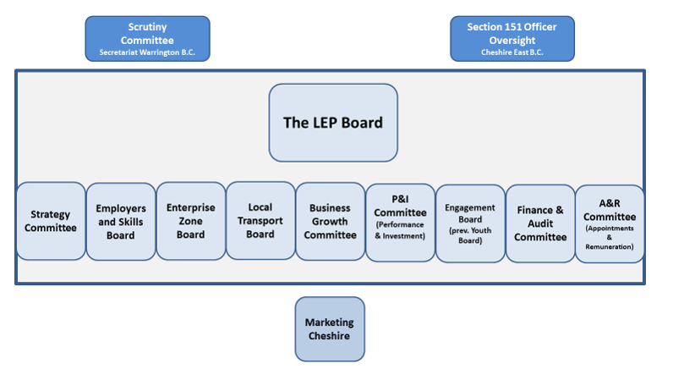
 |  |  |  |  | Sub Boards
First Name | Surname | LEP Board | MC Board | Engagement | Strategy Committee | Employers & Skills | Business Growth Committee | Growth Corridors - Science & Innovation (EZ) | Local Transport Board | Digital Connectivity
Maggie | Chen | √ |  | √ |  | √
Conor | Diskin |  |  | √ |  |  |  |  |  | √
Yulanda | Duff |  |  | √ | √
Joe | Toward |  | √ | √

Our Teams

Growth and Skills Hub
The Growth Hub provides bespoke support to businesses at every stage of their growth journey from start-ups to large business. Working with a wide network, they provide the right support to ensure businesses can grow; develop their teams; innovate and trade more successfully.
As part of a national Growth Hub network, they provide unrivalled local knowledge of the support that is available across business growth challenge areas such as skills, marketing and innovation.
The Skills Hub are leading the delivery of ambitious skills programmes that will ensure our region has the skills employers need. The three main programmes are:
- The Pledge Partnership – working with schools, businesses and youth groups to inspire and inform young people on the career pathways open to them in Cheshire and Warrington.
- Digital Skills Partnership – The Digital Skills Partnership works with businesses, training providers and residents to develop the digital skills of the current and future workforces, so businesses and people can fully utilise digital technologies.
- Skills Bootcamps – Working with training providers and businesses to deliver free, flexible courses of up to 16 weeks, giving people the opportunity to build up sector-specific skills and fast-track to an interview with a local employer.

Cheshire Science Corridor and Enterprise Zone
The LEP is responsible for the ongoing investment delivery into the Cheshire Science Corridor and Enterprise Zone. A partnership between the LEP and the three local authorities, the Science Corridor joins together Cheshire and Warrington’s nationally and internationally significant research facilities at Alderley Park, the nationally significant nuclear cluster at Birchwood in Warrington, the University of Chester’s Thornton Science Park, and a cluster of sites in Ellesmere Port.
The Enterprise Zone offers a portfolio of investment opportunities ranging from affordable development sites to world class laboratories across 100 hectares.

Marketing Cheshire
The LEP and Marketing Cheshire merged late 2018 to build further on the skills and expertise of both organisations to ensure Cheshire and Warrington’s place on the international stage. Marketing Cheshire are the destination marketing agency for the sub-region and are responsible for leisure tourism, business and conference tourism, place marketing and the corporate marketing and communications for the LEP.

Terms and Conditions
Members of our Engagement Board will be voluntary positions and require a commitment of between one and two days per month.
The age range for members on appointment is 18-27 years. Appointments will be made for 2 or 3 years, and may be renewable, if members are still within the age range.
The board will elect a Chair and Deputy Chair, and the Chair will be invited to join our full board meetings. The board holds 5 or 6 open meetings (where the public can attend) and 5 or 6 discussion forums (held in private) each year. They are normally held between 4.30pm and 6.30pm in Winsford.
We will reimburse expenses incurred in the performance of the role.
Because the LEP is responsible for how public money is spent and invested, you will be asked to follow the 7 Principles of Public Life.

How to Apply
Please complete an application form and diversity monitoring form. Both are available on our website Please also complete the personal statement (no more than 500 words) explaining why you are interested in this role and why you think you can help us. Send everything to hr@cheshireandwarrington.com

Closing date for Applications is 9.00am xxxx
If you have any questions about the role or this information pack, please send an email to hr@cheshireandwarrington.com

Timetable
Advert Go - Live | March 2023
Closing date for Applications | 4th April 2023
Interviews | TBC
Appointment effective | June 2023
Induction | June 2023

