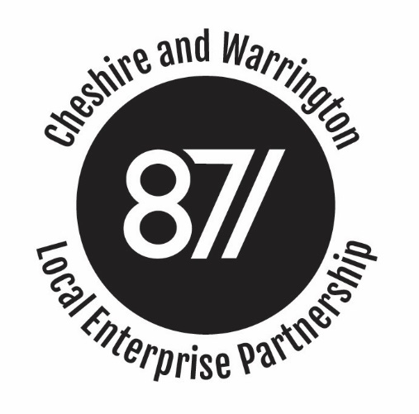

BOARD MEETING

Minutes of the Cheshire and Warrington Local Enterprise Partnership Board Meeting
held on 8th November 2017, Wyvern House, The Drumber, Winsford CW7 IAH

Present:
Christine Gaskell (Chair) Cllr Rachel Bailey Prof Tim Wheeler
Clare Hayward Meredydd David Stephen Kinsey
Pete Waterman Graeme Bristow Ged Barlow
Chris Hindley Robert Mee

Apologies:
Cllr Terry O’Neill Cllr Samantha Dixon Gary Steen
John Downes

Attending / Observing:
Philip Cox (LEP Chief Executive) Mark Livesey Andy Farrell
Katrina Michael

Agenda Item 1: Apologies and Introductions

1.1 Christine Gaskell welcomed Board Members. Apologies were received from Cllr Terry O’Neil, Cllr Samantha Dixon and John Downes.

Agenda Item 2: Conflicts of Interest

2.1 No conflicts of interest were declared in relation to Agenda Items on the open section of the meeting.
Agenda Item 3: Public Presentation
3.1 No members of the public were in attendance.
Agenda Item 4: Minutes of the Meeting held on 6th September 2017
4.1 The minutes were agreed as a true and accurate record. Meetings were organised between Economic Directors and the utility providers and the Growth Hub had promoted United Utilities Innovation Hub to local SMEs.
Agenda Item 5: Chief Executive's report
5.1 The Board noted the report and additional comments from the Chief Executive and:
- Agreed that the Board Awayday had highlighted a number of early priorities. The drawing down of remaining EU funding should be a key focus over the next six months, with EZ income providing an opportunity to put the necessary capacity in place. A focus on deploying GPF should be maintained, with consideration of encouraging early development in the Science Corridor. There was a need for stronger external engagement and place marketing, particularly post Brexit. To that end the Growth Hub MkII also needed to ensure it had the right skillsets in place to respond to the challenges ahead.
- Welcomed the imminent meeting with Jake Berry MP, which it hoped would provide a strong indication of the Government’s appetite in supporting us to deliver a £50bn economy in Cheshire and Warrington by 2040.
- Welcomed the submission of the Institute of Technology bid, which was looking to better align curriculum and opportunity throughout the sub-region.
- Welcomed the work that was underway to strengthen the automotive sector within the north west and particularly the work with the Automotive Alliance around the onshoring of the supply chain.
- Welcomed confirmation that members of the Overview and Scrutiny Committee had been appointed and that it would meet for the first time before the end of the year.
Agenda Item 6: Update on Transport Strategy
6.1 Roy Newton, Transport lead in the LEP, gave a short introduction to the sub regional Transport Strategy that had been circulated with Board papers. In discussion it was noted that:
- The Strategy would provide the context and justification for the necessary transport investment in Cheshire and Warrington to support the growth outlined in the Strategic Economic Plan.
- The Strategy would identify the key transport priorities for funding.
- The Strategy document would go to the Strategy Committee on 8th December for consideration, with a view to it going forward to the Local Transport Body in January, when it would also be circulated for consultation.

Agenda Item 7: Skills Delivery Plan

7.1 Clare Hayward introduced the Skills Delivery Plan, making it clear that the Skills and Education Board had been keen to develop a plan that was deliverable and so keenly focussed around a handful of strategic interventions. In discussion the following points were made:
- The plan should be a living document and, as such, should be recognised as an evolving document. The key sectors identified may change over time.
- If we get our approach right, then the document should be out of date in 12 months time, as we will have addressed the immediate priorities.
- It was agreed that delivery plans should adopt a common format, albeit colour coded by subject area.
- The document should make specific reference to the existing networks across the sub-region that already exist and would be key to helping tackle the skills issues.
- The document should also recognise the broader narrative around low pay, so it fully reflected the position across Cheshire and Warrington.
- Subject to these amendments, the Board were happy to approve the Skills Delivery PLan for publication and thanked Pat Jackson for rhe work she had done on this. Action: LEP Executive to amend the Skills Plan

7.2 The Board confirmed it was content for the Statutory Accounts to be signed off and lodged with Companies House.

Agenda Item 8: Mary Ney Review
8.1 The Deputy Chief Executive introduced this agenda item and took the Board through the key recommendations of the recently published Mary Ney Review. The Review had been carried out over a 6 week period and was focussed, following a recommendation from the Public Accounts committee, on what LEPs should already be doing in terms of governance and transparency.
8.3 The Review had highlighted the need to make the Annual Conversation a more rigorous process and, for the first time, would require a statement from the S151 officer, flagging any areas of concern. The LEP Chair and CEO, would also submit a statement in advance, which would explain how the LEP measured up against the governance and transparency requirements. The Board agreed it was important that we satisfied these requirements.
8.2 The Board noted the increased attention that was being given to the role of the S151 officer and welcomed the fact that further guidance would issue around the role. The Board also welcomed the recommendation to look again at LEP funding profiles and the suggested deep dive into those LEPs that may be causing concern. The Board concluded that governance and transparency must remain a key priority for the LEP, if it was to maintain trust.
Agenda Item 9: Northern Cultural Regeneration Fund
9.1 The Chief Executive introduced this item and explained that northern LEPs had been asked to submit a single bid to DCMS to potentially secure funding from a £15m legacy fund. DCMS would be looking to make three or four capital grants of £3-£4m each.
9.2 The Board noted that the fund was primarily looking to benefit areas that have had historically low levels of cultural and creative investment, could benefit children and local communities and were, more or less, shovel ready.
9.3 The Board were taken through the three projects:
- The First light Project – Jodrell bank
- Transformation of Whitby Hall – Action Transport Theatre
- Pyramid Centre Redevelopment – Culture Warrington
9.4 After a short discussion, the Board confirmed that it was content with the recommendation that the Action Transport Theatre provided the best fit, when set against the DCMS criteria. The Board further commented that all projects were worthy of further support and the LEP should work with each to identify alternative mechanisms to ensure they were able to progress. Action LEP Executive
Agenda Item 10: Board Sub-Committee Reports
10.1 The Board noted the minutes as tabled.
Item 11: Any other business
11.1 No items were raised under AoB.
Date and Time of Next Meeting:
Wednesday 17th January 4.30pm.
Action points:
Action: LEP Executive to amend the Skills Delivery Plan as agreed and publish.

Action: LEP Executive to work with Jodrell Bank and Culture Warrington, to identify possible support.

