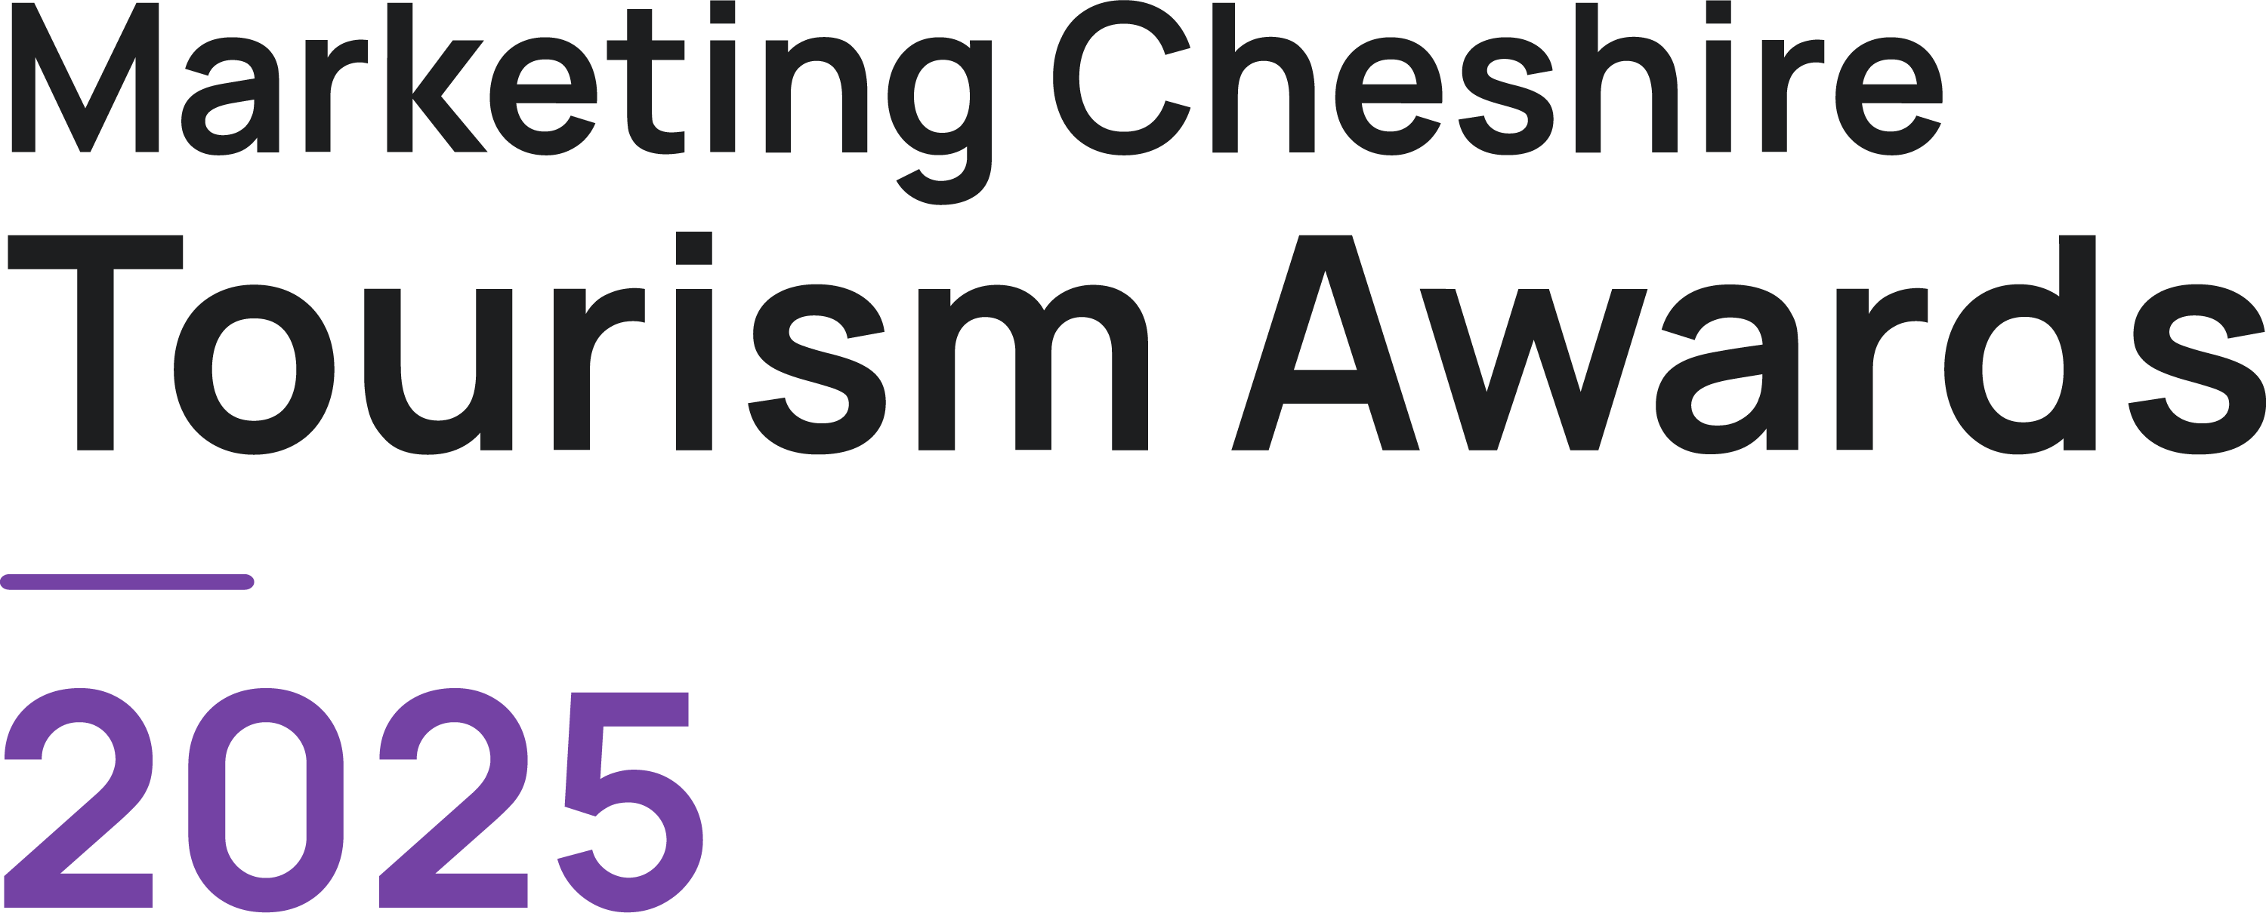

Best Tourism Marketing Project of the Year

Eligibility Criteria
- Must have produced a tourism marketing initiative or campaign to promote Cheshire since June 2023.

- Directly involved in tourism, making a contribution to the visitor economy with a significant proportion of business generated by people visiting from outside the local area.

- If you have any questions, please email awards@marketingcheshire.co.uk

The judging will be based on this entry form, your website (viewed on desktop, mobile and tablet), and any other online presence that you might have, including social media. The judges will also look at your online customer reviews.
If there is any other information (not available online) that you would like to include to illustrate points made in your entry, for example, regional or national press coverage, please upload one pdf document no larger than 5mb. If more than one document is sent or it is larger than 5mb it cannot be sent on to the judges. Please ensure each piece of evidence is indexed to the relevant question.
Please try to answer all questions as fully as possible, but within the word limit. At the end of each question, you may include web links, if you have them, to support your answer. These can be in addition to the word count.
Please ensure you read the awards terms and conditions on the website

Please give details of the person we should contact in regard to this entry. The email given here will be the email address we will use for all future correspondence
Applicant & Business Details
Applicant’s Name

Applicant’s Job Title

Applicant’s Phone Number

Applicant’s Email

Business Name
Give the name you use when promoting your business, as you wish it to appear in all publicity materials, on certificates, in presentations etc.

Business Address

Name of Tourism Marketing Project being nominated
Promotional description
Provide a promotional description of your business.
- Focus on its strengths and stand out features
- Write your description with regard to this category
- This wording will be used in PR and awards literature if you are short listed as a finalist
- Wording provided is subject to edit
- 120 word maximum
Promotional images
Provide up to three landscape high resolution photos.
- Photos should relate to this category
- Photos should not be edited in any way e.g. embedded text or logos, a collage
- Only include photos that you own the copyright for
- If the photo requires a credit e.g. photographer, please provide details
- These photos will be used in PR and awards literature if you are short listed as a finalist

Background
Briefly outline the story of your business (250 words maximum).

Judges will be looking for:
- Length of time business has been under current ownership
- Target market(s) and typical customer profile
- Key milestones in developing the business
- Indication of size of business
- Number of staff employed, if any

List any awards, ratings and accolades received in the last two years that relate to the marketing project. Include the title, awarding body, level and date achieved.

For example:
- Successes in this competition and the VisitEngland Awards for Excellence
- TripAdvisor Certificate of Excellence

There is no requirement for your business to be quality assessed. However, if you have an independent quality assessment/mystery shopping report from the last two years, you might wish to attach it when emailing your completed application form /upload it here (optional).

Online Presence & Reviews
Provide links to your online presence, which will be reviewed and scored by judges in addition to your answers to the four questions.

Website
Social Media Platforms

Provide links to any business pages/profiles on Facebook, Instagram etc. and Twitter handles

Online Review Sites

Provide specific links to any customer review listings for your business e.g. TripAdvisor, Google.

- Outline the brief for the marketing project
For Example
• What was the aim of the campaign?
• What was the target market?

(200 words maximum).

- What marketing channels did the campaign use
For Example
• Print, digital etc.
• How did you reach the target market?
• Have you noticed any industry trends that influenced the campaign?

Maximum 200 words

Links to relevant supporting evidence online (optional):

3: Project budget
Budget for the whole campaign | £
Media spend for the campaign | £

4. Results of the project

Give an overview of the results, how did you measure success and assess return on investment?
For Example
• How did you measure the success of the project?
• Did you achieve the aim of the project

Maximum 500 words
Links to relevant supporting evidence online (optional):

