Lion Salt Works Museum’s
Thompson Suite Room Layouts

Theatre Facing Window
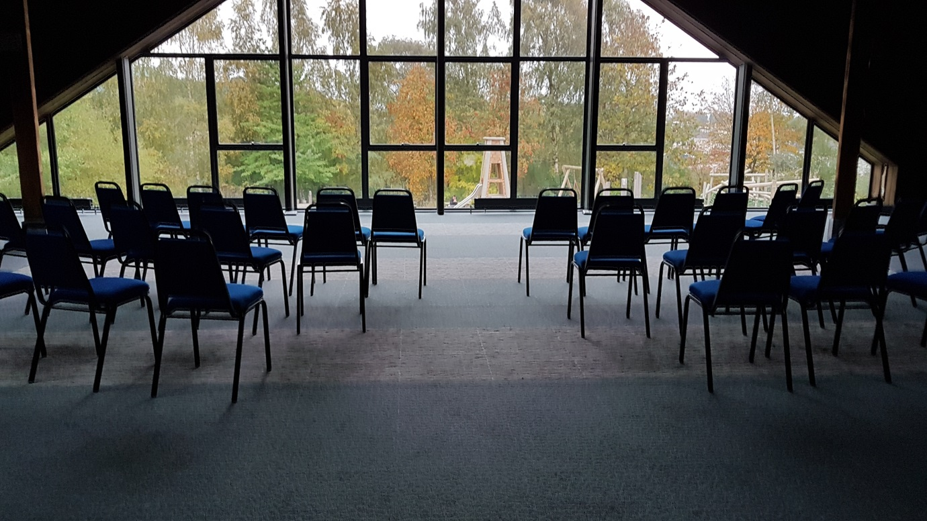
Cabaret Facing Window
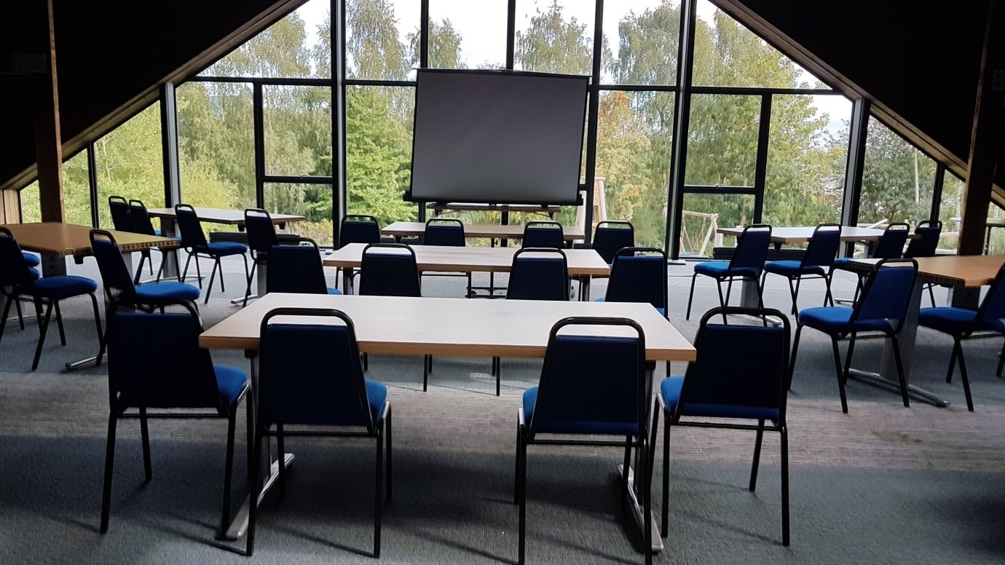

Cabaret Facing Wall
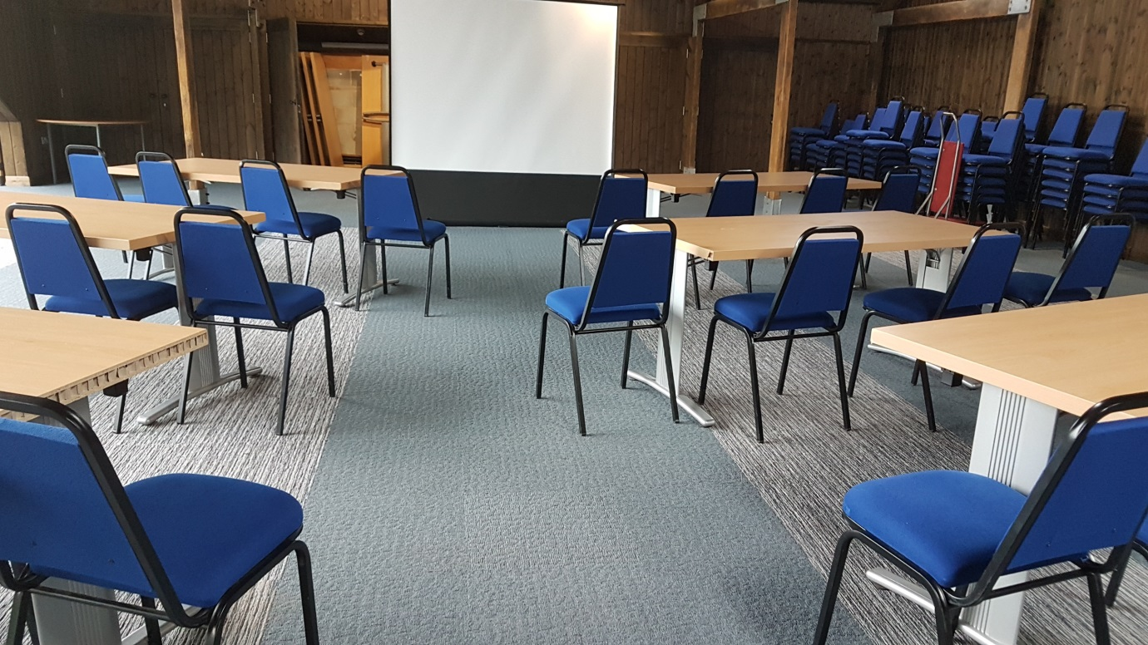
Boardroom
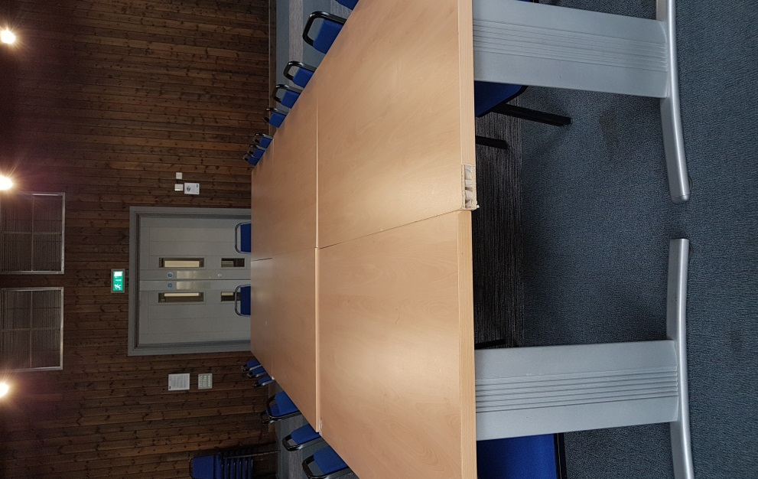
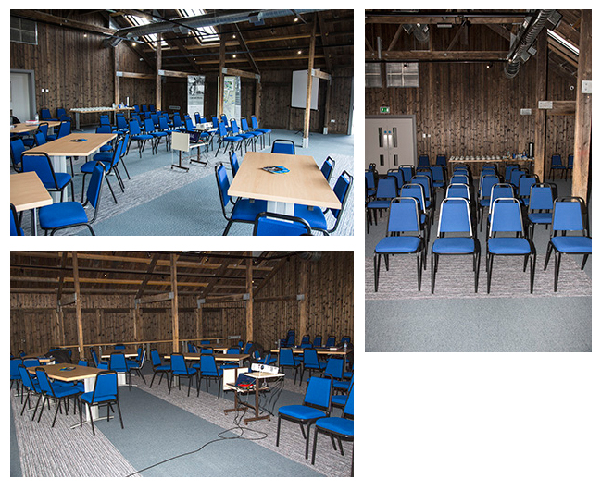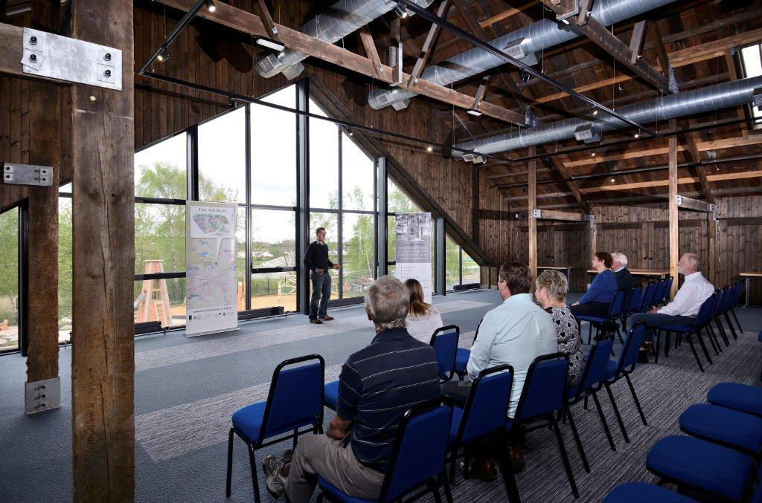

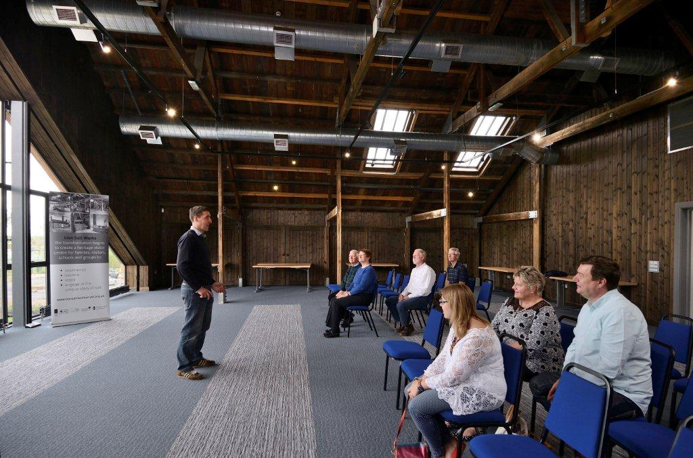
Room Layout Before Covid
(Please note the Thompson Suite has a ventilation system and not air-conditioning).
If you do not specify all requirements in advance, we may not be able to meet your needs on the day.
Boardroom Style | 50 | Theatre Style | 100
Open ‘U’ Style | 25-30 | Cabaret Style with out catering  With Catering | 70 50
Room Direction:
Seats facing the wall |  | Seats facing the window
Equipment Required:
Projector |  | Screen
Flipchart Stand (provide own paper & pens) |  | Extension Lead

Seating numbers may verry due to Covid 19 rules and regulations will need to contact bookings for updates.

Venue Hire Corporate Rate | Half day (4 hrs) between 9am and 5pm | £100.00
Corporate Rate | Full day (8 hrs) between 9am and 5pm | £ 190.00
Corporate Rate | Daytime - per hour | £ 30.00
Corporate Rate | Week day evening 5.30 - 10.30 | £ 420.00
Corporate Rate | Weekend evening 5.30 - 10.30 | £ 500.00
Functions Rate | Half day (4 hrs) between 9am and 5pm | £ 125.00
Functions Rate | Full day (8 hrs) between 9am and 5pm | £ 250.00
Functions Rate | Week day evening 5.30 - 10.30 | £ 380.00
Functions Rate | Weekend evening 5.30 - 10.30 | £ 450.00
Functions Rate | Additional Hours weekend evening | £ 50.00
Tea & Coffee per serving per person. |  | £1.80

