Life Sciences Mapping and Gapping
Research Findings Report

Prepared by 7i Group for Cheshire and Warrington
Local Enterprise Partnership
February 2022

Contents
1. Life Science Clusters 3
Characteristics of a life-science cluster 3
2. Mapping Exercise (Desk Research) 4
Summary of the mapping exercise 5
Comparisons With Other Research 7
Conclusions 8
3. Gapping Exercise (Qualitative Research) 9
Summary of the qualitative research 9
Summary of the factors identified in the research 9
Conclusions 12
4. Comparisons with International Life Science Clusters 13
Size Comparison 13
NW life sciences cluster versus Golden Triangle 16
Conclusions 17
5. SWOT Analysis 18
Strengths and Opportunities 18
Links with universities and academic research 18
Business costs 18
Transport 18
Quality of life 18
Weaknesses and Threats 18
Scientific reputation and marketing of the region 18
Access to funding and investment 19
Lab space and flexible office space 19
Talent pool and networking 19
Business support and eco-system 19
6. Overall Findings and Concluding Remarks 20
References 22
Appendix I: Headcount Analysis Using LinkedIn 23

1. Life Science Clusters

A life science cluster may be defined as a network of life science organisations within the same location that usually have strong university, laboratory and manufacturing links⁽¹⁾. One could argue that these organisations have shared values in terms of advancing the field of life sciences as a whole.
It is the presence of the whole life science eco-system in one geographical, integrated place which support the life cycle of a drug or product, from R&D to post-launch. Moreover, it is the interactions that organisations within the cluster have with each other and with universities, research centres, and the public health system which provide opportunity to collaborate.

Characteristics of a life-science cluster
- A life science cluster is more than just the presence of biopharma companies in one area. Whilst biopharma is the largest sector in life sciences in terms of turnover (Fig 1), a lot more is required to become a life science cluster.
- An important aspect of a life science cluster is critical size – an undersized cluster will not be self-supporting in the long-term. For example, current and future employees may be attracted to other geographical locations, leading to a skills shortage. This may be further compounded if the links and collaboration with local universities are not well established.
- Strong links with academia and universities are key to a good life science cluster as these provide good opportunities to collaborate in the research and development space.
- An abundance of supply chain and support services, which facilitate the organisations within the cluster and allow then to grow and develop
- Integrated transport infrastructure, ease of access within the cluster and ease of travel both nationally and internationally.
- A cluster is also usually known to have a strong reputation in terms of clinical trial activity.
- It is greater than the sum of its individual parts, organisations interact and collaborate across the cluster, which creates a true eco-system and synergy across the cluster.

The above characteristics create a self-sufficient eco-system with a variety of sectors and sub-sectors that support all aspects of the life sciences industry.

Figure 1. Turnover of life science industry in the UK (2020) 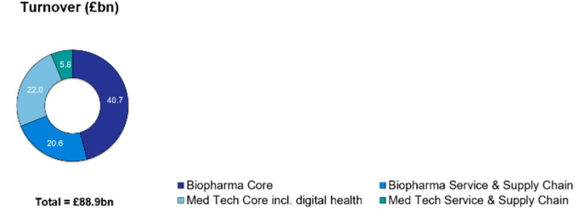
Source : ONS⁽²⁾
From our research it also became clear that the level of clinical research is an important component of a life science cluster, because it reflects not only the research activities of commercial organisations but also the involvement of academic organisations and public sector clinical research. All of which add to the life science eco-system.
In the UK, we have existing life science clusters, including (but not exclusive to) the North West (between Liverpool City Region, Greater Manchester and Cheshire and Warrington) and the Golden Triangle (Oxford, Cambridge, and London). International examples of a life science cluster include:
- Boston
- Basel
- California
See section 4 for a more detailed comparison of these life science clusters.
For the purposes of this report, the following have been excluded from this definition research, although these organisations could be included in future research:
- Veterinary organisations
- Crop / agriculture
- Consumer healthcare organisations, including retail pharmacies
- Organisations which do not have a major focus on life science

2. Mapping Exercise (Desk Research)
The purpose of this stage of research was to map out the eco-system that currently exists NW life sciences cluster between Cheshire and Warrington, Greater Manchester and Liverpool City Region. Organisations were categorised into sectors and sub-sectors. These groups were not necessarily mutually exclusive.
The organisations which comprise the NW life science cluster were identified from various sources, including the Office of National Statistics (ONS), Knowledge Transfer Network database, existing information on file and online searches. The initial list of organisations that was consolidated from these sources was then subject to a validation process. Any organisation that was not sufficiently focused on the life science sector was removed from the list. The validated organisations were then analysed in terms of headcount, mainly using LinkedIn as a consistent and accurate source of identifying the number of employees who are based in the region and who work for an organisation included on the validated list. Further detail on the methodology used to quantify headcount is shown in Appendix I.

Summary of the mapping exercise
The mapping part of this research identified and validated 501 organisations that fell into 7 different sectors. Organisations were then categorised into sub-sectors and mapped out. The result can be seen in Fig2 below. The estimated employee headcount of the corridor is 32,925. The breakdown of organisations and headcounts can be seen in tables 1 and 2.

Figure 2. Map of life science eco-system in the NW life sciences cluster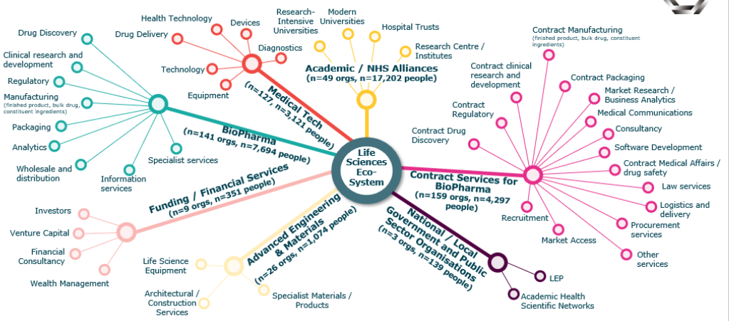

Table 1. Number of organisations within the NW life sciences cluster broken down by sector
 | Number of Organisations | Headcount
Academic / NHS Alliances | 49 (10%) | 17,202 (52%)
Advanced Engineering & Materials | 26 (5%) | 1,074 (3%)
Biopharma | 141 (28%) | 7,694 (23%)
Contract Services for Biopharma | 159 (32%) | 4,297 (13%)
Funding / Financial Services | 9 (2%) | 351 (1%)
Medical Tech | 127 (25%) | 3,121 (9%)
National / Local Government and Public Sector Organisations | 3 (1%) | 139 (<1%)
Total | 501 | 32,925
Note: Totals add to >100% due to some double counting where one organisation may appear in more than one sector

Table 2. Number of organisations within the NW life sciences cluster broken down by sub-region
 | Number of Organisations | Headcount
Cheshire & Warrington | 214 (43%) | 11,360 (35%)
Greater Manchester | 166 (33%) | 15,152 (46%)
Liverpool City Region | 153 (31%) | 14,324 (44%)
Total | 501 (100%) | 32,925 (100%)
Note: Totals add to >100% due to some double counting where one organisation may appear in more than one sub-region

Excluding the NHS / Academic sector, biopharma has the highest number of employees, almost one quarter of the total headcount (23%). It also has the second highest number of organisations (28%). Contract services for biopharma had the second highest number of employees (13%) and the highest number of organisations, almost one third of the total (32%). This is likely due to the presence of bio hubs such as Alderley Park and Sci Tech Daresbury, which provide a variety of critical services to biopharma. In terms of business makeup of the region, the majority (58%) of businesses are small enterprises. This suggests that there are many start-ups in the region and that there is a good growth opportunity for these businesses. The region also contains an array of larger companies that are substantial in the life sciences sector and should be regarded as assets of the region. Amongst the high calibre universities, there is also presence of big pharmaceutical companies such as AstraZeneca and GlaxoSmithKline. Moreover, the region is home to some of the more specialist services of the life sciences industry, such as Waters corporation (involved in laboratory analytics, such as mass spectrometry).
In terms of regions within the cluster, Greater Manchester had both the highest number of organisations (166) and the highest headcount (46%). Liverpool City Region had the second highest headcount of (44%). There was little difference between Greater Manchester and Liverpool City Region in terms of number of organisations, with each contributing almost a third. The Cheshire West and Warrington Region has the greatest number of organisations.
The size and complexity of the life science cluster is evident from the map in Fig2. It is largely orientated around biopharma and contract services for biopharma. The strong presence of medical tech companies could further benefit the cluster in terms of innovative research which could be pivotal for the future of the life sciences sector. The inter-connectivity between regions in the cluster further adds to the collaboration potential of the cluster. Although there are 130 large enterprises within the region, there seems to be a gap in terms of presence of big pharma. Whilst large organisations such as GlaxoSmithKline and AstraZeneca do have a presence, there is limited big pharma R&D investment in the region. There is, however, significant drug discovery and development work undertaken by smaller / start-up biopharma companies at several sites across the region such as Alderley Park. The presence of big pharma R&D company could increase the critical mass of the eco-system and therefore increase awareness of the NW life sciences cluster, potentially improving reputation.
Given the variety of biopharma specialist organisations, there is opportunity for the region to expand in terms of life science organisations. Within the region, there is the capability to support life sciences throughout the product development phases, from drug discovery to market as well as provision of important support capabilities by organisations in the ‘contract services’ arm of the eco-system map (see Figure 2 above).

Comparisons With Other Research
Similar research has previously been undertaken to estimate the size of the life science cluster in the North West. However, these research pieces have varied in terms of geographies, methodologies and inclusion criteria. The findings and comparisons from each source have been shown below in Fig3 and Fig4.

Figure 3. Estimated headcount of life science employees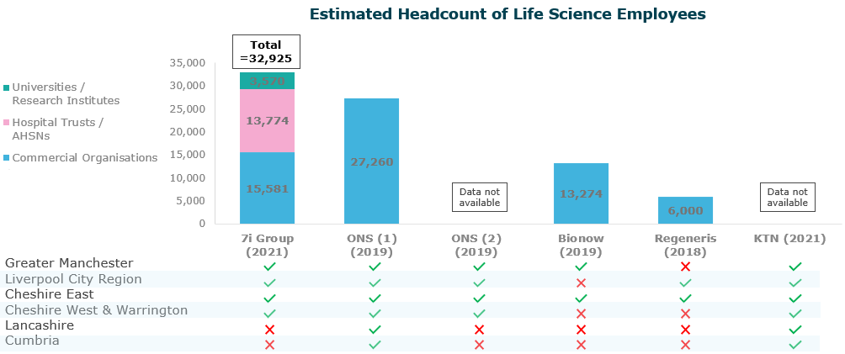

Note: ONS, Bionow and Regeneris do not include headcounts for hospitals and universities.

Other research appears to have underestimated the size of the life science eco-system in the NW life sciences cluster. Different definitions of life science may have resulted in omission of key companies within the region. Moreover, by including hospital trusts and universities this research has captured the headcount of the whole eco-system. If you set aside universities and hospitals, it looks as through the headcount is approximately 15,000-16,000 people. The outlier is the ONS figure, which is reporting a figure of 27,000. This has been examined in detail and it was found to contain many companies that 7i Group has excluded from our research on the grounds that they were insufficiently focussed on the life science sector. The ONS categorisation includes companies that are in the nutrition, medical accessories (i.e. wheelchairs / hearing aid), care home, insurance and aesthetics sectors. For example, it includes SHS international which is a subsidiary of Danone and is a nutrition company, this has 250+ employees. It also includes homecare companies such as Calea Homecare who have 250+ employees. Moreover, the ONS database includes some companies that are part of the same company, for example, Evotec is the parent company of Cyprotex, yet that has been listed twice in the same location. This means that we are unable to determine where double counting has occurred. It also contained some companies that have since dissolved, such as Westpoint Industries.
There is reasonable robust evidence that the size of the life science sector in our region is 15,000-16,000. This is small when compared with some of the international clusters (see section 4).

Figure 4. Estimated number of life science organisations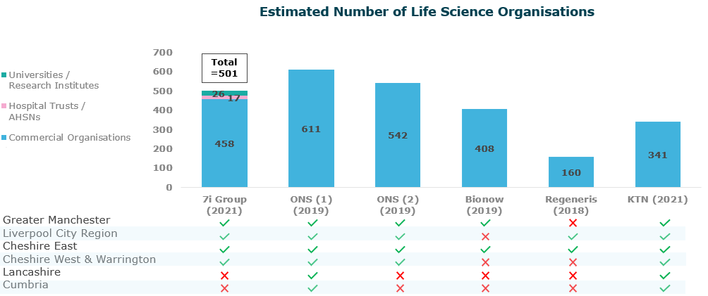
Note: ONS, Bionow and Regeneris do not include headcounts for hospitals and universities

Conclusions
When mapping out the life science eco-system in the NW life sciences cluster, there is an extremely complex existing eco-system that consists of 501 organisations. Some of these organisations fall across multiple sectors, sub-sectors and locations. It is estimated that the region employees over 32,000 people within the life science eco-system.

3. Gapping Exercise (Qualitative Research)
This part of the project involved n=20 60-minute in-depth interviews with various organisations within the region. The purpose was to understand the advantages and disadvantages of the region, as well as gaining insight into the gaps and opportunities in the region. The organisations varied by size, sub-sector within healthcare, location across the region and date of establishment.

Summary of the qualitative research
This research revealed some interesting findings on respondents’ perceptions on the life sciences eco-system in the NW life sciences cluster focused on Cheshire and Warrington, Liverpool City Region and Greater Manchester. It identified that there are some great strengths and assets within the region, as well as some gaps that should be addressed.
The biggest strengths of the region included: links with universities and academia, business costs, quality of life and transport infrastructure. However, it was found that these strengths are not being communicated well enough, both within the region and externally. There was a shared perception that if the region collaborates more it has the potential to be a bigger and better life science cluster. This would also lessen the fragmentation across the region that currently exists. Moreover, the theme of collaboration also extends to collaboration between the private and public sectors. If public/private collaboration is encouraged, for example through even closer links between universities and biopharma commercial organisations, it enables the region to become more widely recognised as a life sciences cluster.
Marketing of the region and communication were common themes throughout the research. A united communications and marketing strategy for the region would be beneficial, both in reducing the fragmentation of the region and aligning the region as one life science cluster.
Whilst this research is informative of these exploratory findings, it is not in itself a detailed implementation plan. This therefore merits further research into implementing the findings and the establishment of one or more ‘implementation workstreams’.

Summary of the factors identified in the research
The factors identified during the research are shown below in Fig5.
Each factor was analysed by sentiment (positive to negative) and by importance (most important to least important). By mapping the factors on a matrix, it is possible to prioritise the factors.
Figure 5. Prioritisation matrix of identified factors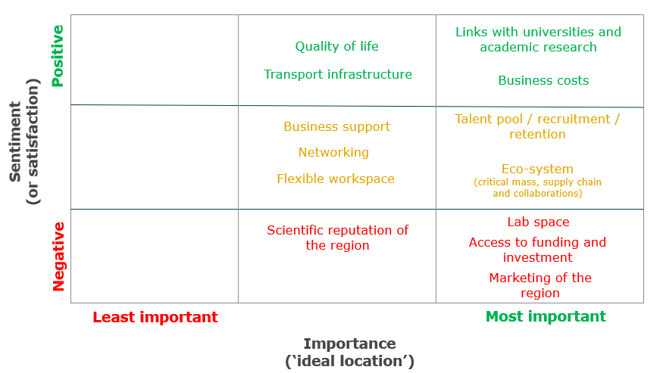

Links with universities / academic research
This was one of the highest ranked aspects in both the sentiment and importance scores. Respondents perceived this to be a strength of the region due to a variety of reasons. These included the high calibre of scientists (and research) that are working in or graduating from universities within the region. It was also discussed that there are world-leading institutions in the region, such as the Pandemic Institute, which has been pivotal for the UK in the last two years in particular. The amount of R&D, particularly the number of clinical trials that are undertaken in the region are seen as a great strength. Respondents also mentioned that the links to academia within the region are strong. However, some respondents felt that these links were fragmented across the region and in some cases collaborations are difficult. Moreover, it was discussed that the universities in the region are not as highly regarded internationally as Oxbridge.
Business Costs
The costs of running a business within the region had both a high sentiment and importance score. Respondents discussed the cost-effectiveness of running a business being a strong advantage of the region. Respondents also spoke of salaries within the region being better when compared with the golden triangle due to the high cost of living in that area. That said, some respondents spoke of increasing costs in science parks within the region and additional costs such as parking which could hurt SMEs.
Quality of life
Quality of life within the region is seen as a great asset. Whilst it may not have been as important as the above topics, it had a high sentiment score with many spontaneous positive comments. Respondents spoke of the great outdoor spaces in the region, and it being a great place to raise a family. Interestingly, no respondents spoke negatively of the quality of life within the region, highlighting that it is a true asset of the region.
Transport Infrastructure
When transport was discussed by the respondents, they generally felt positive about the transport in the region and perceived it to be of medium importance. Respondents spoke of the great access to airports, motorways and felt the region was relatively easy to travel to and from. Where respondents spoke negatively about the transport in the region, it was due to difficulty in getting across the region and the need for improvements in public transport.
Talent Pool
When respondents spoke of talent within the region, it tended to be around both staff retention and the talent pool in the region. It was perceived to have a medium sentiment and high importance to respondents. Respondents discussed that nurturing staff enabled them to largely retain staff. They also spoke of the ease of recruiting graduates within the region. Where respondents were negative, they spoke of talent pool being pulled across regions within the UK, and how younger staff tend to relocate to jobs in the golden triangle after some time. Some respondents spoke of the difficulty in showing potential employees what the region has to offer that makes it stand out against other regions. They also spoke of the difficulty in finding staff of ‘medium’ (5+ years) experience level.
Eco-System
Respondents had mixed views on how good the region’s eco-system was. On the one hand they felt it was of high importance. When discussing the eco-system, respondents spoke of critical mass / supply chain, and collaborations. Respondents discussed the fact there are lots of companies already within the region in the life science sector, and this has generated the existing eco-system. This in turn has created the potential to collaborate and organisations feeling part of a community.
However, respondents also spoke of a general lack of understanding of the existing organisations within the region and the need to grow these companies. They also spoke of the fragmentation across the region leading to further complexities in finding potential collaborations.
Overall, it was felt that the region does have many if not all of the capabilities needed for a successful life sciences eco-system, but there is a general lack of awareness about the extent or opportunities to collaborate. It may be argued that the region is not effectively leveraging the assets it has across the eco-system.
Business Support
Business support was categorised as ‘medium’ in terms of importance and sentiment. There was some awareness of existing platforms that organisations can use to help get the support they need. Respondents also spoke of the great potential opportunity the region has to make strong collaborations between organisations. Respondents felt that there is a general lack of awareness of the variety of business support available and that improved communication regarding networking and support events such as incubators would help overcome this challenge.
Networking
In terms of networking, respondents categorised this as ‘medium’ in terms of importance and sentiment. Respondents felt that within science parks, the opportunity to network was high, and previous connections within the science parks help in terms of networking. However, respondents felt that ‘natural’ networking does not occur often and is driven by individuals rather than as a region as a whole. Respondents further discussed the fragmentation of the region and expressed that they felt the region was disjointed.
Flexible Workspace
Respondents categorised flexible workspace as ‘medium’ in terms of importance and sentiment. Positives around this aspect were centred around the variety of types of office space and the relative ease with which companies had found the process of setting up an office to be in the region. However, respondents also spoke of the high cost associated with offices, especially for companies where staff can now work from home. They also discussed inflexible contracts that were too long to commit to as a start-up company.
Scientific Reputation of the Region
The scientific reputation of the region was medium in terms of importance but scored low in terms of satisfaction. Respondents discussed the potential the region has to become a highly regarded life science cluster. However, the region needs more work before achieving this. Respondents thought the region was not yet mature enough and that there is a need to maximise on what already exists within the region in order to be ‘on the map’ and recognised internationally.
Laboratory Space
The laboratory space within the region was high in terms of importance but scored low in terms of satisfaction. Respondents spoke of the availability of space giving companies the opportunity to grow within the region. However, respondents were dissatisfied in terms of availability and length of time waiting for laboratory space. High cost of laboratory space and long contracts are not deemed ideal for start-ups.
Access to funding and Investment
Access to funding and investment within the region was high in terms of importance but scored low in terms of satisfaction. Respondents spoke of both public and private investment, as well as the opportunity to meet with investors and access to growth support. Whilst respondents stated that funding was available and improving, they also spoke of how they felt they had to overcome more hurdles in order to access funding. This was exacerbated by the smaller population of investors in the region and the difficulty in contacting them. Respondents felt that the lack of funding is inhibiting the growth of the region and there is a general lack of understanding into the support that is available to them.
Marketing of the Region
Marketing of the region was high in terms of importance but scored low in terms of satisfaction. Respondents stated that the region has the potential to appeal to many organisations because of its existing eco-system. However, they generally perceived that there is a fragmented approach to marketing across the region and a general lack of awareness of what already exists within the region. Respondents expressed the need for more aligned and considered marketing of the region as a whole.

Conclusions
When looking at the qualitative research as a whole, the research findings suggested that the major strength of the region include links with universities and business-related costs. These are assets of the region and should be shared with current and future communications. In terms of gaps, availability of lab space, access to funding and marketing of the region were identified as requiring improvement by the respondents. These recommendations should be addressed in an aligned and consistent manner. The approaches taken to address the above should be widely communicated across the whole of the NW life sciences cluster.

4. Comparisons with International Life Science Clusters
In order to understand the comparative size of the NW life sciences cluster and how it compared with other life science clusters, headcount was assessed. Comparing the UK sites with other major markets both within Europe, as well as USA, Japan and China. Due to the size of USA, the major life science states were split out and individually for further comparison.

Size Comparison
So that the size of global life science clusters could be compared, headcount was used. There is no global report that reports headcounts for all of the clusters. Whilst there are individual reports for companies and clusters, these all use different definitions of life sciences, different inclusion criteria and different methodologies to collect headcount. Therefore, individual reports could not be compared. Therefore, we chose to base our analysis on the LinkedIn headcount for the following reasons:
- Benefits of using LinkedIn as sourced data for headcount by geography:
- Consistent across countries
- Up to date and accurate as it is self-maintained
- Accurate in terms of industrial sector categorisation (see below)
- LinkedIn headcount at the sector level is the LinkedIn total and independent of number of connections
- Because of the consistency and up to date nature of the data, using LinkedIn for source of headcount data lends itself to an annual update which could be very valuable to give the annual growth rate of the various clusters around the world
- There are some limitations with using this methodology to be aware of (see appendix).
  - Japan’s numbers are understated reflecting a low uptake of LinkedIn in that country
  - Self-declaration of categories may, in some cases, not be accurate
  - There may be people included who have retired, died or not updated their profile
- However, on balance, the benefits outweigh the limitations of using the LinkedIn headcount It provides a much more balanced approach to the other fragmented and inconsistent headcount sources
This methodology uses the individuals’ company-assigned sector, of which there are 149 sector categories and an organisation can only be assigned to one of them. Of the 149 categories, we have used 3 categories as our inclusion criteria: pharmaceuticals, biotechnology and medical devices. The full list of categories can be seen in the appendix.
These data can be seen in tables 3-9.

Table 3. LinkedIn Headcount by Sector for Europe 7 (000s)
 | UK | France | Germany | Italy | Spain | Switzerland | Belgium
Pharms | 170 | 150 | 100 | 100 | 93 | 53 | 47
Biotech | 69 | 61 | 53 | 37 | 32 | 21 | 16
Medical Devices | 66 | 60 | 92 | 38 | 46 | 28 | 13
Total | 305 | 271 | 245 | 175 | 171 | 102 | 76
The UK has a higher headcount than any of the other European countries. It has the highest headcount in all sectors bar medical devices, where is comes second to Germany.

Table 4. LinkedIn Headcount by Sector for NW life sciences cluster (000s)
 | Greater Manchester | Liverpool City Region | Cheshire & Warrington
Pharms | 6.5 | 3 | 6.5
Biotech | 2 | 1 | 1
Medical Devices | 2 | 1 | 1
Total | 11 | 5 | 9
When looking at the NW life sciences cluster, Greater Manchester has the highest headcount versus the other regions. Interestingly, Cheshire and Warrington have a greater proportion of people in the pharmaceutical sector than Liverpool, and a similar amount as Liverpool in the biotech and medical device sectors.

Table 5. LinkedIn Headcount by Sector for Golden Triangle (000s)
 | Greater London | Cambridgeshire | Oxfordshire
Pharms | 49 | 6 | 3
Biotech | 16 | 5 | 3
Medical Devices | 10 | 2 | 2
Total | 75 | 13 | 8
When looking at the Golden Triangle, Greater London unsurprisingly has the highest headcount by far. Cambridge has a higher headcount that Oxford in the pharmaceutical and biotech cluster but have roughly the same in terms of medical device.

Table 6. LinkedIn Headcount by Sector for NW life sciences cluster and Golden Triangle (000s)
 | NW life sciences cluster | Golden Triangle
Pharms | 17 | 57
Biotech | 5 | 24
Medical Devices | 4 | 13
Total | 26 | 94
The Golden Triangle has a significantly larger headcount in every sector when compared with the NW life sciences cluster. This is driven by Greater London. In terms of headcount, the NW life sciences cluster is almost a quarter of the size the Golden Triangle. The headcount for the NW life sciences cluster in this figure is greater than the 7i figure of 15,581 (see Fig3). This headcount includes companies that 7i excluded, but this methodology provides an aligned comparison with the global cluster.

Table 7. LinkedIn Headcount by Sector for Key USA Cluster States (000s)
 | Boston (Massachusetts) | San Francisco | Los Angeles | New York / New Jersey | Philadelphia (Pennsylvania and Wilmington) | Chicago (Illinois)
Pharms | 51 | 32 | 42 | 160 | 92 | 48
Biotech | 74 | 84 | 40 | 49 | 23 | 16
Medical Devices | 43 | 42 | 52 | 53 | 32 | 28
Total | 168 | 158 | 134 | 262 | 147 | 92
When looking at major life science clusters in the USA, the largest cluster by far is the New York / New Jersey cluster. It leads the way in all sectors apart from the biotech cluster, which is led by San Francisco.

Table 8. LinkedIn Headcount by Sector for Europe (7), USA, Japan and China (000s)
 | USA | Europe (7) | Japan | China
Pharms | 980 | 713 | 26 | 5,000
Biotech | 620 | 289 | 8 | 2,000
Medical Devices | 690 | 343 | 17 | 2,000
Total | 2,290 | 1,345 | 51 | 9,000
Note: Europe 7 total is an arithmetic sum of the 7 European countries. USA, Japan and China were based on queries run at the country level.

Table 9. Overview of sector size and number of clinical trials
Region | Country | Cluster | Headcount  (commercial organisations) |  | Number of current clinical trials
 |  |  | Headcount (000s) | Size vs. NW life sciences cluster
Europe | UK | Entire country | 305 | x11.7 | 3,455
 |  | NW life sciences cluster | 26 | x1.0 | N/A
 |  | Golden Triangle | 94 | x3.7 | N/A
 | Germany | Entire country | 245 | x9.4 | 3,462
 | France | Entire country | 271 | x10.4 | 3,824
 | Italy | Entire country | 175 | x6.7 | 3,317
 | Spain | Entire country | 171 | x6.6 | 3,646
 | Switzerland | Entire country | 102 | x4.0 | 1,059
 | Belgium | Entire country | 76 | x3.0 | 2,042
North America | USA | Entire country | 2,290 | x88.0 | 16,875
 |  | Boston (Massachusetts) | 168 | x6.4 | 1,110
 |  | San Francisco | 158 | x6.0 | 1,289
 |  | Los Angeles | 134 | x5.2 | 389
 |  | New York / New Jersey | 262 | x10.1 | 7,353
 |  | Philadelphia (Pennsylvania and Wilmington) | 147 | x5.7 | 3,615
 |  | Chicago (Illinois) | 92 | x3.6 | 2,257
Asia | China | Entire country | 9,000 | x346.1 | 13,751
 | Japan | Entire country | 51 | x2.0 | 4,742

When looking at the size of other clusters relative to the NW life sciences cluster, it is evident that we are much smaller in terms of headcount and size. Interestingly, the UK has a higher headcount in life sciences than any of the other European countries included in this analysis. Unsurprisingly, New York and Boston are the largest of the USA clusters and are 6-10 times the size of the cluster in the North West.

In terms of clinical trials, the 5 major markets in Europe are of similar size (France, Germany, Italy, Spain, UK). In the USA, the East Coast is by far the largest in terms of clinical trial. Despite the UK being much smaller in terms of size when compared with the other regions, with the number of current clinical trials on a par with Philadelphia.

NW life sciences cluster versus Golden Triangle
The NW life sciences cluster has a wealth of organisations within the eco-system, however, there are still gaps when compared with the Golden Triangle. The NW life sciences cluster is still ‘early’ in terms of being a life science cluster whereas the Golden Triangle is much better established. This has further been exacerbated by the media around the pandemic and the development on the Oxford/AstraZeneca vaccine. There are many big players in pharmaceuticals that are situated within the Golden Triangle and this presence is lacking within the NW life sciences cluster.
Last year, AstraZeneca opened a new R&D centre in Cambridge, the £1bn centre is the company’s biggest investment to date⁽³⁾. This shows that their focus is on their Cambridge sites and that in turn will generate funding and help the eco-system within the Golden Triangle. Whilst the NW life sciences cluster has all the ‘ingredients’ required to be a highly regarded life science cluster, it is held back by the fragmentation of the region and sub-scale companies. This is further worsened by the fact that Cambridge is set to outpace the region, driven by their new R&D facility. Whilst the NW life sciences cluster is improving as years go on, so is the Golden Triangle, however they are improving at an accelerated pace. This is also true when comparing the UK to clusters such as Boston, where $13bn was raised last year⁽⁴⁾. Whilst the qualitative research did not bring about findings for international comparisons, there was a shared perception from the respondents that the NW life sciences cluster is behind when compared with the Golden Triangle. One respondent stated: “[The] Golden triangle is 30 years ahead of us, Boston is 30 years ahead of that”. This aligns well with the above and shows the enormity of other life science clusters, especially in the US, when compared with both the UK as a whole and the UK’s individual clusters.

Conclusions
Whilst the NW life sciences cluster has a life science eco-system, there are more advanced clusters which operate more efficiently and have better reputations. The NW life sciences cluster has the potential to be a well-known cluster however, we must note that other clusters such as Boston are accelerating and improving at a much faster rate. This is likely due to a well-established reputation and an abundance of world-leading organisations.

5. SWOT Analysis
Normally a SWOT analysis (strengths, weaknesses, opportunities, threats) is used at an organisation level or a product level, where ‘strengths and weaknesses’ are internal to the organisation and ‘opportunities and threats’ are external to the organisation. With regard to the SWOT analysis for the NW life sciences cluster, it is perhaps more appropriate to consider the positives (i.e. strengths and opportunities) together, and similarly the potential negatives (i.e. weaknesses and threats) together.

Strengths and Opportunities

Links with universities and academic research
The links with academia are a great strength of the region. There are 49 Academic/NHS Alliances (Fig 2), which include 13 universities. This provides the region with a great base for research and development. It also means that smaller organisations have a greater opportunity to collaborate with academia as there is a good critical mass present. The calibre of academic research within the NW life sciences cluster is extremely high, this has been further shown by the research conducted by the Pandemic Institute, University of Liverpool, during Covid-19.

Business costs
The costs associated with running a business are also a great strength of this region. The cost are comparably lower than other regions such as the Golden Triangle. This favourable factor means there is a great opportunity for business owners to invest into the growth of their companies and/or asset base.

Transport
Within the region, there is good access to major motorways, airports, train stations and also the freeport. This is a great strength of the region as it means that travel both nationally and internationally is easy, whether you are travelling for business or distributing a product.

Quality of life
The quality of life in the region has been widely recognised as a great asset. The mix of city and country living within close proximity is unique to the region and makes it appealing to a wide range of people. The work/life balance was perceived as great in the region, this is helped by the natural beauty that the region provides.

Weaknesses and Threats

Scientific reputation and marketing of the region
The NW life sciences cluster is fairly unknown internationally in terms of having the reputation of being a life science cluster. This should be addressed in order to put it ‘on the map’ for the wider global market. The more the region is consistently advertised both nationally and internationally the more of a reputation it will gain. This will allow the region to become widely recognised and compete with other global clusters. Moreover, the marketing of the region on both a national and international basis has been scarce and fragmented. This should be increased and aligned in order to make a bigger impact. The fragmentation and lack of collaboration within the region was a common theme throughout the research and further exacerbates the above issue. Organisations should be aware of the existing eco-system within the region in order to enhance the opportunity to collaborate and naturally promote the region to clients.

Access to funding and investment
When looking at the investment into the region, it is far behind other regions such as the Golden Triangle and Boston (see section 4). The lack of critical mass of investors further inhibits the region and this research found that there was a perception amongst organisations that they had to work harder in order to obtain the capital that they require. Funding is particularly crucial in determining the success of SME’s of which there are many within the region. Currently there is a large unmet need in terms of funding within the region and this should be communicated and addressed.

Lab space and flexible office space
With the majority of turnover from a life science cluster being brought in from the biopharma sector (see section 1), laboratory space for research is therefore fundamental. Yet, within the region there is a scarcity of available laboratory space of varied size for organisations. This is inhibiting the growth of organisations. Whilst there is some laboratory space available within the region, either the location is not convenient or cost is high. This issue is further worsened by the fragmentation and lack of communication across the region as some organisations require laboratory space yet are unaware that there is space available. This kind of business support is lacking within the region and therefore widens the gap when comparing the NW life sciences cluster with other life science clusters. Moreover, there has been great change in the last two years in terms of the ability to work from home. Some organisations have largely unused office spaces or may have even got rid of their office space. Therefore, a wider availability of flexible office space could be of great benefit to the region as it allows people to use space on an ad-hoc basis. The more flexible office space, the more likely organisations are to network with other organisations in the same situation and this could therefore improve the collaborations within the region.

Talent pool and networking
The smaller size of the NW life sciences cluster can be seen compared to other life science clusters is shown in Table 9. The size of the region therefore directly impacts the available talent from which to recruit and therefore makes finding the right employees a more difficult task. There is generally less competition for jobs and means that organisations are more limited when selecting the right candidate and may have to compromise. The smaller size is also evident when looking into networking in the region. Natural networking does not occur as often as the region is more fragmented and has a smaller number of employees. These factors all contribute to weaknesses of the region as other regions (such as Boston) are advancing at a much higher rate than the NW life sciences cluster.

Business support and eco-system
In terms of business support, whist accelerators do exist within the region, there are fewer when compared with elsewhere. The region should have some form of live, updatable resource for companies to use to help them understand where to source companies, such as lawyers or accountants, that have had experience working in the sector. Sharing the 7i generated list of organisations could help organisations easily identify the services they need. This is especially important for start-up companies and would aid them grow within the region and further help develop the existing eco-system.

6. Overall Findings and Concluding Remarks
This research provided a deep understanding of what the eco-system in the NW life sciences cluster looks like as well as providing some insight into the advantages and disadvantages of the NW life sciences cluster.
To position the region and a life science cluster, collaboration must be encouraged and supported. This aligns with the NP11 NHSA recommendations and will help encourage new relationships to grow. Moreover, the NP11 NHSA report also reported that access to capital is a drawback for the region and a real challenge for businesses, which is also true in the research 7i group conducted. The region benefits from great access to high calibre research and good links with universities. This opportunity was also identified in the report generated by the Department for International Trade. The NW life sciences cluster should take all of the above into consideration in order to form a strategic plan to level up the region to make to a great life science cluster.
In order to be a cluster of both national and international significance, the NW life sciences cluster needs to secure regular and substantial funding, as well as working collaboratively across what is currently a fragmented region. The region has some long-standing large organisations as well as a plethora of start-up companies which provides a great opportunity to grow.
The factors plotted in the matrix can be clustered into 4 sections, place-based factors, employment factors, incubators and support and business infrastructure.
The categories with the highest level of satisfaction (i.e. key strengths of the region) were:
- Place-based factors (quality of life, transport infrastructure)
- Employment factors (staff retention, talent pool and universities / academic research)
The categories where there are ‘gaps’ across the regions are:
- Incubators and business support (opportunity to meet with investors, public and private sources of funding, business and growth support, networking)
- Business infrastructure (laboratory space, flexible workspace, critical mass of the eco-system, costs of business)

Key recommendations
- Coherent and co-ordinated branding and marketing of the cluster
- Encourage and promote active networking across the cluster, in particular between science parks and the public/private sectors
- Ensuring the continued available supply of high quality, but affordable laboratory space
- Ensuring improved/increased access to sources of funding and business growth advice

Proposed Next Steps
The mapping and gapping exercise has been valuable in terms of identifying the key issues and pointing the right direction towards a successful and sustainable life science eco-system. However, the research does not address in detail the tactical actions to reach that goal. In order to address this need, it is recommended that one or more work streams be established to develop a more action-focussed implementation plan. For example, laboratory space is an important factor and is an unmet need / gap – a workstream could examine this issue in more detail and develop an action plan to address this issue.
It is recommended that the following workstreams are established to focus on key categories:
- Employment factors
- Business support
- Business infrastructure
- Place-based factors
Each workstream would develop a detailed action-focused implementation plan and report back with its recommendations to representatives of each of the key geographical locations across the region.

References
- https://blog.eglifesciences.com/life-sciences-clusters
- https://www.gov.uk/government/statistics/bioscience-and-health-technology-sector-statistics-2020/bioscience-and-health-technology-sector-statistics-2020
- https://www.astrazeneca.com/content/astraz/media-centre/press-releases/2021/astrazeneca-unveils-the-discovery-centre-disc-in-cambridge.html
- https://www.bizjournals.com/boston/news/2021/12/29/top-10-venture-capital-deals-boston-biotech-2021.html

Appendix I: Headcount Analysis Using LinkedIn

Sectors Included in LinkedIn
When an organisation is created in LinkedIn, the creator of the organisation’s profile is asked to allocate the organisation into one of 149 categories. The organisation cannot be allocated to more than one category at any single point in time. To change the organisation’s category a password is required. This was set by the person who created the original organisation profile in LinkedIn.
Once the organisation profile has been created, any LinkedIn member can allocate their current or previous employment history to that organisation.
Searches were undertaken using the premium subscription of LinkedIn (known as Sales Navigator) in order to calculate the headcount in the following 3 categories:
- #12. Biotechnology
- #88. Medical Device
- #107. Pharmaceuticals
The headcount figure returned by Sales Navigator in each of these searches was based on the total LinkedIn community membership and was not limited by the number of LinkedIn connections of the person conducting the search.
A sub-group analysis is made possible in Sales Navigator by including additional filters in the search query e.g. geographical location.
A list of all 149 categories used to allocate an organisation in LinkedIn is shown below.
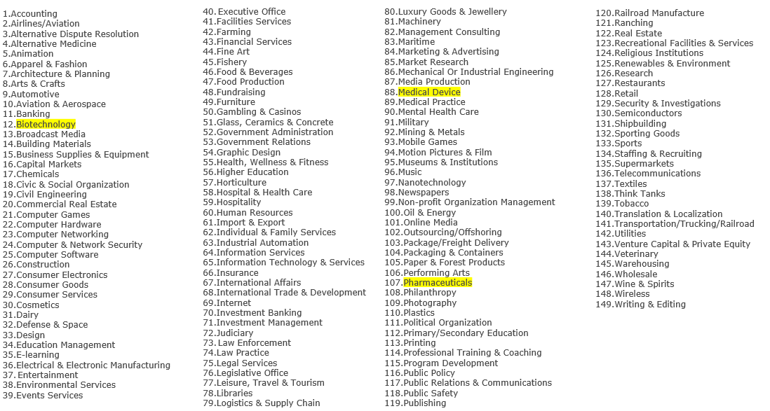
Note: The Hospital & Health Care category (#58) was reviewed and excluded from the headcount analysis due to discrepancies in definition across countries.

Assumptions and caveats
- Creators of an organisation’s profile are accurately selecting the correct category that reflects most or all of the organisation’s operations
- Headcount figures exclude those people who are not a LinkedIn member
- Some LinkedIn members may not have linked themselves accurately or at all to their organisation
- Headcount figures may include users who have not updated their profile e.g. they may now be employed by an organisation in a different sector or they may have retired or died.
- Headcount estimates in Japan may be underestimated as the size of the LinkedIn community is lower in that country on a per capita basis compared to other countries in Europe and North America.

Rounding
The headcounts reported by the LinkedIn search functionality are rounded to varying degrees depending on the headcount size of the search result as shown in the table below.
Number of people returned by the search criteria | Rounding
Up to 999 | None
From 1,000-9,9500 | Rounded down to the nearest 500
10,000-99,000 | Rounded down to the nearest 1,000
100,000-999,000 | Rounded down to the nearest 10,000
1,000,000+ | Rounded down to the nearest 1,000,000

The above points regarding ‘Assumptions and caveats’ and ‘Rounding’ will probably result in an underestimate of the headcount in any given sector.

Locations using LinkedIn search filters
In order to cover the whole of the NW life sciences cluster, where there were multiple options for one region, all of those were selected. Please see below what was selected for each region:
- Cheshire and Warrington
  - Cheshire East
  - Cheshire West and Chester
  - Cheshire
  - Greater Cheshire West and Chester
  - Warrington
- Liverpool City Region
  - Liverpool area
  - Merseyside
- Greater Manchester
  - Greater Manchester

