**OUTLINE BUSINESS CASE - Omega to Burtonwood Shared Use path, Warrington**

|  |  |
| --- | --- |
| **Cheshire & Warrington Enterprise Partnership**  **LOCAL GROWTH FUND BUSINESS CASE TEMPLATE** |  |

The Local Growth Fund is awarded on a competitive basis and as such the LEP has to ensure that it is presenting a compelling case to Government and that the projects it submits show a clear rationale and well defined benefits. Further guidance on the Local Growth Fund is available at: -

<https://www.gov.uk/government/publications/growth-deals-initial-guidance-for-local-enterprise-partnerships>

In order for the LEP Executive and others to appraise proposals, all Promoting Organisations are required to complete this Local Growth Fund Business Case Template. In addition to headline project details, the form comprises six sections: -

B: Strategic Case

C: Economic Case

D: Financial Case

E: Management Case – Delivery

F: Commercial Case

G: Evidence and Supporting Information

Please complete the form as fully as possible ensuring that all information requested is included. If there are elements that you are not yet in a position to complete please indicate clearly when this information will be available.

Where additional information is requested, such as location maps or Gantt charts, please supply these as separate documents or files, rather than attempting to embed them within this form.

Please note that questions B6 and C3 are only applicable to Transport Schemes.

Additional information may be requested for projects seeking funding from specific streams of LGF (e.g. FE Skills Capital).

**Note that all project proposals must align to the priorities identified within the LEP’s Strategic Economic Plan.**

On completion, please return the form to Rachel Brosnahan at Rachel.brosnahan@871candwep.co.uk

|  |
| --- |
| **Section A: Scheme Details**  This section asks you for basic information on your scheme, including a brief description, type of scheme, scheme location and contact details for further information. |

|  |  |
| --- | --- |
| **A1: Scheme Name** | Omega to Burtonwood Shared Use path |
| **A2: Promoting Organisation** | Warrington Borough Council |
| **A3. Accountable Body** | Warrington Borough Council |
| **A4: Main Point of Contact** | ***John Nichol (Principal Transport Planner, capital delivery):***  ***01925 443867***  [***jnichol@warrington.gov.uk***](mailto:jnichol@warrington.gov.uk)  ***Transport for Warrington, Economic Regeneration, Growth and Environment, Floor 3, New Town House, Buttermarket Street, Warrington, WA1 2NH*** |
| **A5: Type of Scheme** | ***Please indicate the type of scheme being submitted***   Transport infrastructure  Regeneration  Enabler  Other (please specify): |
| **A6: Scheme Description** | ***Please give a brief description of your scheme*** *(in no more than 100 words)*  Provision of a new 3.5m wide shared use path between the village of Burtonwood and the start of the shared use paths at J8, M62 Omega. It would allow residents from Burtonwood (and from St Helens to the north) a safe route to allow them access to the retail and job opportunities presented by the Gemini and Omega employment areas. |
| **A7: Total Project Cost** | *Please indicate the total capital cost of your project*  **£1,000,000** |
| **A8: LGF Requested** | *Please confirm the total amount of LGF requested*  **£500,000 Percentage [50% ] of total project costs** |
| **A9: Geographical Area** | ***Please provide a short description of area covered by the Scheme*** *(in no more than 100 words)*  The proposed scheme runs alongside a C class road (Clay Lane/Burtonwood Road) which links the village of Burtonwood to junction 8 of the M62 in North west Warrington. There is a phase 2 scheme which is not part of this business case which will make use of Barn Lane as a non trafficked link between the eastern end of Burtonwood village and Clay Lane.  ***Please supply a location map and where possible a map showing the site boundary (and Mapinfo Table(s) where available).*** *If possible please highlight existing transport infrastructure and other points of particular interest to the bid e.g. development sites, areas of existing employment, constraints etc.* |
| **A10: Alignment to Strategic Economic Plan and National Policies** | ***Please select which strategic priorities the scheme aims to support. Please select all categories that apply***.  Constellation Partnership  Cheshire Science Corridor  Crewe High Growth City    Warrington New City  Mersey Dee Economic Alliance  Other(s), Please specify –  ***Please provide evidence of how your proposal also aligns with and supports relevant National policies or initiatives***.  The project is aligned with government policy in terms of the National Planning Policy Framework (NPPF 2018), the Growth Agenda, and also in supporting the government’s Cycling and Walking Investment Strategy (2017). Please refer to Annex E for details.  **The Project has the following SMART objectives**  The primary objectives of the scheme area as follows:   * Provision of a safe and direct route for pedestrians and cyclists between Burtonwood village and the job and retail opportunities at Omega/Gemini. * Minimise the number of crossing points of Burtonwood Road/Clay Lane which might place the user at risk of a collision with motor vehicles on the road.   The wider strategic objectives are as follows:   * To improve the health of residents by allowing them to travel in a more sustainable manner * To improve the safety and personal security of residents * To improve the quality of life for residents by creating a more pleasant travelling environment * To provide economic opportunities for residents * To benefit the wider environment by reducing carbon emissions, traffic pollutants and traffic noise as a result of more people walking and cycling between Burtonwood and the rest of Warrington. |

|  |
| --- |
| **B: Strategic Case**  This section should set out in more detail the rationale for making the investment and evidence on the strategic fit of the Scheme. |

|  |  |
| --- | --- |
| **B1: Current LEP Challenges / Market Failures / Opportunities Addressed by Scheme** | ***What are the current problems or market failures to be addressed by your Scheme? (Describe any economic, transport, skills, environmental, social problems or opportunities which will be addressed by the scheme). Please provide quantitative examples of how the problems will be addressed by your Scheme.***  The Cheshire and Warrington SEP is targeting a £35bn economy with GVA per head at 115% of the UK average by 2030. However a number of challenges remain with respect to increasing sustainable travel behaviour as part of everyday life, improving access to employment opportunities and housing sites and realising the true economic potential of strategic areas and sites.  At the LEP scale, the development of prime brown-field land in sustainable locations is currently restricted because supporting transport infrastructure is missing and sustainable modes of travel are not comprehensive enough to offer a realistic alternative to car travel. The type of workforce based at Omega is generally less likely to afford or have access to a car so sustainable travel links are required to both unlock sites and ensure that they are accessible for low income groups.  At a more local level, parts of Warrington remain within the most deprived in the country. JSA claimant rates are over twice the national average in several wards of Warrington and in neighbouring wards of St Helens. These areas also have the highest rate of unemployment, lowest educational attainment, worst health deprivation and low levels of car ownership. Air quality management areas have been declared in Warrington along the M62 in close proximity to the Omega and Gemini employment sites. Car use for commuting in Warrington (70.6%) is also well above the national average of 57.5%.  Sustainable transport improvements and a shift from car travel to walking and cycling will release capacity in the highway network and enable the network to accommodate increased travel demand that arises from new developments, improve local air quality and increase GVA through enabling job seekers to access employment.  The proposed Scheme will directly and indirectly support local economic growth in Warrington. By removing barriers to employment, the scheme will enable people to enter, or re-enter the labour market. Improvements to the physical fitness and wellbeing of the workforce within the entire strategic area also have both direct and indirect linkages to economic productivity.  Improvements to walking and cycling provisions by this Scheme to the key employment site of Omega will continue to improve access for all to jobs and education facilities as well as to the emerging housing developments. This will stimulate improvements to deprivation levels and air quality throughout the Borough as well as promoting improved health. |
| **B2: Future LEP Challenges / Opportunities Addressed by Scheme** | ***Are there any problems you have identified that will occur in the future that your Scheme is intended to address? (e.g. congestion, road safety, access to services and opportunities etc.).***  Through enabling sustainable access to housing and employment by improving walking and cycling infrastructure, the Scheme will deliver measurable congestion benefits to the highway network in this part of Warrington. Congestion in key development areas ultimately affects access to a suitably qualified pool of labour, suppliers and markets, and both congestion and labour are two crucial factors when investors, developers and businesses consider locations.  The aspirations of the Cheshire and Warrington Strategic Economic Plan together with the Warrington Means Business strategy will inevitably lead to increased pressure on all transport networks. Current trends suggest that much of this demand will be car-borne unless interventions and investment is achieved for other modes, most notably walking and cycling.  There is a concern that even if the funding is provided for large scale capital investment on highway schemes, the highway network would be unlikely to cope with the additional demand. The resulting traffic congestion could therefore act as a throttle to growth and prevent access to jobs and labour, stifling inward investment. In addition this may lead to a negative impact on local air quality with further Air Quality Management Areas needing to be declared.  Alternatives to car travel have a valuable role to play in strengthening the economic resilience of the region and therefore must be viewed as a priority for investment. |
| **B3: Wider Geographic Impact** | ***Please provide information on any potential impacts the project may have outside of Cheshire and Warrington, for instance does it involve partnership working with another LEP or organisation. You should indicate those areas that will directly benefit, areas that will indirectly benefit and those areas that will be impacted adversely.***  The Scheme is located in the north west of Warrington and is adjacent to St Helens which is within the Liverpool City Region. There have been regular meetings with St Helens Council to identify projects which could help with cross boundary movements of workers. One such project is the creation of a link between St Helens town centre to Burtonwood village via the Bold employment site. Together with the Warrington project this would create a cross boundary walking and cycling route between St Helens and Warrington. St Helens council are pursuing this project through the Liverpool STEP programme with a timeframe of delivering a scheme in 2019/20. |
| **B4: Alternative Options** | ***Please describe what alternative options and funding sources have been considered and why these have been rejected. Include information on the likely implications of the intervention not happening. How have you prioritised the options considered in order to reach an optimal solution?***  Several alternatives to the project were considered and prioritised based on the ability of each alternative to meet the project objectives as follows:   * Do nothing – people will continue to walk or cycle alongside the road linking Burtonwood and the employment areas of Omega and Gemini. This was not considered acceptable by local people due to road safety concerns. * Do something options 1, 2, 3 and 4 – These all utilised the upgrading of some of the public rights of way across the fields. This was considered not acceptable to local people because of personal security concerns. * Do something 5 (preferred option) – a new path alongside the road using land acquired from landowners. This was supported by residents and would address road safety and security concerns. The specific route expected to be delivered would avoid any road crossings thus providing a direct route which would be attractive to users.   A fuller description of these options are provided in Annex A.  The value of the Scheme (at around £1m) is far higher than local transport capital resources are able to provide. The Warrington Local Transport Plan, for example, only allocates around £300,000 per year to cover a range of small scale sustainable travel projects.  It follows that larger footpath/cycleway schemes such as the Burtonwood to Omega project have tended to rely on additional government funding such as the LSTF programme which ran from 2012 to 2015. This was succeeded by the government’s Access Fund for sustainable transport projects, the capital element of which was incorporated within the Growth Deal. This provided an opportunity for local authorities through their LEPs to bid for capital funds to deliver larger cycle and walking projects.  The joint Active Travel Investment Strategy submitted by the C&W LEP authorities was included within the LGF3 Growth Deal. These schemes are those which best support sustainable access to economic growth and opportunity and can be delivered within the timescale of the Access Fund. All of the projects (including the Burtonwood to Omega project) scored very high BCRs and offer wide economic, social and environmental benefits in terms of promoting alternatives to car dependence, reducing congestion, promoting regeneration and improving personal safety and security.  In the event of the project not happening then there would continue to be a high dependency on car travel for access to the Omega/Gemini employment areas. The non car owning residents of Burtonwood would continue to feel dis-enfranchised in terms of their opportunity to reach these areas and for those attempting to make the journey on foot or by bike then they would continue to be at risk from the traffic on the roads. |
| **B5: Contingency Planning** | ***If Local Growth Fund monies are not available for your Scheme, do you have a contingency plan for this Scheme? If your answer is 'no' please comment on the potential impacts of this scheme not being implemented.***  ***Include both qualitative and quantitative information on the potential negative impacts likely to occur.***  If LGF monies were not available for this project then as referred to in section B4 it would be unaffordable and therefore not deliverable. The alternative funding scenario would be for the Council to take on the full cost of the scheme through additional borrowing approval.  The impacts of failing to deliver the walking and cycling connections, new jobs and new houses of this scheme are numerous:   * Spending on highway maintenance will increase as a result of a rise in car-kms; * Spending on health and social services will increase as a result of a failure to tackle obesity and low physical activity levels as well as health inequalities arising from traffic emissions and noise levels; * Spending on benefit payments will increase as a result of a failure to tackle worklessness. A report from the Joseph Rowntree Foundation entitled ‘The benefits of tackling worklessness and low pay’ indicates that for every £1 saved from the annual £6,900 spend per person on benefits, 80p accrues to the Department for Work and Pensions (DWP), and HM Revenue and Customs (HMRC), 10p to NHS commissioners, 7p to the local authority and 3p to criminal justice services, fire services, and social housing providers. Savings on benefits can therefore contribute a significant benefit to wider society; and * Inward investment within Warrington could reduce as businesses and developers will not perceive the area to have adequate transport links to enable them to operate a financially viable business. |
| **B6: Policy Fit with LTB Policy Objectives**  **(Transport Schemes Only)** | ***For transport schemes please provide a description for how your Scheme will meet the LTB objectives (in no more than 100 words against each objective):***  **Reduce congestion and improve the efficiency of the network to support economic growth and regeneration**   * Through the development of new shared use paths, connectivity by walking and cycling to key employment sites and identified housing development sites, and supporting further growth at these sites. * The new route will encourage modal shift towards cycling and walking as a means of travel for regular short-distance journeys, removing vehicles from the surrounding highway network and improving the attractiveness of the area to new investors and developers. * High decongestion benefits as demonstrated by the Cheshire & Warrington LSTF economic evaluation report. The LSTF schemes across the C&W LEP area for 2012/15 generated £44.5m decongestion benefits.   **Reduce the impact of traffic on the environment, reduce carbon emissions and adapting the transport network to the effects of climate change**   * This schemes will support modal shift towards methods of travel that support carbon reduction and contribute to improved air quality. * This scheme provides improved walking and cycling connections to the employment and retail sites of Omega and Gemini thereby reducing the frequency at which private vehicles are used as a mode of travel. This will facilitate a noticeable improvement to local air quality and daily congestion levels. * The economic evaluation for the LSTF 2012/15 schemes in Cheshire & Warrington also assigned a £2.9m benefit from improved local air quality, reduced greenhouse emissions and lower levels of noise across the LEP area.   **Maintain large transport structures**   * Not applicable in this instance   **Contribute to safe and secure transport and promote types of transport that are beneficial to health**   * This scheme will provide over a new off-road routes in Warrington, directly contributing to the Government’s ambitions within the Cycling and Walking Investment Strategy to improve access for all users to safe and attractive walking and cycling routes. * Delivery of this new route will encourage active travel as the natural mode of choice for shorter journeys; walking and cycling for just 10 minutes can contribute towards the recommended 150 minutes of moderate intensity physical activity for adults per week as recommended by the UK’s Chief Medical Officers, reducing the risk of conditions including cardiovascular disease and type 2 diabetes. * The LSTF Economic Evaluation for Cheshire & Warrington also estimated that LSTF schemes delivered £9.2m benefits from reduced traffic accidents and £4.6m from increased physical activity, a demonstration of both the safety and health benefits that investment in active travel can deliver.   **Improve accessibility to jobs and key services, particularly for disadvantaged communities or groups**   * This scheme is would access the 10,000+ jobs in the Omega/Gemini area * The new route will be constructed to meet Equality Act standards to allow safe, direct and accessible routes for people with a mobility impairment. |

|  |
| --- |
| **C: Economic Case**  This section should set out the case for the Scheme in supporting and accelerating the economic growth of Cheshire & Warrington. It is important that the benefits provided by the proposed project take account of issues including deadweight and displacement and as such benefits and outputs should be shown as net. |

|  |  |
| --- | --- |
| **C1: Job and Wealth Creation and Impact on Skills Across Cheshire & Warrington** | ***Please indicate (where possible) the scale of direct and indirect employment opportunities being created as a result of implementing this Scheme.***  The new facility would provide a link to the employment areas of Omega, Gemini and Lingeley Mere which collectively has over 14,000 jobs and is expected to increase by a further 1,800 jobs between 2017 and 2021.  It is estimated that around **50 jobs** would be created.  The walking and schemes included represent a continuation of the successful sustainable travel initiatives delivered by LSTF programmes. An economic evaluation of the LSTF programmes for 2012/15 across the CWLEP area show a high NPV and BCR and increased GVA, as indicated in the infographic below. |
| **C2: Growth in GVA** | ***Please provide an estimate of the impact of your Scheme in growth of Gross Value Added. Indicate how this estimate has been arrived at including details of any impact assessment model that you have used.***  The growth in GVA per annum that this scheme could bring to the Warrington economy is **£1,118,250.**  This is based on applying the average GVA per Warrington worker to the number of new employees expected to take up work at the employment areas of Omega, Gemini and Lingeley Mere and expected to walk or cycle when using the new path. |
| **C3: Productivity Benefits to Business** | ***Please describe how the Scheme will improve travel times, accessibility changes to business, unlocking land for development etc.***  As highlighted by the economic evaluation of the LSTF programme already undertaken in the Cheshire and Warrington LEP area, investment in walking and cycling can deliver local productivity benefits to business and a demonstrable impact for the Strategic Economic Plan (SEP) Strategic Imperatives (SIS):   * Help retain and attract talent and businesses in target sectors and locations, by minimising the adverse impacts of road traffic congestion (SI2); * Boost productivity and GVA, by increasing access to jobs and labour and helping to create a healthier population (SI1, SI3 & SI5); * Unlock strategic development sites for employment and housing, ensuring that road traffic congestion does not threaten future growth (SI2 & SI4); and * Improve local, regional and international connectivity, enabling businesses to forge better connections with each other, suppliers, and markets (SI6).   The CWLEP LSTF programmes delivered £44.5M in decongestion benefits, providing benefits to road users through increasing the accessibility of employment sites and freeing up capacity for additional development (in turn stimulating economic activity). Walking and cycling investment derived £4.6M benefit in from increased physical activity which results in a healthier more productive workforce and reduced absenteeism. |
| **C4: Value for Money** | ***Please provide evidence of how your proposal offers value for money. For a transport scheme this can be a BCR figure. Please state numerically. If no BCR available please provide explanation of when it may be available or other justification (including for non-transport schemes an indication of return on investment or unit costs).***  The project was originally calculated to have a BCR of **3.76** as part of the LGF3 Active Travel Investment Strategy business case first submitted to the C&W LEP in May 2016.  A revision of this figure was undertaken in January 2018 as part of the Sustainable Travel Access Fund application to the LEP which was subsequently accepted. Changes to the calculation included a higher figure provided for the length and numbers of new cycling and walking trips expected to be created by the scheme. The revised BCR figure is **4.57** which according to DfT criteria, represents **high Value for Money**. The package of schemes has a Present Value of Benefits of £5.4m against a Present Value of Costs of £1.2m (both in 2010 prices and discounted to 2010).   |  |  | | --- | --- | | **Analysis of Monetised Costs and Benefits (£000s and in 2010 prices)** |  | |  | **£000s** | | Ambience benefits | 1,358.2 | | Travel Benefits (Decongestion) | 203.0 | | Mortality /health benefits | 3,596.2 | | Reduced Absenteeism | 174.4 | | Environmental benefits | 17.3 | | Accidents | 55.0 | |  |  | |  |  | | Present Value of Benefits | 5,404.1 | | Present Value of Costs | 1,183.7 | |  |  | | **Benefit to Cost Ratio** | **4.57** | |  |  | |
| **C5: Other Outputs** | ***Please quantify any other benefits or outputs arising from the project, stating whether these are direct or indirect. You will need to provide evidence of how you have arrived at your benefit and output figures.***   * The scheme will provide amenity value to those that use it regularly and form part of the local network of route ways and pathways used by local people. Housing development on land accessed by walking and cycling routes will also generate more demand for connectivity to employment areas service. * There are also further qualitative benefits that the project will deliver but for which it has not been possible to monetise within this business case. This includes positive impacts on productivity levels, absenteeism and wellbeing. * Saving on possible future requirement for major strategic transport investment. * Future savings to the Exchequer stemming from the higher likelihood of gaining and retaining employment by residents of the area. * Future savings to the exchequer as a result of reduced crime or improvements in health from greater levels of walking and cycling to work. |

**If an Appraisal Summary Table (AST) or other Assessment Summary is available for this Scheme, please append to this Information Form.**

No AST was considered necessary for a project of this value.

|  |
| --- |
| **D: Financial Case**  This section is asking you to set out the financial case for your Scheme. |

|  |  |  |  |  |  |  |  |  |  |  |  |  |  |  |  |  |  |  |  |  |  |  |  |  |  |  |  |  |  |  |  |  |  |  |  |  |  |  |  |  |  |  |  |  |  |  |  |  |  |  |  |  |  |  |  |  |  |  |  |  |  |  |  |  |
| --- | --- | --- | --- | --- | --- | --- | --- | --- | --- | --- | --- | --- | --- | --- | --- | --- | --- | --- | --- | --- | --- | --- | --- | --- | --- | --- | --- | --- | --- | --- | --- | --- | --- | --- | --- | --- | --- | --- | --- | --- | --- | --- | --- | --- | --- | --- | --- | --- | --- | --- | --- | --- | --- | --- | --- | --- | --- | --- | --- | --- | --- | --- | --- | --- |
| **D1: Scheme Costs** | ***Before putting forward a Scheme proposal for potential funding, Scheme promoters should ensure they understand the financial implications of developing the Scheme (including any implications for future resource spend and ongoing costs relating to maintaining and operating the asset), and the need to secure and underwrite any necessary funding outside the Local Growth Fund contribution.***  ***Please provide details of a funding profile (by year) for the Scheme in terms of:***   * ***Total annual cost*** * ***Local Growth Fund funding sought;*** * ***Promoting Organisation contributions;*** * ***Third Party contributions (public and private).***   *£000’s*   |  |  |  |  |  |  |  | | --- | --- | --- | --- | --- | --- | --- | |  | **Pre-18/19 spend** | **2018/19** | **2019/20** | **2020/21** | **Totals** | **%** | | LGF3 grant |  |  | 500 |  | **500** | 50 | | WBC borrowing | 32 | 200 | 10 | 10 | **252** | 25 | | Private sector contribution |  |  | 250 |  | **250** | 25 | | Other |  |  |  |  |  |  | |  |  |  |  |  |  |  | | Total project  £m | **32** | **200** | **760** | **10** | **1,002** | 100 |   A full breakdown of scheme costs for scheme feasibility, detailed design, construction, contingency and other land/legal/planning costs are summarised in the table below.  £000’s   |  |  | | --- | --- | |  |  | | A. Land acquisition | 130 | | B. Professional fees | 92 | | C. Statutory undertakings | 30 | | D. Works | 750 | | E. Equipment | 0 | | **Total expenditure** | 1,002 |   *If applicable please show capital and revenue costs as separate lines. You may attach the funding profile as a separate annex if required.*  **Not applicable** |
| **D2: Promoting Organisation Contributions** | ***Please provide a commentary on your commitment to spend. Scheme promoters must demonstrate that they can commit a minimum contribution fund of at least one third of the total scheme cost and any cost increases incurred after Final Approval will be borne in full by the promoting authority.***  Warrington Borough Council commit to the minimum contribution of one third of scheme costs and cost increases. This funding will be sourced from the individual Council’s capital programmes and any appropriate section 106 contributions deemed relevant to this project. |
| **D3: Third Party Contributions and Leverage** | ***Please provide further details on any third party contributions for your Scheme. This should include evidence to show how any third party contributions are being secured, the level of commitment and when they will become available. Please include contributions of cash and in-kind (e.g. land and buildings). Also provide information on any additional resources that your project will leverage in as a result of the initial investment.***  The project budget includes £250,000 funding from the Omega s106 Agreement which has already been received.  Existing employers on the Omega employment park and OWL regeneration company (Omega and Warrington Ltd) have expressed their full support for the Local Growth Fund bid for the Burtonwood to Omega shred use path. Letters of support from the Miller group and from Lingley Mere are provided in Annex B.  This bid has been developed as a direct result of these ongoing discussions and we will continue to engage with the private sector to secure an appropriate level of commitment to their proposals. |
| **D4: Affordability and Financial** | ***How resilient is your proposal to changes in financial circumstances? What risk allowance has been applied to the project cost (e.g. QRA / Optimism Bias, Contingency)?***  ***How will cost overruns be dealt with? How will these costs be shared with any third party funding partners?***  The investment proposals and enabling works will be delivered by stage and by exception in accordance with Warrington Borough Council project delivery framework and public sector procurement regulations. Warrington Borough Council has a proven track record in the delivery of capital and revenue programmes on time and to budget, and delivering sustainable access to employment projects. This project therefore provides a low risk investment.  An assumed QRA allowance of 18% has been applied to the project construction costs though for projects of this type this is considered high and is likely to be reduced as scheme costs are revised and finalised.  Any costs overruns will be underwritten by Warrington Borough Council. |
| **D5: Legacy Benefits** | ***Please provide information on any legacy benefits of your Scheme.***  The legacy benefits of this Active Travel Investment Strategy can be broadly split into three categories: economic growth, accessibility and health and wellbeing, as demonstrated in the infographic below.    In addition, the project provides a new permanent link on the Warrington cycling and walking network. This means that local people will have more choice on active travel routes to use to get them to their chosen destination. |

|  |
| --- |
| **E: Management Case - Delivery**  This section is asking you to demonstrate how you intend to assess whether your Scheme is deliverable in the next spending round or at some future date as well as providing assurance that you have the capacity and capability to deliver the project as proposed. |

|  |  |
| --- | --- |
| **E1: Current Scheme Status** | ***Please state scheme status*** ***e.g. Is the scheme at the conceptual stage? Has a business case been developed? What if any internal and external approvals does it require? Is the project reliant on external funding? If so, has a bid for funding been submitted/ was it successful?***  The scheme is currently at the preliminary design stage. The following work has taken place to date:   1. Consultation with key stakeholders 2. External funding has been obtained through the Omega S106 Agreement 3. Approval for receipt of LGF3 grant and the overall budget package was approved at the Council’s April 2018 Executive Board meeting 4. Site surveys including drainage, topographic and ecology 5. Preliminary drawings produced and re-working of cost estimates 6. Land referencing and CPO process initiated 7. Stage 1 and 2 Road Safety Audit requested 8. Draft tender pack produced subject to RSA   Internal approval for the land required to be acquired using CPO powers will be sought at the Council’s October 2018 Executive Board meeting. |
| **E2: Project Plan** | ***Please provide a scheme programme and phasing showing key activities and milestones.***  A full scheme programme is provided in Annex C.  Details of the construction delivery milestone dates will be supplied after the tendering process and discussions with the appointed contractor. |
| **E3: Other Partners Involved in Scheme Delivery** | ***Please provide details of the partnership bodies (if any) you plan to work with in the design and delivery of the proposed scheme. This should include a short description of the role and responsibilities of the partnership bodies.***  Scheme design and supervision of delivery will be undertaken in house using the Council’s Infrastructure Delivery Service.  ***Please provide specific information on any private sector partners.***  Not applicable  ***Stakeholder engagement***  An individual stakeholder management plan for this project has been developed in line with the council’s standard practice on this matter.  The following interest and influence diagram highlights the key stakeholders for which engagement has been undertaken. A full engagement exercise with the local community is will be carried out prior to scheme construction.    Letters of support have been obtained from some of the key stakeholders (Annex B). |
| **E4: Operational Issues** | ***Please provide the proposed project management structure:***  An overview of the governance structure for the project is indicated in the organogram below. The Senior Responsible officer for the project will be Stephen Hunter and the Programme Manager will be John Nichol.    The work programme for the scheme is shown in Annex C which shows the main gateways and approval stages required for this project. |
| **E5: Scheme Acceptability** | ***Please comment on any community support for this Scheme.***  There is strong community support for the scheme. Both local ward members, including the Council Leader Terry O’Neill, are very keen to see the path constructed and are supported by the Burtonwood resident association.  ***Has public consultation on the Scheme demonstrated its public acceptability?***  Public consultation for the Burtonwood Transport study in 2014 and 2015 showed strong support for improved linkages between the village and the Omega and Gemini employment areas. Subsequent consultation for other schemes such as the M62 J8 improvement project also revealed local support for the scheme.  Though the justification for the scheme has been accepted by the local community, a stakeholder engagement exercise will take place prior to the start of works. The aim is to inform residents and interested parties of the proposed scheme and to alert users of Clay Lane/Burtonwood Road of the forthcoming traffic management programme.  ***Is the scheme likely to invoke objections or involves damage to the local environment? For example use of greenbelt land, destruction of heritage of cultural landscape including listed buildings, or development in an area with special landscape designations e.g. SSSI, AONB***  No objections are expected.  There will not be any significant damage to the local environment as all land to be acquired to construct the scheme is immediately adjacent to the highway and has low agricultural and amenity value. |
| **E6: General Risk to Scheme Delivery** | ***Please describe the principal risks (and risk mitigation) associated with your Scheme, including:***   * ***Planning e.g. likelihood of a public inquiry*** * ***Political*** * ***Commercial*** * ***Land acquisition*** * ***Legislative – if additional legislative powers are required to deliver the Scheme, please state. Have legislative powers being awarded (yes/no)*** * ***Procurement*** * ***Policy*** * ***Management***   Warrington Borough Council has a proven track record in the delivery of capital and revenue programmes on time and to budget to support sustainable access to employment. For example the LSTF programme implemented between 2012 and 2015 through DfT grant (£7.5m), the Birchwood Pinchpoint Project completed in 2016 (£5m) and the M62 J8 project completed in 2018 (£13m). The proposed Burtonwood to Omega shared use path project therefore provides a low risk investment compared with other high value projects delivered by Warrington Borough Council.  An assessment of the key risks for the project is provided in Annex D. This demonstrates that the project is low risk and that a number of mitigation controls can be used to guarantee successful implantation of the schemes. The risks that have been highlighted will be monitored as part of this project.  ***How will any identified risks be managed between Scheme delivery partners?***  Not applicable |
| **E7: Monitoring and Evaluation** | ***Please indicate proposed arrangements for monitoring progress of the project and post project evaluation. The LEP would expect such evaluations to be made publicly available as part of its transparency and accountability agenda.***  Warrington Borough Council have well established mechanisms for monitoring and evaluating the outputs, outcomes and monetary benefits resulting from investment in sustainable travel programmes. The Council would ensure that monitoring data from previous, current and future projects is collected and evaluated to justify investment. For example:   * Installation of an automatic traffic counter (atc) as part of the scheme design for ongoing cycle counts along the new path and also the adjacent highway. * Inclusion of the new path within the scope of the Council’s annual pedestrian and cycle count programme held in May each year. * Feedback from residents using return survey forms * Feedback from employers on Omega employment park * Feedback from the Omega Transport Steering group |

|  |
| --- |
| **F: Commercial Case** This section outlines the proposed deal in relation to the preferred option outlined in the economic case. |

|  |  |
| --- | --- |
| **F1: Products and Services** | **What goods and or services are being procured? E.g. are you going to procure a building contractor and project management support?**  This will be a highway engineering contract to construct a new path.  Project management will be carried out in house.  External commissions will be sought for specialist work such as ecology surveys, topographic surveys, and land referencing for the CPO process.  The client is the Transport Planning team of the Council. |
| **F2: Procurement** | **Please state how the project will be procured**  The delivery of the scheme will be undertaken by a contractor selected from the Council’s Highway’s term framework. This helps to save time with the procurement process and it ensures that the work is being undertaken by a contractor with local experience.  The procurement process has been approved by the Council’s s151 officer as noted at the April Executive Board meeting which considered this and other highway projects in this part of Warrington. A link to the relevant report is as follows:  <https://cmis.warrington.gov.uk/cmis5/Document.ashx?czJKcaeAi5tUFL1DTL2UE4zNRBcoShgo=PsdOW4XoVoR966jfl5RK%2fkJASWWHmG8bx%2b%2fRbtkv4jUsrRiOGC%2bWEg%3d%3d&rUzwRPf%2bZ3zd4E7Ikn8Lyw%3d%3d=pwRE6AGJFLDNlh225F5QMaQWCtPHwdhUfCZ%2fLUQzgA2uL5jNRG4jdQ%3d%3d&mCTIbCubSFfXsDGW9IXnlg%3d%3d=hFflUdN3100%3d&kCx1AnS9%2fpWZQ40DXFvdEw%3d%3d=hFflUdN3100%3d&uJovDxwdjMPoYv%2bAJvYtyA%3d%3d=ctNJFf55vVA%3d&FgPlIEJYlotS%2bYGoBi5olA%3d%3d=NHdURQburHA%3d&d9Qjj0ag1Pd993jsyOJqFvmyB7X0CSQK=ctNJFf55vVA%3d&WGewmoAfeNR9xqBux0r1Q8Za60lavYmz=ctNJFf55vVA%3d&WGewmoAfeNQ16B2MHuCpMRKZMwaG1PaO=ctNJFf55vVA%3d> |
| **F3: Value for Money** | **How will you ensure value for money?**  All of the companies on the Council’s highways term framework have been proven to deliver a range of highway projects in keeping with the standards required by the framework process. It follows that the mini competition within the framework will seek the best price and that this would ensure the best value for money for the construction of the project.  There would be ongoing site supervision of the construction process with staged payments based on key delivery milestones. A standard 2.5% retention of the tender price will be held back for satisfactory completion of the project and compliance with a Stage 4 Road Safety Audit. |

|  |
| --- |
| **G: Evidence and Supporting Information** |

|  |  |
| --- | --- |
| **G1: Evidence** | ***Please list here and provide copies of all technical reports documenting the evidence base for the Scheme and the Scheme’s performance***   1. Burtonwood Transport Study (2014) 2. Evaluation of Economic Benefits of LSTF projects in the Cheshire and Warrington area (2016) 3. Active Travel Investment Strategy submission to the LGF3 Growth Deal process |
| **G2: Supporting Information** | ***Please include any additional facts which may assist the Local Enterprise Partnership to assess this Scheme against strategic fit and deliverability.***  This project fits with local and national transport strategy as provided in detail in Annex E.  National Transport Objectives   * National Planning Policy Framework (2018) * Cycling and Walking Investment Strategy (CWIS) * Growth Agenda   Local transport strategies   * Local Plan * Local Transport Plan (LTP4) * Local Cycling and Walking Investment Plan (LCWIP)   Non transport local strategic aspirations  • Warrington Borough Council Corporate Strategy (2018-20);  • Warrington Local Plan Core Strategy (2014);  • Warrington Means Business (2017).  • Health and Well being strategy (2015-18)  • Air Quality Action Plan (2018)  A logic map for the scheme has been provided in Annex F. |

**Annex A**

**Alternative projects (Ref section B4)**

The Acquiring Authority considered a number of options to address the problem of a lack of a footpath between Burtonwood and Omega. These are listed in table 1.

| **Options** | **Description** | **Comment** |
| --- | --- | --- |
| Do nothing | Allow residents to continue walking or cycling in the road or on the grass verge next to the traffic. | Not acceptable due to safety risks |
| Do Something 1 | Construct a new path across fields along line of Public Right of Way footpath No. 28. This would start within the village on Chapel lane, cross the fields southwards and re-join the main road near Tan House Lane. At this point there would be a new pedestrian/cyclists crossing to take users to the west side of Burtonwood Road and thereon on a new path to the Omega network.  As a variation to this route the first part of the path could utilise the northern section of Barn lane which starts on Chapel Lane near the Burtonwood community centre and extends southwest towards Clay Lane. The Scheme would then pick up the PROW footpath 28 as described above which runs southwards towards Tan House Road.  This option would require land acquisition from the owners of the fields through which the foot path runs to create space for a 3.5m path together with a 2m buffer on each side making a total width of 9m. | This option was rejected as:  (a) There are personal security concerns for the user especially at night on a remote path in the middle of a field. This was noted by consultees at the Burtonwood transport study consultation events. Both variations of this route would suffer from this specific impediment.  (b) There are safety concerns due to the need for a new crossing of the main road near Tan House Lane.  (c) The northern end of footpath 28 narrows to a 1m wide footpath constrained by housing development before emerging onto Chapel Lane. It is therefore not suitable for cycle usage and therefore prevents the scheme from meeting one of the primary objectives of the scheme.  (d) The new path would have to allow for access to fields by the landowner using large vehicles and machinery which would impact on its attractiveness as a safe and secure route by pedestrians and cyclists. |
| Do something 2 | Construct a new path on west side of Burtonwood Road from Omega to Tan House Lane, then switch across to the east side of the road with a new pedestrian/crossing. The path then continues north on the east side of Burtonwood Road until it reaches the entrance to Barn Lane. At this point there is a new crossing to switch pedestrians and cyclists back to the west side of Clay Lane. The path continues along the west side until it reaches the village.  This option would require land acquisition from landowners both on the north and south of Burtonwood Road and Clay Lane in order to create the width necessary for a 3.5m path plus 2m verge/buffer. | This option was rejected as:  (a) It does not provide a continuous route and is therefore less attractive to the user.  (b) It places the user at risk as a result of having to undertake two separate crossings of a busy road.  (c) The crossings would cause disruptions in the flow of traffic on Burtonwood Road/Clay Lane causing delays and driver frustrations. |
| Do something 3 | Construct a new path adjacent to Farmers Lane and Tan House Lane linking the east end of Burtonwood to Burtonwood Road. A new crossing would be required at the Tan House Lane/Burtonwood Road junction to take pedestrians and cyclists to the existing paths on Burtonwood Road near J8 of the M62.  This option would require the acquisition of land adjacent to Farmers Land and Tan House Road to create the space necessary for a 3.5m path plus 2m verge/buffer. It is likely that this option would require the path to switch sides repeatedly in order to avoid properties and mature trees. | This option was rejected as:  (a) It is not on a desire line identified by villagers and would therefore be little used.  (b) There are many difficult engineering obstacles to overcome to create a new path adjacent to this route.  (c) There are safety concerns due to the need for a crossing of the main road near Tan House Lane and the several crosisngs required along Farmers Lane/Tan House Road.  (d) The new crossings would cause disruptions in the flow of traffic on Burtonwood Road causing delays and driver frustrations. |
| Do something 4 | Construct a new path on the west side of Clay Lane then utilise the footpath across the fields south towards the property known as Highfield. The route would then turn east to use Joy Lane and thereafter join Burtonwood Road and continue on the west side down to Omega.  A variation of this option is to bear west after Highfield along Joy Lane to its junction with Wrights Lane and then follow Wrights Lane south and then east towards Burtonwood Road.  Land would be required for this option for the first part of the route across the fields between Clay Lane and Joy Lane. It would also be required for the section of the route between Wrights Lane and Omega. | This option was rejected as:  (a) There are personal security concerns for the user especially at night on a remote path in the middle of the fields. This was noted by consultees at the Burtonwood transport study consultation events. Both variations of this route would suffer from this important issue.  (b) The route is not direct and would therefore be less attractive to users.  (c) the route across the fields would be crossed by agricultural vehicles as there would be the need to reach the field adjacent to Clay Lane/Burtonwood road. |
| Do something 5  Preferred Option | Construct a new path on the west side of Burtonwood Road/Clay Lane from Omega to Burtonwood village.  This option would require land to be acquired from only the west side of Burtonwood Road/Clay Lane. | This is the preferred option as:  (a) The path is continuous and therefore a faster and more attractive experience for the user.  (b) It is safer as the path does not involve crossing the main road.  (c) It is more secure as there is natural security provided by its proximity to the main road.  (d) There is no impact on traffic flow on Burtonwood Road/Clay Lane.  (e) providing a safe and direct route for secondary school children between Burtonwood and Great Sankey high school would offer potential savings to the council as it would negate the need for school transport to be provided. |

These options are illustrated on the plan below

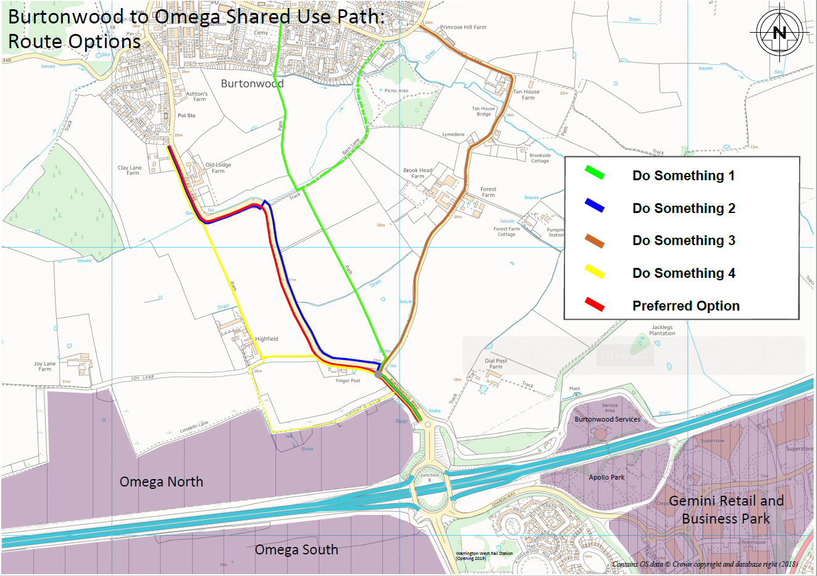

The common feature of all the route options is that due to the restricted width of the existing roads between Burtonwood and Omega there would be the need for some land acquisition in order to construct a 3.5m wide path together with room for a verge/buffer area. The choice of route was therefore based on the meeting the key Scheme objectives as defined in section A10.

**Annex B**

**Letters of support (Ref section D3)**

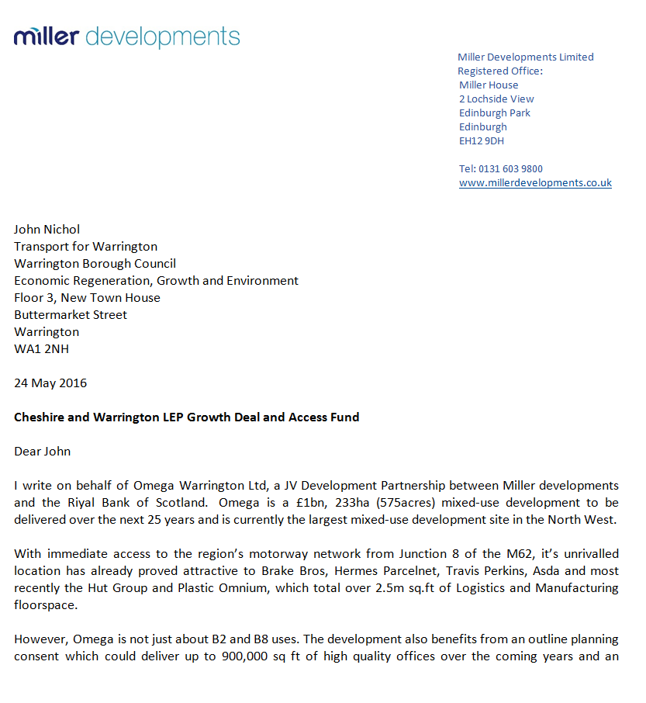

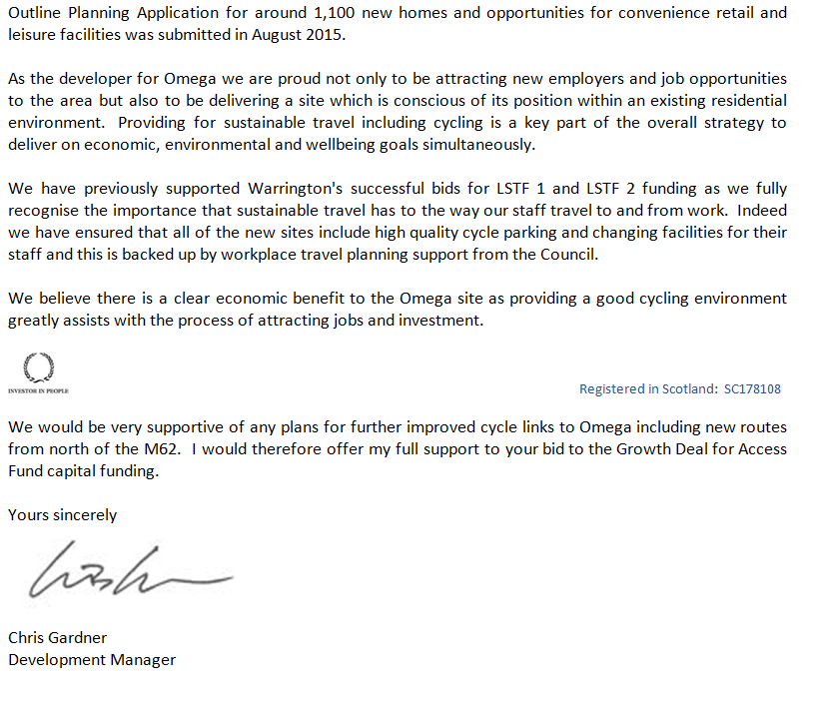

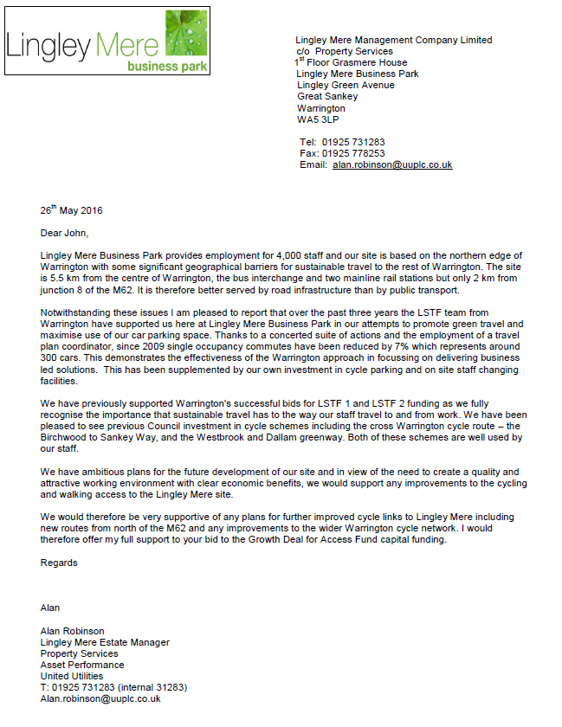

**Annex C**

**Scheme Programme (Ref section E2.)**



**Annex D**

**Risk Assessment (Ref section E6.)**

**Key**

Likelihood (1 = remote, 2 = unlikely, 3 = possible, 4 = probable)

Impact (1 = minor, 2 = low, 3 = moderate, 4 = high)

Risk Rating (1-6 = low, 7-11 = medium, 12-16 = high)

|  |  |  |  |
| --- | --- | --- | --- |
| **Risk** | **Description** | **Level of risk** | **Mitigation controls** |
| **Financial** | Operating costs vary from budget and additional revenue is required | Likelihood - 3  Impact - 3  Risk Rating = 9 (medium) | Develop detailed project appraisal schedules and ensure regular monitoring of expenditure |
| **Management** | Changes in the team responsible for delivery of the project | Likelihood - 3  Impact - 3  Risk Rating = 9 (medium) | Respond quickly to changes to delivery staff and ensure that staff outside of the immediate team are aware of the project |
| **Funding** | Failure to secure funding from partners/developers or Council’s own budgets, resulting in delays or a reduced programme of activity | Likelihood - 2  Impact - 4  Risk Rating = 8 (medium) | Use of formal agreements (i.e. S106 and developer contributions); partner funding largely identified from committed sources; officer steering groups to support LEP budget setting process |
| **Uptake** | Failure to secure buy in and take up of aspects of the project, resulting in failure to meet output milestones and modal shift targets | Likelihood - 2  Impact - 4  Risk Rating = 8 (medium) | Project has been developed around a strong evidence base and community support. Regular assessment of outputs is needed alongside liaison with partners, stakeholders and key client groups |
| **Consents & Legal Agreements** | Failure to secure third party land for the scheme. | Likelihood - 2  Impact - 3  Risk Rating = 6 (low) | Use of CPO powers to acquire land. |
| **Political** | Reversal of support from local councillors | Likelihood - 2  Impact - 2  Risk Rating =4 (low) | Ongoing involvement of councillors to ensure their buy in. |
| **Delivery** | Failure to deliver elements of the project on time or to budget, resulting in delays to implementation | Likelihood - 1  Impact - 4  Risk Rating =4 (low) | Ensure ongoing monitoring takes place by officers to ensure that schemes progress within agreed budgets and on time |
| **Partnerships** | Potential for partners to withdraw from activities, resulting in a programme with a reduced impact | Likelihood - 1  Impact - 3  Risk Rating =3 (low) | Effective liaison with partners to agree on shared objectives and a commitment to work together |

**Annex E**

**Other Strategic fit evidence (Ref section G2.)**

**National Transport Objectives**

The key drivers for transport investment associated with the Scheme align with national transport objectives aimed at improving the environment, public health and quality of life.

**1. National Planning Policy Framework (2018)**

The National Planning Policy Framework ("NPPF") sets out the Government’s planning policies for England and how they are expected to be applied. The NPPF identifies three mutually dependent dimensions to achieving sustainable development, namely the economy, environment and society. These are the three tenets against which all transport infrastructure projects should be assessed in planning terms. At the heart of the NPPF is a presumption in favour of sustainable development.

There is a very strong emphasis on sustainable transport. Chapter 9 states that planning policies should:

a) support an appropriate mix of uses across an area, and within larger scale sites, to minimise the number and length of journeys needed for employment, shopping, leisure, education and other activities;

b) be prepared with the active involvement of local highways authorities, other transport infrastructure providers and operators and neighbouring councils, so that strategies and investments for supporting sustainable transport and development patterns are aligned;

c) identify and protect, where there is robust evidence, sites and routes which could be critical in developing infrastructure to widen transport choice and realise opportunities for large scale development;

d) provide for high quality walking and cycling networks and supporting facilities such as cycle parking drawing on Local Cycling and Walking Infrastructure Plans (LCWIPs).

The Scheme therefore fully complies with the NPPF in that it is providing for sustainable travel.

**2. Cycling and Walking Investment Strategy (CWIS)**

The national Cycling and Walking Investment Strategy (CWIS) sets out the Governments ambition to:

"…to make cycling and walking the natural choice for shorter journeys, or as part of a longer journey"

It seeks to achieve this through three methods:

• Better safety – making cycling safer through reducing the severance effect of roads, reduced speeds and creating streets where cyclists and pedestrians feel they belong;

• Better mobility – offering world class cycling facilities, a denser network of routes and safe paths along busy routes; and

• Better streets – streets designed for people not vehicles, more routes through green spaces and better public realm

Local authorities are expected to support the CWIS by developing and delivering their own walking and cycling schemes and these should be described in Local Cycling and Walking Strategies (LCWIPs).

The Scheme clearly meets the government objectives as it is a scheme which meets the safety and mobility objectives of the CWIS and it is designed for people rather than for vehicles.

"…to make cycling and walking the natural choice for shorter journeys, or as part of a longer journey"

It seeks to achieve this through three methods:

• Better safety – making cycling safer through reducing the severance effect of roads, reduced speeds and creating streets where cyclists and pedestrians feel they belong;

• Better mobility – offering world class cycling facilities, a denser network of routes and safe paths along busy routes; and

• Better streets – streets designed for people not vehicles, more routes through green spaces and better public realm

Local authorities are expected to support the CWIS by developing and delivering their own walking and cycling schemes and these should be described in Local Cycling and Walking Strategies (LCWIPs).

The Scheme clearly meets the government objectives as it is a scheme which meets the safety and mobility objectives of the CWIS and it is designed for people rather than for vehicles.

**3. Growth Agenda**

The two key policy documents at the sub-regional level that are driving the need for increased economic growth include:

a) Cheshire and Warrington Matters – A Strategic Economic Plan and Growth Plan for Cheshire and Warrington; and

b) Cheshire and Warrington Growth Deal;

(a) Cheshire and Warrington SEP

The Cheshire and Warrington LEP (C&W LEP) is one of 38 Local Enterprise Partnerships across England which were created in 2011 by the government. They are local business led partnerships between local authorities and businesses and play a central role in determining local economic priorities and undertaking activities to drive economic growth and the creation of local jobs. The C&W LEP is responsible for projects within East Cheshire, Cheshire West and Chester, and Warrington unitary authorities.

The C&W LEP produces a Strategic Economic Plan (SEP) which provides a vision and strategic framework for the next decade to guide the prioritisation and decision making processes for Cheshire and Warrington, enabling major growth and transformation to the local, North West and UK economies.

To achieve the growth targets contained within the SEP, there is a need to deliver transport investment schemes for infrastructure that drive growth and productivity, tackle congestion, maximise housing growth, and provide a broader housing offer in order to support the region’s economic aspirations, maximising infrastructure growth assets, including property and place.

As a result, the SEP is underpinned by a Transport Strategy within which 6 priorities are identified. The Burtonwood to Omega shared use path would address 5 of these priorities, as follows:

1. Improve connections to support development of priority employment sites including those within the Cheshire Science Corridor;

2. Improve connections to neighbouring sub regions, including international gateways to ensure that business has connectivity to global markets and facilitate the economic benefits of both out and in commuting that takes place daily;

3. Resolve pinch points and congestion in the transport network, both road and rail, which act as barriers to growth if left unaddressed. Delays and unpredictable journey times affect business activity directly (e.g. the supply of components to the automotive sector) and indirectly, and influences commuting flows;

4. Address network resilience issues to deliver predictable and efficient journey times to support business productivity; and

5. Make best use of the existing road (e.g. smart motorways) and rail network (e.g. electrification) to capitalise on existing infrastructure, offering efficient mechanisms for improvement, and helping deliver best value for money from investment.

(b) Cheshire and Warrington Growth Deal

In July 2014, the Government announced the first wave of Growth Deals, which provide the LEPs money from the Local Growth Fund ("LGF") for projects that benefit the local area and economy. The growth deal provides an ‘in principle’ allocation of funding for a LEP area wide Sustainable Transport project. This was made up of 10 cycling and walking projects from across the sub-region which all aimed to improved sustainable connections between residential areas and employment areas. Indicative funding was awarded for three projects within Warrington one of which is the Omega to Burtonwood shared use footpath.

The justification for awarding LGF3 grant to the Scheme is that it directly contributes to the aims of the SEP including the tackling of traffic congestion (by offering alternative means of travel) and strengthening connectivity (for example between home and jobs). The Omega employment site is a key location within the Borough for inward investment and has been very successful in attracting some major logistics companies including Amazon, Hermes, The Hut Group, Brakes, and Travis Perkins. There are many people who live in Burtonwood and also St Helens for whom a better footpath and cycleway connection would be very beneficial.

**Warrington Local Transport Plan**

The Local Transport Plan is a vital tool to help each local authority work with its stakeholders to strengthen its place‑shaping role and its delivery of services to the community. The document helps address local transport issues by;

• Providing a framework for decisions on future investment;

• Setting objectives for transport to support our wider goals and ambitions;

• Establishing policies to help us achieve these objectives; and

• Containing plans for implementing these policies.

Warrington’s current Local Transport Plan is LTP3 and was adopted in March 2011 and sets out our the Local Transport Plan Strategy for the period 2011-2030. Its vision is that;

“by 2030, Warrington will be recognised as one of the best places to live and work in the UK, where everyone enjoys an outstanding quality of life”

Active travel is one of the seven key themes in the LTP, and its key challenges for active travel include:

• Creating and promoting a cycle network that will encourage more people to cycle; and

• Working with partners to facilitate and encourage travel to employment sites and other services by actives modes.

Priority is given to a number of routes including “routes within and linking to Warrington Town centre”, and this would include the Chester Road corridor.

WBC is now developing the fourth LTP and reviewing its local transport policies to make sure they reflect Government and local priorities as well as growth aspirations, new technologies and the priorities of the Local Enterprise Partnership.

**Warrington Local Cycling and Walking Infrastructure Plan (LCWIP)**

Local Cycling and Walking Infrastructure Plans (LCWIPs), as set out in the Government’s Cycling and Walking Investment Strategy, are a new strategic approach to identifying cycling and walking improvements required at the local level. They enable a long-term approach to developing local cycling and walking networks and form a vital part of the Government’s strategy to increase the number of trips made on foot or by cycle.

The key outputs of LCWIPs are:

• A network plan for walking and cycling which identifies preferred routes and core zones for further development;

• A prioritised programme of infrastructure improvements for future investment; and

• A report which sets out the underlying analysis carried out and provides a narrative which supports the identified improvements and network.

By taking a strategic approach to improving conditions for cycling and walking, LCWIPs will assist Local Authorities to:

• Identify cycling and walking infrastructure improvements for future investment in the short, medium and long term;

• Ensure that consideration is given to cycling and walking within both local planning and transport policies and strategies; and

• Make the case for future funding for walking and cycling infrastructure.

WBC is currently preparing a LCWIP for the Warrington district and this work utilises an award for technical support from the government to help identify and tackle many of the crucial infrastructure related issues that are preventing people from walking and cycling in the Borough. These include the 'last mile' into Warrington Town centre and the dis-connect between rural communities and the rest of Warrington as is the case for Burtonwood.

**Other Non-Transport Local Strategies**

The following paragraphs outline how the Scheme could contribute to the Acquiring Authority's non transport local strategic aspirations, including reference to the following key policy documents:

• Warrington Borough Council Corporate Strategy (2018-20);

• Warrington Local Plan Core Strategy (2014);

• Warrington Means Business (2017).

• Health and Well being strategy (2015-18)

• Air Quality Action Plan (2018)

Warrington Borough Council Corporate Strategy 2018-20

The Strategy outlines the Acquiring Authority’s vision for Warrington up to 2020. The Acquiring Authority intends to work with residents, businesses and partners to make Warrington a place where everyone can thrive, whilst dealing with the major challenge of reductions in funding and increased demand for services. The Scheme achieves this as it creates a new transport link which benefits people who do not have access to a car or who prefer not to use a car for the journey between Burtonwood and Warrington. It is therefore socially equitable and has a wider community benefit.

The Strategy also identifies the need to invest in, maintain and build Warrington’s economic and environmental infrastructure, in order to grow a strong economy. With regard to the Scheme, this is achievable as the new path will access the Omega site which is still being developed thus offering job opportunities to local people.

Warrington Local Plan

The statutory development Plan for the Borough of Warrington is the Local Plan Core Strategy (July 2014). The Local Plan sets out a number of Objectives and Policies that support the provision of the Scheme. The Acquiring Authority published its Local Plan Preferred Development Option for consultation in 2017, and is currently reviewing its Local Plan with a view to producing a new plan by 2020. Whilst this document does not represent the Acquiring Authority's policy at the present time because the draft Local Plan is still at an early stage of preparation, many of the objectives and policies from the Local Plan Core Strategy (2014) have been carried forward in the current Core Strategy.

Those or relevance to the Scheme are described below:

Local Plan Strategic Objective W4 seeks to ensure that the Borough is as accessible as possible whilst reducing the need to travel and providing opportunities to move people and goods by non-car modes.

Policy CS 4 Overall Spatial Strategy-Transport, states the Council will support improvements to Warrington’s Transport Network in a number of ways. Relevant improvements supported by policy in this instance are:

• Strengthening public and sustainable transport links between recognised areas for business, general industrial and storage/distribution uses, the Town Centre and Inner Warrington, focusing particularly on areas of deprivation;

• Improve access to the Town Centre, health facilities, education, culture, leisure and the natural environment by all modes, especially by walking and cycling; and

• Reducing the impact of traffic on air quality and reducing carbon emissions to help tackle climate change.

Policy MP 1-General Transport Principles, states to secure sustainable development the Council and its partners will support proposals where they:

• Reduce the need for private car use through its location, travel planning and marketing (smarter choices) and any other measures to change travel behaviour; and

• Consider demand management measures including the effective reallocation of road space in favour of public transport, pedestrians and cyclists.

Warrington Means Business (2017)

Warrington Means Business is Warrington’s regeneration strategy. It is a comprehensive framework that sets out the methodology and intent to drive, progress, encourage and facilitate future business growth in the town. It is a live working document which reflects the current status, plans, opportunities, aspirations and desire to maximise Warrington’s potential.

The strategy recognises that “walking and cycling are a fundamental part of Warrington’s transportation and leisure infrastructure. They are also an essential ingredient of Warrington’s image, distinctiveness and its economic attractiveness. We will complete Warrington’s cycling and walking network on-road and off road. The latter is particularly important using Warrington’s network of open space and greenways.”

More specifically the Warrington Means Business Strategy plans to see the “completion of our strategic cycling and walking network linking key employment areas with housing growth.” This fits the description of the Scheme which provides a new link between the Omega and Gemini employments areas to the village of Burtonwood which will see new housing through the Local Plan.

Health and Well Being Strategy

The Warrington Health and Wellbeing Strategy sets out Warrington Health and Wellbeing Board’s and Warrington Partnership's, ambitions to improve the health and wellbeing of the town’s residents. Board members include representatives from key council services, NHS organisations in the area and a number of other private and voluntary sector services.

The strategy looks at how all organisations working across public service provision in Warrington can work better together, how services are commissioned and the changes that need to take place so that residents are supported with the right care, by the right person at the right time.

One of the six strategic outcomes of the strategy relates to creating ”a sustainable transport infrastructure that enables access to work, health and leisure facilities for all.” The Scheme is supportive of the strategy as it will increase the numbers of people using sustainable travel (public transport, cycling, walking) and improve air quality.

Air Quality Action Plan

The Warrington Air Quality Action Plan (AQAP) has been produced as part of the Council’s statutory duties required by the Local Air Quality Management framework. It outlines the actions the Council will take to improve air quality in Warrington between 2017 and 2022.

While the AQAP covers the years 2017-22, initial actions will focus on a framework of policies and plans to improve air quality and to support wider action to promote health and wellbeing and tackle social injustice. One of the specific measures is the delivery of the Burtonwood to Omega shared use path which would encourage more walking and cycling and therefore reduce traffic emissions from cars.

**Planning consent**

This Scheme does not require planning consent as it is permitted development under Part 9 Class A of the Town and Country Planning Order 2015, General Permitted Development document. This states that permitted development by highway authorities includes:

The Carrying out by a highway authority –

(a) on land within the boundaries of a road, of any works required for the maintenance or improvement of the road, where such works involve development by virtue of section 55(2)(b)(g) of the act; or

(b) on land outside but adjoining the boundary of an existing highway of works required for or incidental to the maintenance or improvement of the highway.

**Annex F**

