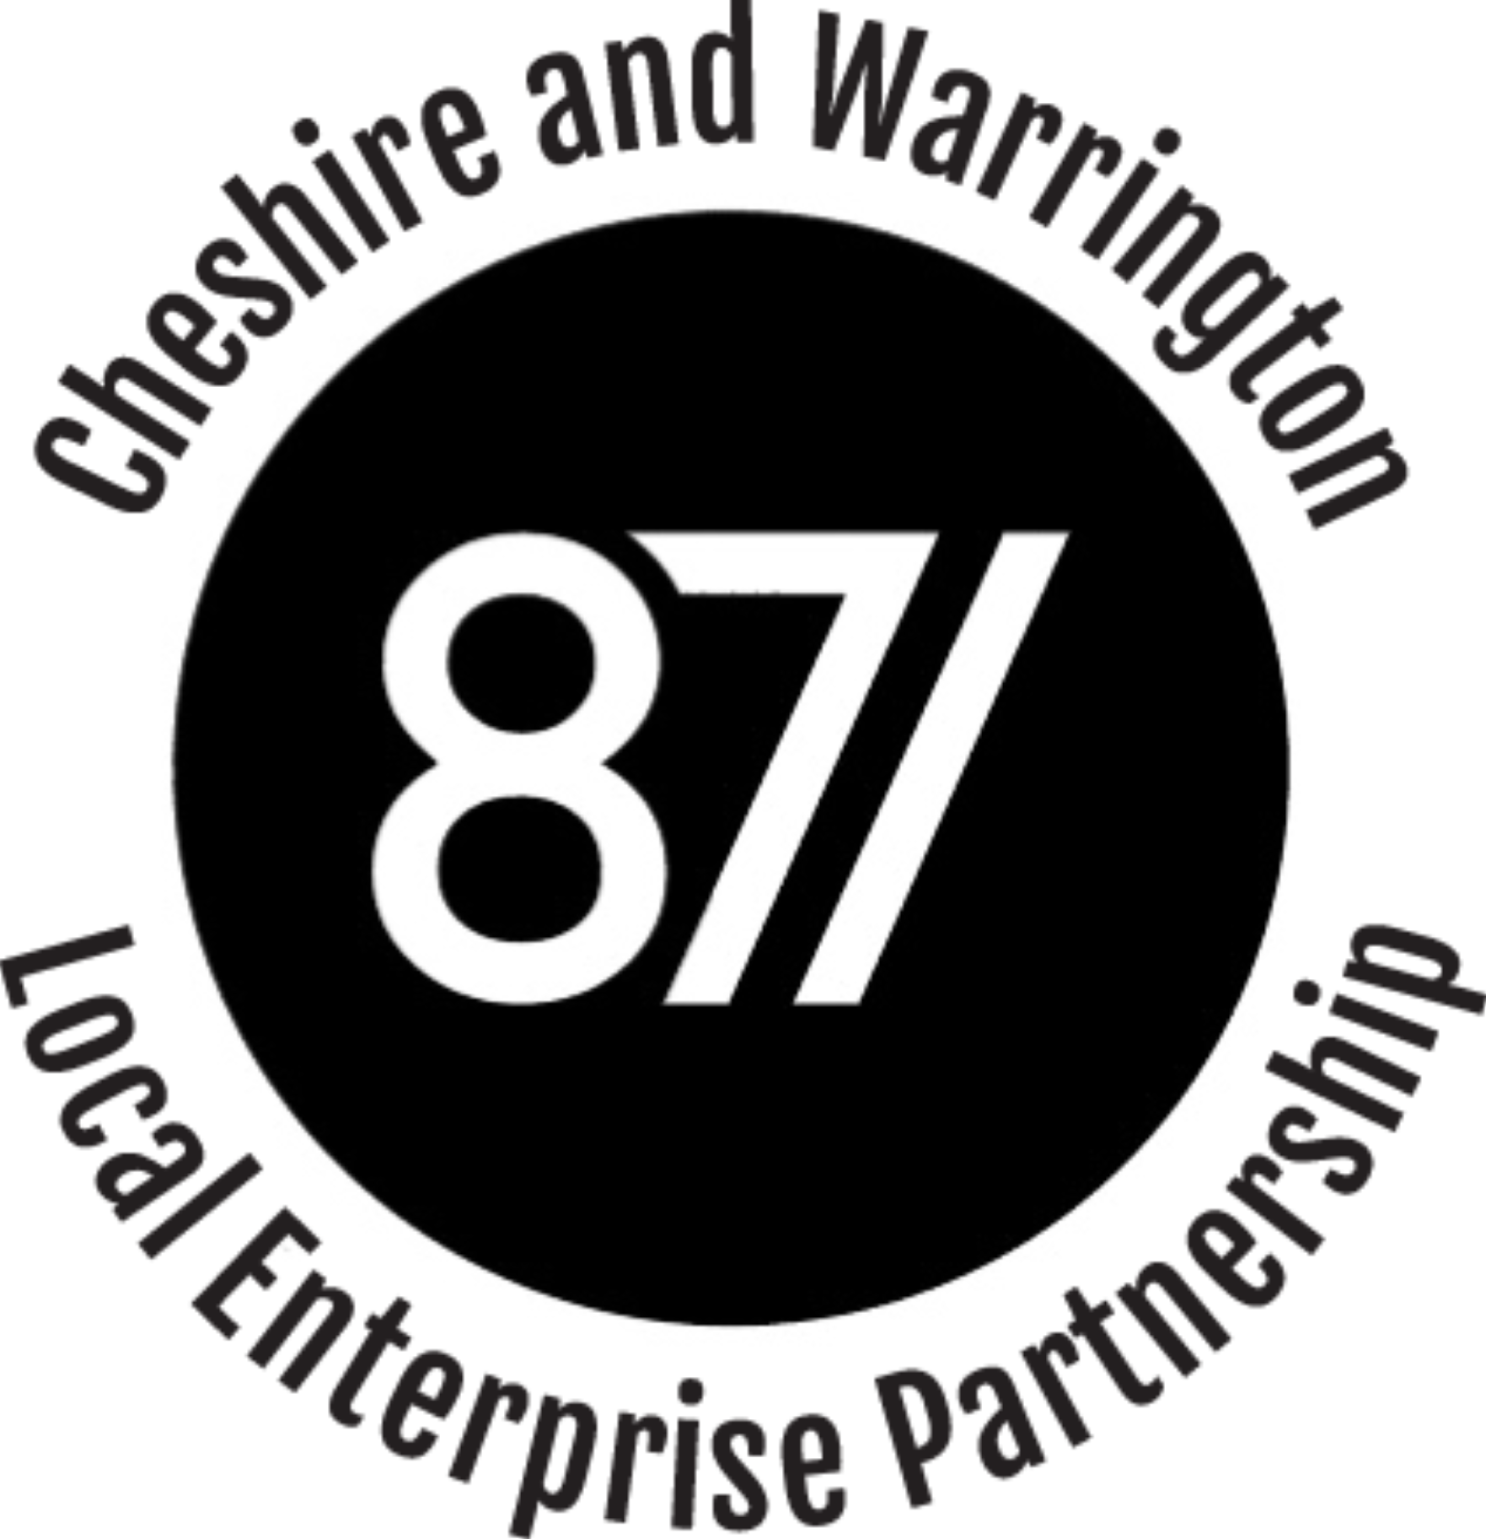

BUILDING BACK BETTER TOGETHER:
SUPPORTING RECOVERY IN CHESHIRE AND WARRINGTON

2021-22

DRAFT v.10 – FOR DISCUSSION

CHESHIRE AND WARRINGTON – BUILDING BACK BETTER TOGETHER
Foreword
[DN – To be drafted for CH]
2020 has been one of the most challenging years for a generation or more – at a local national and international level.
Economy and society have had to cope with multiple issues at a level that has caused significant cumulative impact.
Situation has proven how resilient we can be, stimulated innovation and accelerated change.
Highlighted the value we place on the word around us and helped many reconnect with it
Reflect that delivering recovery will be a collective, collaborative effort by the public and private sectors and civil society to ensure that activity is co-ordinated and reinforcing.
This plan has a LEP focus – each of the local authorities is also working on their respective plans for recovery and to deliver our vision for Cheshire and Warrington.

Introduction
This draft plan sets out the sub-region’s vision for the recovery of Cheshire and Warrington from Covid19 and the LEP’s priorities for local delivery over 2020-21. We are publishing in draft for stakeholder comment and feedback. We look forward to working with you to build a better future together.
Working in partnership with the public, private, and voluntary sectors we have already taken significant steps to help restart the Cheshire and Warrington economy. We have channelled and promoted the Government support that is been made available for businesses and introduced tailored support locally.
We are clear that in returning to growth and striving to deliver on the vision for Cheshire and Warrington we will not return to the ‘old normal’ – an economy that worked for many but not for everyone, and in which the impact of our activities on the earth’s natural resources was not fully acknowledged. Covid-19 has also exposed many of the weaknesses in the economy and reinforced some of the inequalities experienced by our poorest and most disadvantaged communities. We are therefore committed to building back better together. We want to create a future for Cheshire and Warrington that makes it the healthiest, most sustainable, inclusive, and fastest growing place in the country.
Our recovery will focus on four strategic objectives which together will enable Cheshire and Warrington to return to the growth and prosperity it enjoyed before Covid:
- Healthy. Supporting the wider public sector and civil society as they lead the recovery in the health and wellbeing of our communities, including the mental wellbeing of workers and business owners. Continuing to back our life sciences industry to become a global leader in complex medicines.

- Sustainable. Demonstrating that Cheshire and Warrington is at the heart of the Green Industrial Revolution, we are ready to deliver the government’s 10-Point Plan with clear proposals for decarbonising our economy and creating green jobs.

- Inclusive. Supporting skills and employment opportunities locally, channelling investment to provide opportunity and growth for all our communities, levelling up economic disparities, and boosting town centres and high streets.

- Fast-growing. Investing in our health, sustainable, and inclusive objectives is essential to delivering fast growth that benefits everyone in our area. At the same time, we also must get the foundations of the economy right for skills and labour markets; innovation and ideas; business growth; and connectivity and infrastructure.
Healthy, Sustainable, Inclusive and Fast Growing: Building Back Better Together.
The Cheshire and Warrington Sub Regional Leaders Board agreed a new vision for Cheshire and Warrington, launched in September 2020 – to make it the UK’s most ‘Healthy, Sustainable, Inclusive and Growing economy’.
To help chart the course towards the delivery of this vision, the Leaders’ Board established a Sustainable and Inclusive Growth Commission (SIGC) to develop thinking and act as a catalyst for how it can be realised. The Commission will act as a catalyst for and provide advice on the development of a programme that will realise Cheshire & Warrington’s (C&W) ambition of becoming the most sustainable and most inclusive sub-region in the UK
The Commission will operate for two years, and progress through four phases: collate -> plan -> consult -> promote->.
Work is concentrated around five areas of focus: -
- Decarbonising industrial and domestic heat and power
- Decarbonising transport – and boosting sustainable transport
- Landscape management and climate change mitigation (including decarbonising farming and agriculture)
- Inclusive growth and economy
- Funding and finance
The Commission brings together expertise from industry, academia and the public sector. Its progress will be reported through a series of interim reports and initial plans will be shared for consultation later in 2021. The LEP and other sub-regional partners will consider and take account of any recommendations from the Commission in drafting future strategies and plans.

Covid-19 is not the only significant factor that our economy will have to respond too. After a long period of uncertainty the UK has reached agreement with the EU on a Free Trade Agreement which came into effect on 1st January 2021. These new trading arrangements and associated legal and regulatory regimes will also bring change for business and for our business support offer. Businesses also continue to adapt to the impact of new technologies, global competition, changing customer demands, and specific local challenges, such as recent flooding.
[D.N., THE TEXT IN GREEN IS A REPEAT OF OBJECTIVE FOR FAST GROWTH WITH SOME MORE DETAIL ON SPECIFIC WORK AREAS. CHOICE TO MAKE ON WHETHER TO INCLUDE THIS MUCH INFO HERE.]
Cheshire and Warrington’s leaders are determined to offer a better future to those who live and work in the sub-region. Investing in our health, sustainable, and inclusive objectives is essential to delivering fast growth that benefits everyone in our area, whether that be through backing our life sciences and energy sectors, or in providing careers advice and skills support for our young people. At the same time, if we are to continue have a fast-growing economy, create jobs and opportunities locally, and restore Cheshire and Warrington’s prosperity and productivity, we also must get the foundations of the economy right. We will focus on the following four areas.
- Skills and labour markets: Equipping our existing and emerging workforce with the skills needed to thrive in a changing economy and helping those who face particular challenges to get back into employment and connected with opportunities.
- Innovation and ideas: Capitalising on the amazing innovation assets in our area, including our world-class energy, life sciences and manufacturing sectors and building stronger links with other places in the UK and beyond so that new ideas can be supported and brought to market.
- Business growth: Supporting business to grow and successfully adapt to change. As well as recovering from the impact of Covid19, this also means adapting to our new trading arrangements with the world, and making sure that our economy remains outward-facing and an exporting powerhouse.
- Connectivity and infrastructure: Making sure that we stay connected, physically, and digitally, and that we have clear plans for investment in the infrastructure that we need for a successful, growing, inclusive economy.
Growth in Cheshire and Warrington also benefits residents beyond our borders, with a significant proportion of our workforce commuting from other parts of the North West and North Midlands such as the Wirral, St Helens and Stoke on Trent and also of North Wales. The Mersey Dee area is a strategically important and dynamic region, straddling West Cheshire and Chester, Liverpool City Region and North Wales. It contributes £22 billion to the UK economy and is one of the north’s proven and ‘business-critical’ employment locations with a high density of significant employers, R&D assets and academic expertise. The area has proven what successful partnership working can deliver, and with continued investment this unique region can enhance its contribution to the Northern Powerhouse and the UK and to increased trade with Ireland and Europe due to its proximity to strategic shipping lanes.
[N.B., I THINK SIGNPOSTING TO EVIDENCE WOULD BE A GOOD IDEA AND MAKES THE POINT WE DRAW ON EVIDENCE AND SOME OF THE FUNDAMENTALS REMAIN THE SAME]
Our proposals draw on the independent economic evidence that the LEP has gathered over recent years, whilst also adjusting for the impact of Covid19 and our new trading relationship with the European Union. We have republished some of the background evidence alongside this report.
We are keen to get the views of our partners and stakeholders on our economic vision, proposed actions to make an impact in the short term, and opportunities for further collaboration in the longer term. We will be running a series of virtual roundtables over the coming months to discuss this Strategy in further detail.

RESTARTING THE CHESHIRE AND WARRINGTON ECONOMY
Prior to Covid19, Cheshire and Warrington was one of the UK’s success stories. It had a strong and diverse business base, high jobs growth, highly skilled workforce and a track record of partnership working and successful project delivery. An engine for growth, the Cheshire and Warrington economy doubled in size over the last 20 years to a GVA, pre-Covid, of almost £32.5 billion and has the potential to double again over the next twenty.
Like the UK, our economy has been severely disrupted by Coronavirus and the national efforts to limit the spread of the disease. Over 100,000 people in Cheshire & Warrington are employed in the five sectors hit hardest by lockdown; 128,500 workers in the area are or have been furloughed at some point during the crisis with a further 29,400 people accessing the Self-Employed Income Support Scheme, and the number of people claiming Universal Credit has increased by over 80% since March. [DN – consider options to present key stats as an infographic]
Partnership and communications
Over the course of the pandemic, the LEP, business groups, local authorities, trade unions and the Community and Voluntary Sector and other key agencies have worked together to respond, and as far as possible, mitigate the business impacts of the restrictions imposed to limit the spread of the virus. This has included establishing a dedicated Economic Resilience Cell under the Sub Regional Resilience Forum and developing the Cheshire Business Forum which brings together the voices of many business representation bodies and Government to ensure Cheshire business voices are directly heard.
Giving consumers and visitors confidence that Cheshire and Warrington is somewhere that is open and safe to visit will increase footfall. Marketing Cheshire has focused activity on signposting businesses to grant support and guidance, working alongside the Growth Hub. Marketing activity focused on communicating what businesses were open and inspiring people to visit later. In the summer when businesses were open, we supported national schemes such as ‘We’re Good to Go’ and ‘Eat Out to Help Out’. As Tier systems evolved Marketing Cheshire delivered campaigns 'We Can Turn This Around /Open for Business' in partnership with the local authorities and Business Improvement Districts. We focused on ‘what you can do’ with social media, radio, and print media content which evolved into a winter campaign focused on promotion of online offers, pay‐it‐forward, and shop local during November and December.
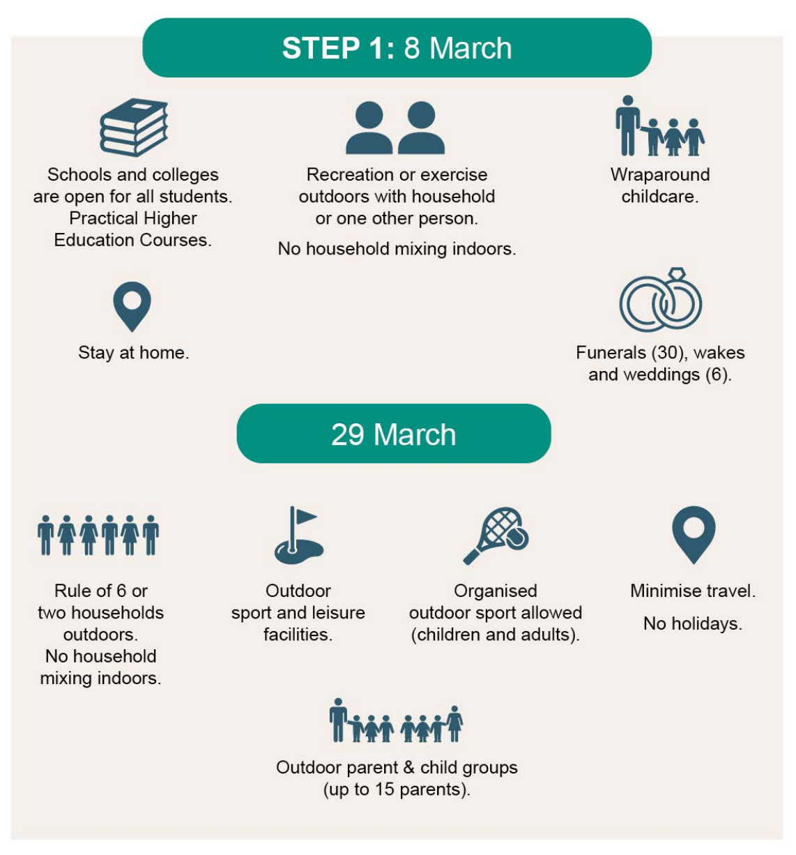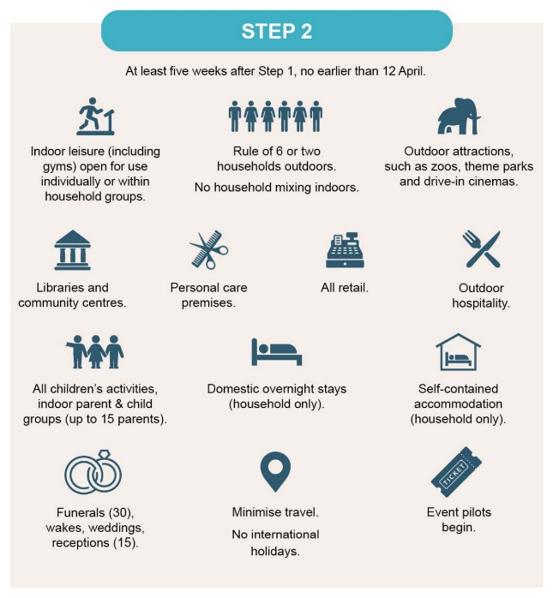
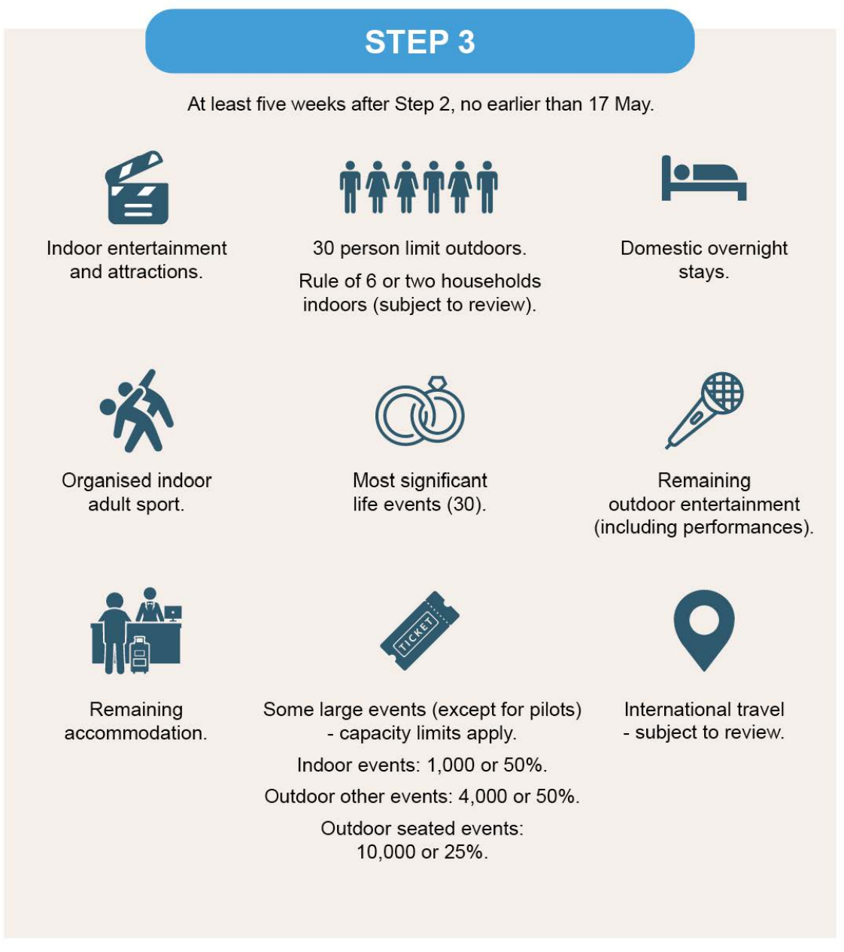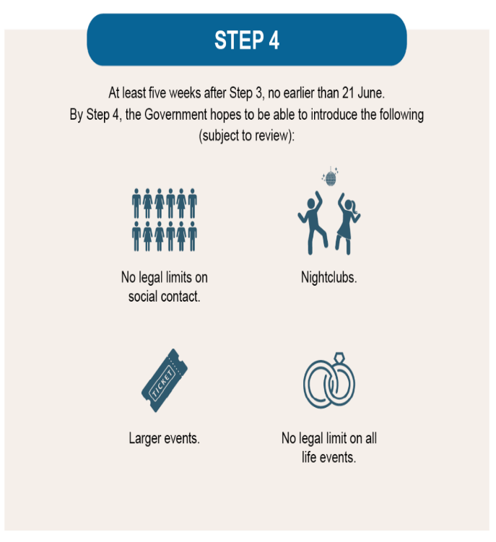
Supporting the sectors hit hardest by the Covid19 pandemic
We want to continue to support those sectors and businesses that have been hardest hit by the Covid-19 pandemic. This includes our visitor economy, as well as the culture, events, hospitality, leisure, and retail sectors. Towns and high streets have been hit hard by lockdown. Google Mobility data illustrates that the closure of non-essential shops and activities has resulted in a 63% reduction in footfall, leaving city and town centres empty.
Cheshire and Warrington is made up of many towns, from those with a strong industrial heritage to rural market towns, as well as the city of Chester. We will support our diverse places in collaboration with local authorities, through on-going High Street, Towns and Levelling Up Funding.
The historic City of Chester provides the main visitor economy of the area alongside important national tourism attractions such as Tatton Park, Jodrell Bank, the Peak District and on into the North Wales Coast. The visitor economy is also crucial to the economy in our rural areas with many large hotels and wedding venues providing anchors to local supply chains. Marketing Cheshire and the LEP are focussed on building on our support for the visitor economy and will work with Government to create opportunities for career development and drive productivity in the sector through ongoing domestic promotion. We are also working with the network of Destination Management Organisations (DMOs) across the North West to promote Cheshire & Warrington and engage nationally in Government’s DMO review.

The Destination Chester cluster and Destination Cheshire forums representing over 20 business groups and larger visitor economy businesses have now been formalised and together we are engaged in developing a partnership driven coordinated strategy towards reopening and recovery.
Over £280 million of grant support has been provided by government and distributed to over 15,000 businesses through Cheshire East Council, Cheshire West and Chester Council and Warrington Borough Council. The LEP has also provided targeted support. The Cheshire & Warrington Recovery & Restructure Grant offers a grant of up to £5,000 to cover 80% of the cost of small items of equipment and other investment to support Cheshire & Warrington businesses adjust to the Covid-19 outbreak. Around 50% of the LEP funding is directed towards the region’s hard-hit visitor economy, targeting tourism, hospitality and retail businesses with support, the balance going to other businesses.
The LEP has also introduced a peer-to-peer networking programme for SME leaders through the Growth Hub. The networks have been developed to give businesses the opportunity to work together to address issues ranging from Covid19, to EU transition, to identifying new market and growth opportunities.

DELIVERING OUR VISION: HEALTHY
Supporting the wider public sector and civil society as they lead the recovery in the health and wellbeing of our communities, including the mental wellbeing of workers and business owners. Continuing to support our w life sciences industry to become a global leader in complex medicines.
Since the start of the pandemic there have been almost 55,000 cases of Covid-19 in Cheshire and Warrington and in excess of 2,100 deaths. In addition to the direct impacts on individuals and families there is increasing recognition of the toll that the pandemic and successive lockdowns have had on the wider health and well-being of communities, workers and business owners.
A safe and secure business environment
The LEP, Marketing Cheshire, local authority partners and business groups have been working closely together to help the owners of business premises understand the steps they need to take to remain ‘Covid-secure’ when open. This included the Cheshire and Warrington Restructure and Recovery Grant.
[D.N. WANTED TO ADD THE GRANT SCHEME IN]
Case Study - Cheshire and Warrington Restructure and Recovery Grant
The Cheshire and Warrington Restructure and Recovery Grant has allowed a range of businesses and the third sector to create safer and healthier environments. Beneficiaries range from hotels, to sports clubs, to outdoor food market providers. The introduction of Personal Protective Equipment and screens allowed some businesses to continue vital work in person, such as a small engineering firm that required the use of on-site laboratory space. Whilst restaurants and cafes were able to invest in new gazebos and outdoor furniture to expand their al fresco offer in line with Government guidance on national and local restrictions, these businesses will also be well placed to reopen in the Spring.
Under normal circumstances the Community and Voluntary sector provide a range of physical and mental wellbeing services. Lockdown has severely curtailed their ability to operate, putting added pressure on primary health services. Supporting charities to restart their support activities will therefore be an important activity as Lockdown begins to ease.
The Cheshire Business Group has established virtual drop-in sessions to provide business to business advice on providing a Covid19 secure environment for employees and customers. The Federation for Small Businesses for Cheshire and Merseyside has introduced weekly virtual cafes to help, inform, advise, and assist small businesses in adapting to Covid19 guidance and regulations. Marketing Cheshire has worked closely with all three local authorities to provide targeted public health messages to both local communities and visitors.
Mental health and economic inactivity
[DN – HAVE ADDED MENTAL HEALTH HERE. NOT SURE IF WE WANT TO INCLUDE TEXT IN GREEN ON ECONOMIC INACTIVITY]
Local research suggests that the highest reason that people take time off work due to illness is due to mental health conditions including stress, depression, and anxiety. We are concerned that the negative impact of the pandemic will have exacerbated this situation further. There is a stigma that exists around poor mental health and enable local people to identify and support their family, friends, and colleagues to seek help and support early thus preventing crisis. Employers report that they feel limited in their ability to support people who are suffering with poor mental health.
Cheshire and Warrington plans to address this challenge by designing and promoting a range of evidence based interventions that would enable people to feel more able to manage their mental health both when they are in work but also for those who are off work or unable to gain employment due to their condition and how this limits taking on a job. Cheshire West and Chester Council have recently introduced a pilot programme of webinars for SMEs, Wellbeing 4 Performance, to provide local business leaders with a series of free online webinars to provide information and skills to help protect and develop your businesses and employees.
One of the measures of deprivation is health and adults in Cheshire and Warrington spend around a fifth of their life in relatively poor health. Over recent years, of those residents claiming Employment and Support Allowance, 47% have mental and behavioural disorders. Whilst the proportion of residents who cannot work due to chronic illness in (17.6%) is lower than levels in the North West and the UK (22.3%), there are still significant numbers here who could be supported. It is critical that the public sector works collectively to support the wellbeing of all our residents, including those that are unable to work. As set out in our inclusivity objectives the LEP will continue to collaborate with DWP to support unemployed people to find jobs and opportunities locally.
Life sciences and complex medicines
Cheshire and Warrington has been at the forefront of drug discovery and development for over sixty years including the first beta-blockers and anti-oestrogens for use in cancer therapy. The current pandemic has highlighted the important role of our drug discovery and development sector in helping people to continue to live healthy and happy lives. It is the only location in the UK which covers the whole of the life sciences life cycle from discovery to formulation, testing, manufacture and export and Alderley Park was the location of one of the first three Lighthouse Covid testing labs in the country and is also the home of one of the large-scale vaccination centres.
Our vision is for Cheshire and Warrington to be a global leader in complex medicines. We are home to the full lifecycle across discovery, development, delivery, and diagnostics. We have leading digital health capabilities and want to remain at the cutting-edge of medicines manufacturing. The North West Science Corridor between Liverpool City Region, Greater Manchester and Cheshire and Warrington is home to world class companies, world-leading research universities, and fast-growing entrepreneurial businesses. This powerful ecosystem can translate ground-breaking science into commercial investment and scalable medicines manufacturing. We are working with the life sciences sector locally to put this vision into practice and have already identified some early opportunities.
Ensuring that there are effective pathways to the development, formulation, testing and production of new medicines including vaccines will be critical for the UK moving forwards. The Medicines Discovery Catapult, based at Alderley Park, is a national centre of excellence in drug discovery with a remit to support the UK life sciences community. It is addressing systemic problems and bottlenecks and using innovative technologies to enable “fast-to-patient” medicines discovery. In contrast to the speed at which new Coronavirus vaccines have been developed, new drug development typically costs £1.15bn per drug and takes 12 years from the initial discovery stage to reach the market, so the cost and risk of failures are high. In addition, patient expectations are rising; thus, health systems around the world are demanding access to cost-competitive and innovative medicines that provide better results with fewer side effects.
To meet this market need, the medicines manufacturing platform is shifting away from the dominance of small molecules to one with a balance between small molecules and complex medicines. Despite Cheshire and Warrington being home to one of the largest concentrations of talent in Europe, including many organisations set up to support growth in this sector, the region only accounts for a fraction on this market (based on confirmed valuations of SMEs in the region of approx. £120m).
Working with government, colleagues in Liverpool and Manchester, and with the Medicines Discovery Catapult, we want to exploit the area’s critical mass of expertise and infrastructure in the development/commercialisation of novel complex medicines, with robust support, validation and translational propositions to grow the local industry. The Catapult has developed proposals for a £40m National Translational Technology Development Centre and a Catapult Quarter to enable stimulus and capacity building for the UK diagnostics sector. This builds upon its success in delivering the COVID19 lab testing platform and proven national impact across adjacent sectors of new medicines and biomarkers. It also complements government’s recent investment through Strength in Places Fund into the Liverpool School of Tropical Medicine and Alderley Park-based Anti-Microbial Research Centre and Getting Building Fund into a new Validation Centre of Excellence also at Alderley Park.
Cheshire and Warrington are already investing its own funds to strengthen the North West life sciences cluster and is now looking to the Government to provide the funding that the Medicines Discovery Catapult needs to strengthen not only the North West’s but the also UK’s position in this vital industry. The LEP is accelerating investment in the Cheshire Science Corridor through a £30m borrowing facility agreed with the three local authorities and is investing £7.8m into new lab and co-working space at Alderley Park. 150,000 sq ft of new Grade A office space has already completed in the Glasshouse (Feb 2020), which is 90% let.
The LEP has also invested £10m of Local Growth Funding in the Cheshire and Greater Manchester Life Science Fund in 2015/16, alongside, CEC, GMCA and Bruntwood, creating a £31m fund. The fund has helped establish a bio-medical cluster in Alderley park alongside a similar one at Manchester Science Park. It has also raised the profile of the North West as an established place to undertake bio-medical investments and we have some high-profile drug discovery companies that have benefitted from the existing fund such as the Anti-Microbial Research Centre and Blueberry Therapeutics. However, the fund is close to being fully invested and will be closed to new investment in April 2021.
It is crucial we build on the success that the Fund has achieved. There is high demand for life science funding, especially given the 80-90% drop in early-stage capital availability compared to 2019 as investors turn away from higher risk investments. We are therefore seeking funding to enable the LEP to contribute £10m towards the establishment of a new £50m fund, alongside Bruntwood and GMCA on a pari-passu basis. This fund would cover the whole of Cheshire and Warrington and GM and run for a 15-year period with a five-year investment period. In January 2021 the LEP Board approved, in principle an initial investment of £5m.
Health priorities for 2021 – 22
The LEP and its partners will: -
- Continue to work with the Cheshire Business Group to provide advice and guidance to small businesses on creating Covid19 secure environments; and through Marketing Cheshire provide advice to the visitor and hospitality sector as it reopens, including promoting the ‘We’re Good to Go’ industry standard.

- Establish a Life Sciences sector group by June 2021 to develop a plan to reinforce Cheshire and Warrington as one of the best locations in the world for medicines discovery, formulation and manufacturing as set out in the Life Sciences Sector Deal. This will include exploring options for expanding and strengthening the offer of the Medicines Discovery Catapult at Alderley Park

- Accelerate investment in the Cheshire Science Corridor Enterprise Zone following conclusion of a £30m borrowing facility through the LEP’s local authority partners.

- Conclude negotiations by July 2021 to create a successor to the Greater Manchester and Cheshire Life Sciences Fund with a minimum fund value of £25m.

- Deliver £5.05m Getting Building Fund investment in laboratory space for Validation Centre of Excellence at Alderley Park.

- Deliver £4m Enterprise Zone investment in Blocks 22-24 at Alderley Park to provide 90k sq ft of new lab space plus a 2,400-space multi-storey car park.

DELIVERING OUR VISION: SUSTAINABLE
Positioning Cheshire and Warrington at the heart of the Green Industrial Revolution, setting out how we can deliver the government’s 10-Point Plan and developing clear proposals for decarbonising our economy and creating green jobs.
In November 2020, the Prime Minister published the government’s Ten Point Plan for a Green Industrial Revolution. Cheshire and Warrington has the knowledge, expertise and opportunity to be at the forefront of developing responses to four parts of the plan in particular.

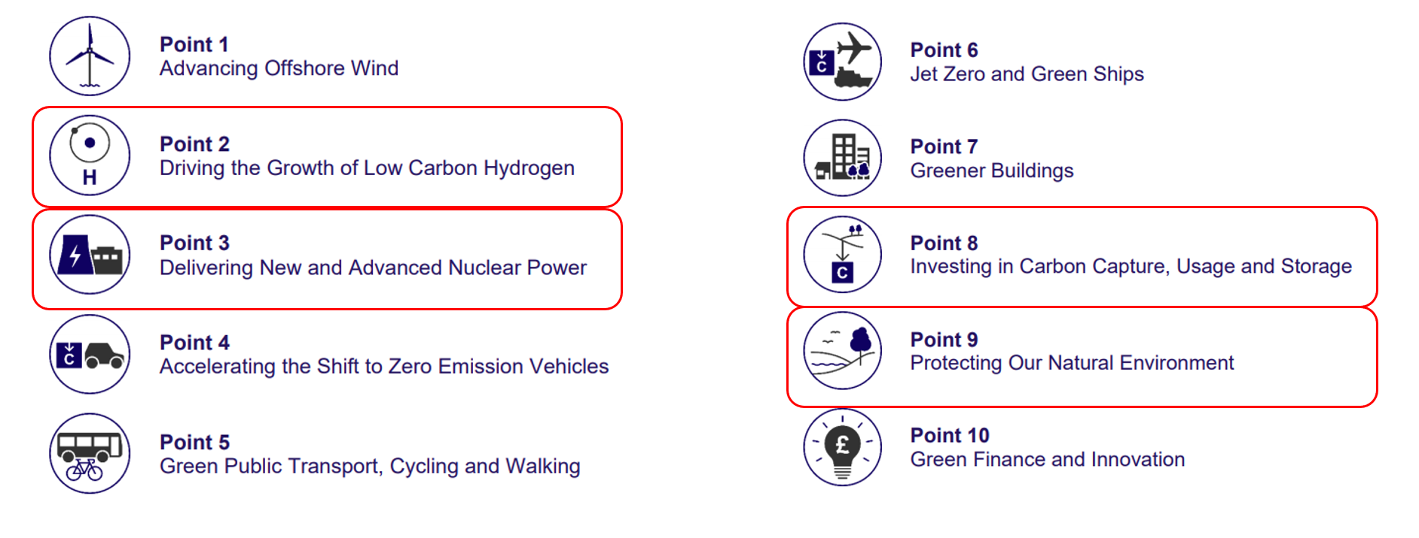
In the immediate short term, they link to the recognised need to decarbonise our industrial cluster at pace and build on the work that is currently being led by those industries and groups such as Cheshire Energy Hub and Net Zero North West. They also link more broadly, to the work that will be required to improve the energy efficiency of our homes, work places and the public sector estate provide an opportunity for the creation of new, well paid ‘green jobs’.
Cheshire and Warrington is recognised as being a leader in the drive to deliver low carbon energy and clean growth, with decades of industry-leading experience in energy distribution systems, fuels and nuclear engineering and design. We also have the fourth highest carbon emissions in the country. We therefore have the incentive and opportunity to be a world leader in developing and applying low carbon technologies driving economic growth and delivering a reduction in carbon emissions that will make a significant contribution to delivering not just local and regional targets but national ones as well.
The message industry tells us is that for this to happen, creating a regulatory and investment framework that encourages innovation, supports a shift to smart production, distribution and storage of low and zero carbon energy (including nuclear) and ensures critical energy infrastructure must not become a barrier during transition has to be an early priority for government.
De-carbonising Our Industrial Cluster at Ellesmere Port
Our initial focus is on progressing the opportunity hydrogen, coupled with Carbon Capture Use and Storage (CCUS) offers in decarbonising the industrial cluster centred around Ellesmere Port. One of the UK’s largest, covering 100km2 and consuming approximately 5% of the UK's energy for industrial processes, heat and transport. The Cluster includes some of Cheshire’s major manufacturing employers covering oil refining, glass manufacture, nuclear fuel enrichment, chemical production and automotive manufacture.
Our area is already advanced in developing firm proposals to take forward hydrogen as a key part of the energy mix. Already work is progressing on the UK’s largest carbon capture usage and storage plant (CCUS) at the Tata Chemicals Europe site in Northwich, which will be operational in 2021. Detailed planning is also underway on deliverable proposals for large scale hydrogen supply; hydrogen distribution; blending of hydrogen with natural gas for supply to homes; and switching of industry from natural gas to hydrogen. Central to all of these is the £1 billion Hynet Project, which has the potential to add £17 billion of GVA, create 5000 new jobs across the North West by 2025 and save over 1 million tonnes of CO2 per annum; the equivalent of taking more than 600,000 cars off the road.
Other innovation assets include the University of Chester’s Thornton Science Park which is developing expertise in the development and use of hydrogen and green ammonia and is home to the LEP-funded Energy Innovation Centre opened in 2016.

Case Study: Net Zero North West
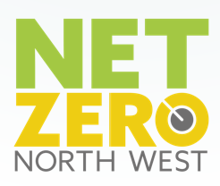
Net Zero North West is a newly formed industry-led cluster acting as a public and private sector investment vehicle for industrial decarbonisation and clean growth projects in the North West. Its core mission is to become the UK’s first low carbon industrial cluster by 2030 and world’s first net zero industrial cluster by 2040.
Through this work the cluster aims to supercharge the UK’s green recovery by driving job creation, innovation, and investment in the North West and net zero economy.
Net Zero North West unites business, Local Enterprise Partnerships, Metro Mayors, boroughs and academia to build a united voice and holistic vision for industrial decarbonisation in the North West.

Smart Energy Networks
Industry and academia have come together through the Cheshire Energy Hub to develop an Energy Innovation District (EID) in Cheshire and Warrington. It has the potential to become the UK’s first low carbon industrial cluster by 2030, implementing market leading solutions to reduce the cost of low or zero carbon energy for all users in the region. Government has recognised this potential already with over £25 million provided in the last year alone to support project development. In support of this ambition the LEP has already commissioned the E-Port Net Zero Blueprint for Capital Investment project, which will conclude in March 2021.
The project will look at existing energy use and generation in the area. This will involve talking to industrial, commercial and residential energy users to find out how much energy they use. It will then consider opportunities for current and future energy generation, including renewables and at how future energy uses, like electric vehicles, and new fuels, like hydrogen, could change the energy market.

The LEP has provided almost £750,000 towards development of a master plan which will set out a ten-year private sector investment programme for developing a smart grid in Ellesmere Port. The smart grid would allow local businesses and residents to buy and trade energy locally, rather than relying on the national grid.
World Leader in Innovative Nuclear Power
The national and international market for nuclear new build, maintenance and decommissioning is estimated at over £1.2 trillion by 2030. Companies in Cheshire and Warrington are at the vanguard of research into the next generation of nuclear reactors including nuclear fusion, small modular reactors and even smaller micro reactors such as U-Battery. The area also has unparalleled knowledge related to the maintenance and decommissioning of nuclear sites. Supporting innovation and enabling new entrants into the nuclear supply chain can be challenging due to the nature of the sector and the level of regulation that applies when working in the nuclear market. The sub-region is working with government, the Nuclear Advanced Manufacturing Research Centre and other LEP areas to develop a business case proposal aiming to strategically support the nuclear supply chain in the UK, as set out in the Nuclear Sector Deal.
From engineering design, construction, operation and decommissioning there are huge opportunities to strengthen the UK nuclear supply chain and export our skills and expertise around the world. The nuclear sector supports over 6,000 jobs in Cheshire and Warrington including a significant concentration of design and engineering expertise at Birchwood, Warrington and at Capenhurst . There is a real opportunity for the UK to grow this further, boost our capacity and capability for R&D into next generation and fusion and small modular reactors in doing so delivering more highly skilled, productive jobs.
The proposals for new nuclear reactors at Sizewell in Suffolk, along with decommissioning of the existing nuclear fleet in the UK and around the world offer significant opportunities for the nuclear supply chain in our area.
We will work with the nuclear sector locally to develop ideas to accelerate, stimulate and inspire innovation between industry, academia and Government to develop, commercialise and promote nuclear energy. Knowledge developed from leveraging the significant nuclear competency at Birchwood Park in Warrington can be applied to other technology dependent sectors, such as aerospace and renewables.
Natural capital and the economy in rural areas
Natural capital, farming and the rural economy play a key role in making Cheshire and Warrington an attractive place to live, visit and invest. It is also critical in building our resilience to climate change and as part of long-term sustainable growth.
Cheshire and Warrington have the second largest dairy herd in the country and almost 2,900 farm holdings covering cereal and crop production, dairy, beef, fowl and other animals. Intensive dairy farming has shaped the landscape of Cheshire and Warrington for centuries.
There are opportunities to work with some of the major landowners in Cheshire and Warrington to respond to the opportunities in the post-Brexit farming and environment framework, to improve farming productivity and practices whilst improving natural capital and soil quality and wider biodiversity. Cheshire and Warrington would be keen to work with Defra to explore how early action could be taken in this area.
During 2020 the LEP has worked with several partners to commission a Natural Capital Audit which will provide a detailed baseline for the existing provision of blue and green infrastructure. During 2021 we will develop initial proposals for an investment pipeline of projects that could, amongst other things, reduce the risk of flooding, increase the amount of carbon stored in the natural environment and improve air quality.
The Sustainable and Inclusive Growth Commission also has a specific workstream looking at land use management and decarbonising agriculture. The LEP will support work to examine the potential for a specific green investment fund for Cheshire and Warrington that could be used to support local carbon offsetting activity for those elements of our economy that are impractical or too costly to fully decarbonise.
Promoting active and sustainable travel
Transitioning to a sustainable economy is not just about decarbonising power. Transport currently accounts for around 26% of greenhouse gas emission. To tackle this, we need more investment in digital infrastructure to reduce the need to travel and support the switch to electric and autonomous vehicles, and to other sustainable transport modes to accommodate travel needs.
We were unsuccessful in bidding for Transforming Cities Fund, primarily because of the focus on larger cities. We will continue to put the case to government that similar funding mechanisms need to be put in place for our key towns, including Chester, Warrington and Crewe, so that we can build upon the work undertaken for the TCF bids and, more recently, the work to implement emergency schemes during the Covid crisis, to encourage a permanent shift to walking and cycling.
Warrington Council has plans which would enable Warrington’s Own Buses, the Council’s arm’s length bus company, to roll out an electric fleet as well as providing associated charging infrastructure which would be available to all other bus operators in the town. The Council is currently in the process of relocating the Warrington’s Own Buses’ existing depot to free up a prime site for regeneration as part of the Southern Gateway plans. Getting Building Fund has been secured to enable provision to be made for it to become an electric bus depot.

Sustainability priorities for 2021 – 22
The LEP and its partners will: -

- As part of ongoing collaboration through Net Zero North West to decarbonise the industrial cluster located along the south bank of the River Mersey, commission economic consultants by June 2021 to develop the strategic and economic case.

- Work with the University of Chester to secure an investment/development partner for Thornton Science Park before the end of the calendar year.

- Work with industry and neighbouring areas to use COP26 in November 2021 as a vehicle to progress the regions energy priorities. This will be supported by a strengthened communications strategy for our Energy and Clean Growth objectives.

- Work with the Cheshire and Warrington Rural Strategy Board to develop proposals for implementing the findings of the Natural Capital Audit, and continue to support the economy in rural areas to recover from Covid19 whilst meeting our sustainability goals.

- The LEP’s Employer Skills Board will work with industry and providers to put in place plans by August 2021 to respond to the employment opportunities and skills requirements of the Green Industrial Revolution.

DELIVERING OUR VISION: INCLUSIVE
Supporting skills and employment opportunities locally, channelling investment to provide opportunity and growth for all our communities, levelling up economic disparities, and boosting town centres and high streets.
Government has placed ‘levelling up’ at the heart of its programme. Notwithstanding the economic success of Cheshire and Warrington as a whole, 5% of our population were in the top 10% most deprived places in the country on the Index of Multiple Deprivation areas and nearly a quarter of our workforce was earning below the real living wage - a larger percentage than in Manchester.
Local Authorities are developing their own plans for supporting recovery in their communities. The LEP has a role to support these plans where appropriate and add value where it can as well as to coordinate projects that are more strategic and larger scale.
Supporting our young people in education and employment
Even before the Covid pandemic, the skills landscape was changing to respond to the needs of business having to operate in a new, digital, and innovative world. The economic impacts of responding to the pandemic have impacted on our existing workforce and our current learners and future talent pipeline.
The young have been particularly affected by the pandemic: -
- Our young people are dealing with a 74% reduction in 16-18 apprenticeship starts this April compared to last year.
- Based on historic data, 54% of 18-year-olds will be seeking a job or an apprenticeship this summer, but those opportunities will probably not be there – this amounts to 10,000 18 year olds 'at risk' in Cheshire and Warrington as well as a further 1,400 16 year olds who have historically not progressed to post-16 education.
- Place of residence, disadvantage and gender constrain young people’s attainment and the constraints are being significantly increased because of Covid.
- The Covid crisis has also highlighted the importance of digital connectivity to the attainment of young people, and that 13% of secondary school pupils who don’t have access to a computer and/or the internet.
The #GettingStudentsOnline initiative provided funding to make local businesses aware of the numbers of our students without access to computers or the internet and invite them to make donations of cash or new computers to schools to assist these students. This was used to purchase laptops for a range of Cheshire and Warrington schools with the highest percentage of students who are eligible for free school meals.
We are already delivering programmes of support where we have worked with our employers to inspire young people. We have established our ‘Pledge’ network to and inform young people about new technologies and career opportunities. During the pandemic this has been complemented by virtual careers fairs delivered in partnership with schools and colleges across Cheshire and Warrington.
Digital Careers and Jobs Fairs
At the beginning of 2020, the Pledge and the Digital Skills Partnership agreed to pilot an approach to on-line Careers/Jobs fairs. The previously well-established model that operated at the time was that a single business would do a session with 30-40 learners in a school or college. Network Rail and Bentley brokered a partnership between Learn Live, the Pledge, and Warrington & Vale Royal College to pilot a very successful on-line event focussed on Wind Turbines in early March 2020.
With the onset of the pandemic this approach to careers and jobs fairs for young people was mainstreamed in Cheshire and Warrington, with regular online events organised. Now, typically, 8,000 young people from across Cheshire and Warrington will take part in an event. Feedback from employers, teachers, and the young people themselves has been very positive. Employers such as Sellafield have said that they value the opportunity to have meaningful encounters with such high volumes of learners.
As the pandemic began to take its toll on jobs, the Pledge partnered with Job Centre Plus to use the approach developed for young people to deliver an all-age online jobs fair. The most recent event attracted 11,000 participants (many aged over 40). Cheshire JCP has now mainstreamed the approach developed with the delivery of monthly online job fairs. As a result of the success of these online events TalkTalk and McCann Medical have approached Cheshire JCP and initiated an online Ambition 21 event for the whole of the North West Region.

Workforce recovery
We need to embed the success of our existing programmes and respond to the priorities emerging from our Workforce Recovery Group including ensuring the success of Kickstart, providing newly unemployed with clear information and help with finding a job, support business start-ups, strengthening of skills brokerage and account manager roles. This complements local programmes, such as Accelerate with the University of Chester and the Digital Skills Partnership.
We will focus on three specific skills and education priorities: -
Young People - our employers will be at the heart of inspiring and informing people about future technologies, career pathways and learning so that they can make well-informed decisions about their futures.
For younger people making career choices or entering the jobs market for the first time, The Pledge programme, led by local employers to inspire and inform young people about new technologies and career opportunities shifted with advice from our Digital Skills Partnership to deliver a programme of successful online career events. Jobcentre Plus quickly adopted this online model and established a programme of online job fairs – the last event attracted over 11,000 participants on the day.
By December 2021 each secondary school in Cheshire and Warrington will have an allocated Enterprise Advisor (currently 61% have one), and we are targeting engagement with addition 100 employers as part of the pledge programme.
Employees - employees will develop the skills and aptitudes that employers require to be able to grow, innovate and adopt digital. Highlighted skill gaps include amongst others green energy, life sciences, logistics, digital and STEM skills to support our key sectors.
We continue to work with partners and business to understand the impact of Covid on the local labour market and also the opportunities for employment growth in recovery. This includes completing by August 2021 a deep dive into the skills needs of the low carbon environmental goods and services sector.
Digital and STEM skills will be central to the future economy and to support this we will develop the business case for an Institute of Technology for submission by April 2022. The LEP will continue to work closely with the University of Chester and other providers to rescope and repurpose the Accelerate Programme.
Economically Inactive and Unemployed – those who are out of work will be helped to access employment; those who are threatened with unemployment will be helped to stay employed; and those furthest from the labour market will be helped to move closer to it. We will align national and local programmes, and local investment (where available), to secure maximum impact.
Whilst clear plans are emerging to prepare people to quickly return people to work, creating jobs for them in the short term is a greater challenge.
Getting workers currently furloughed back into their old jobs as their employers gain the confidence to reopen and make their premises and facilities ‘Covid-secure’ is a first step in the process. We are also engaged with DWP on the implementation of the Kickstart Jobs Scheme to ensure that every young person who wants one is offered a high-quality placement that equips them for a bright future. We are also offering to add 60% to any money that employers spend on formal training for young people on the Kickstart programme. By December 2021 we aim to have secured 1,500 Kickstart placements and successfully delivered a series of skills bootcamps with 40 participants securing job interviews.
Investment in strategic infrastructure and priority housing
As an area we also have specific and unique opportunities to bring forward inclusive growth to unlock opportunities and help level up disparities between communities. Some of these are driven by national investment in key infrastructure.
They include exploiting the opportunities offered by the arrival of HS2 services at Crewe and Northern Powerhouse Rail (NPR) and HS2 at Warrington. These provide a once in a generation opportunity to level up places like Crewe, Winsford and parts of Warrington by delivering high value jobs, housing and infrastructure as well as making a significant contribution to wider economic growth across the sub-region. This will require a proactive public sector investment strategy that facilitates the delivery of key development, infrastructure and other interventions that will unlock and accelerate growth.
We have brought together key strategic employment sites, housing growth areas and town centre regeneration programmes in the towns of Crewe, Middlewich, Winsford, Northwich and Warrington to create a High-Speed Growth Corridor that runs from Crewe to Warrington. This includes significant opportunities around hub stations at Crewe (HS2) and Warrington Bank Quay (HS2 / NPR).
It will build on traditional strengths in high value manufacturing, engineering and logistics as well as growing financial and professional services in Crewe and Warrington. A Tax Increment Financing (TIF) model in which the LEP and its local authority partners actively invest up front in infrastructure (including local contributions to the HS2 and NPR hub stations) and new development by borrowing against future business rate income from a selected number of strategic employment sites.
The proposals have the potential to deliver 39,000 new homes, 6m sq ft of new office space, 9,000 new jobs and a £280+ million of investment.
Housing is an important part of sustainable growth – getting the right houses built in the right locations at an affordable price to attract and retain the talent our economy needs. New housing growth will be facilitated through our strategic partnership with Homes England and alongside work we are doing with colleagues in North Wales through the Mersey Dee Alliance. Within the Growth Corridor we have identified a series of Housing Pathfinder Schemes that will benefit from LEP, Local Authority and Homes England co-investment. A Strategic Outline Business Case for the Growth Corridor has been developed and has been submitted for consideration. We are now looking to government to actively engage in discussions on delivering this ambitious programme.
Warrington Stronger Towns Fund Proposals
Warrington has been awarded £22.5m from the Stronger Towns Fund to support delivery of an ambitious Investment Plan which outlines seven core projects that would help to provide long-lasting benefits to the town. The plan includes funding proposals for:
A health and social care academy – which will support workers to integrate the latest technology into their work, and will offer opportunities to build a social care workforce in Warrington fit for the future.
A health and wellbeing hub in the town centre – which will help reduce health deprivation and improve quality of life, as well as increasing accessibility to healthcare and wellbeing services. The hub would be developed in vacant retail space in the town centre and will help provide more mental health services, assessments for older people and access to a range of council health and wellbeing services.
An advanced construction training centre – which will develop sustainable building skills and provide an opportunity to reskill people in sectors that have declined during the COVID-19 pandemic. This project would provide training across many disciplines including housebuilding, surveying, plumbing and civil engineering.
An all-electric bus fleet depot – which will provide the stimulus for the full electrification of a Warrington bus fleet and replace the current Warrington’s Own Buses depot with land for sustainable housing.
A comprehensive active travel programme – putting in place the right infrastructure to encourage more walking and cycling throughout the town centre. This would include redesigning key town centre streets with cyclists and pedestrians in mind, establishing a Community Cycle Hub in the town centre and would ensure a series of bus priority measures to encourage people to take public or active transport methods.
A digital enterprise hub – which would be aimed at supporting all aspects of digital and disruptive technologies.
A remastered cultural hub at the Pyramid – which will nurture the arts professionals of the future, providing a modern and flexible creative space to collaborate, produce, present and perform. A refurbished Pyramid will improve Warrington’s cultural offering, attracting a range of high quality touring artists, as well as providing a platform to showcase our own local talent.

Accelerating town centre and high street renewal
Several places in Cheshire and Warrington have been successful in securing for funding through the Stronger Towns Fund and Future High Streets Fund. This has recognised the reality that despite the success of our economy overall some parts of the region need additional support and investment if they are to reach their full potential. It will be important that residents and businesses living in these communities see rapid progress in developing and delivering the projects set out in the successful bids from Warrington, Winsford and Crewe. This work will be led locally through the governance arrangements set up to support the bidding process.
Inclusivity priorities for 2021-22:
The LEP and its partners will: -
- Deliver 15 virtual careers events and a comprehensive library of video resources for young people by December 2021.

- Engage an additional 100 employers between now and December 2021 in the successful delivery of the Pledge programme across Cheshire and Warrington.

- Through the Workforce Recovery Group work with the Department for Work and Pensions and Job Centre Plus to expand the range of virtual and online support for people impacted by redundancy because of the pandemic, including delivering six online job fairs by January 2022.

- Work with government to progress the High-Speed Growth Corridor Business Case and ensure it benefits existing communities within Cheshire and Warrington.

- Work with local partners including Town Boards in Crewe, Warrington and Winsford to implement Future High Street Fund programmes and Town Investment Plans and develop ` further bids to the Levelling Up Fund.

- Invest £25,000 during 2021-22 to support development of business cases for the first housing pathfinder projects.

DELIVERING OUR VISION: FAST-GROWING
Investing in our health, sustainable, and inclusive objectives is essential to delivering fast growth that benefits everyone in our area, whether that be through backing our life sciences and energy sectors, or in providing careers advice and skills support for our young people. At the same time, if we are to continue have a fast-growing economy, create jobs and opportunities locally, and restore Cheshire and Warrington’s prosperity and productivity, we also must get the foundations of the economy right.
So alongside the activity set out above, we will focus on the following four areas.
- Skills and labour markets: Equipping our existing and emerging workforce with the skills needed to thrive in a changing economy and helping those who face particular challenges to get back into employment and connected with opportunities.
- Innovation and ideas: Capitalising on the amazing innovation assets in our area, including our world-class energy, life sciences and manufacturing sectors and building stronger links with other places in the UK and beyond so that new ideas can be supported and brought to market.
- Business growth: Supporting business to grow and successfully adapt to change. As well as recovering from the impact of Covid19, this also means adapting to our new trading arrangements with the world, and making sure that our economy remains outward-facing and an exporting powerhouse.
- Connectivity and infrastructure: Making sure that we stay connected, physically and digitally, and that we have clear plans for investment in the infrastructure that we need for a successful, growing, inclusive economy.

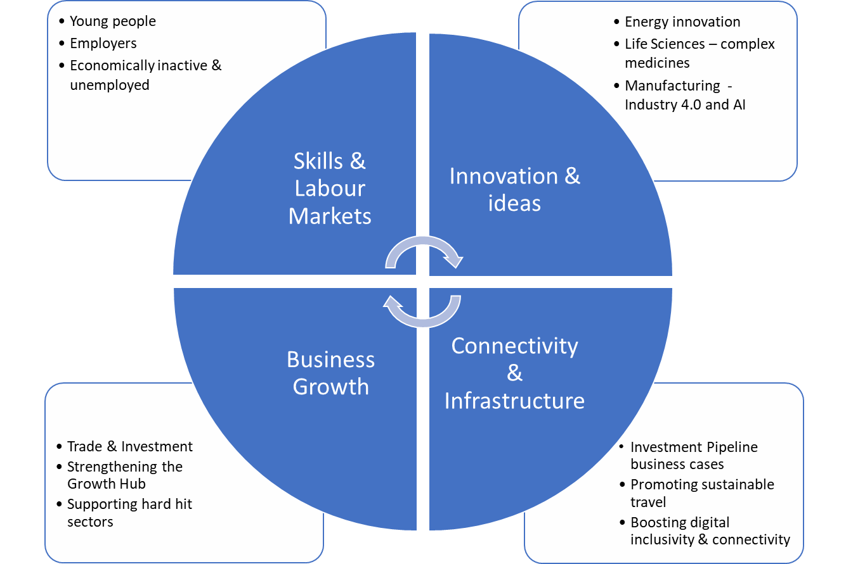

Skills and labour markets

We have already set out the importance of education and skills to our goals for an inclusive Cheshire and Warrington. This is particularly the case for the young people and those that have lost their jobs because of the pandemic.

Alongside the impact of the pandemic, much of the analysis that underpinned Cheshire and Warrington’s Skills and Education Plan when it was published in 2018 remains valid. Many of the key features of the C&W labour market identified therein continue to prevail:

- The employer base is strong and makes a significant contribution to UK plc.
- The ageing workforce will drive high levels of replacement demand.
- Future demand for skills will increasingly be at Level 4+.
- High numbers of residents earn below the Real Living Wage.

The Employers’ Skills and Education Board believes that the key market failure identified in the Plan, that: “we have a clear mis-match between the skills employers need and the skills individuals choose to acquire. This is because not enough people get the information they need to make informed decisions about the subjects to study and the careers to follow. This is particularly true for STEM and Digital skills.”
We will continue to work with businesses to ensure we have an employer led approach that provides skills for growth. As a first step, we will work with the University of Chester to rescope the Accelerate skills brokerage programme to ensure that it can deliver in a post-Covid environment.
Investing in STEM and Digital Skills

We recognise the critical importance of STEM and digital skills to the future Cheshire and Warrington economy. In response to this the LEP has invested £5m skills capital to ensure that learners and businesses can access cutting edge equipment to develop the skills needed for the future. A range of projects are being supported including the Made.Digital project where at least 9,000 young people over 5 years will be learning how to use technology and develop important coding skills. The Widening Access to Technology and Digital Skills (STREAM) project – a collaboration between 3 training providers and various community organisations, raising awareness of digital skills. The project is facilitating access to technology and opportunities to develop digital skills. Live streaming will ensure this project has a wide reach to over15,000 people over 5 years. Advanced Construction Training (ACT) centres involve a ‘hub and spoke’ model and are driving collaboration between all our local colleges and employers to develop, commercialise and promote digital technologies and skills training for construction, nuclear and allied industries. The specialist equipment being purchased through the investment has been agreed upon following consultation with employers and will enhance existing resources at each of the partner colleges.

Innovation and ideas
To deliver sustained improvements in productivity and ensure that Cheshire & Warrington has large numbers of high quality, well-paid and rewarding jobs, science, research and innovation need to be at the heart of recovery and our long-term planning. This has been recognised nationally by government with the publication of its Research and Development Roadmap in July 2020.
Cheshire and Warrington has an enviable depth and breadth of science, research and innovation assets and expertise. From discovery and development of the next generation of medicines and drug treatments, at Alderley Park, energy research expertise at Birchwood Park and Thornton Science Park to the headquarters of the world’s largest science experiment, the Square Kilometre Array, at Jodrell Bank – our area is at the forefront of new discovery and innovation.
We have already set out the importance of the life sciences and energy sectors to our vision for a healthy and sustainable region. We will continue to ensure the Cheshire Science Corridor is a key focus for the development and commercialisation of ideas, and work with other key sectors, such as manufacturing, to help them remain at the cutting edge of innovation.
Manufacturing remains at the heart of the Cheshire and Warrington economy, and at the forefront of manufacturing and process innovation with increasing use of digitisation and artificial intelligence in the design and production process. Home to national and international brands including Bentley Motors, Vauxhall, Siemens, Tata Chemicals and AstraZeneca, Cheshire and Warrington have a rich heritage of manufacturing excellence including a significant legacy from ICI (Imperial Chemical Industries) which had a major presence in the sub region. From luxury cars, fuels, and chemicals, through to a range of household brands in food, drink and consumer goods Cheshire and Warrington benefits from a diverse and highly productive manufacturing base. Around a quarter of Cheshire and Warrington’s GVA is generated by manufacturing activity and almost 10% of employment and includes a mix of primes and lower tier suppliers. This in turn drives significant export activity and inward investment.
Near to two major UK cities and with excellent transport links, Cheshire and Warrington is a major logistics hub, with concentrations in Warrington and Crewe. A large employer with over 29,000 jobs, logistics and distribution has experienced high employment and business growth in recent years. It includes well know names such as Eddie Stobart, ASDA, Hermes, and AO. This has been accelerated during the Covid19 pandemic.
The growth of logistics in Cheshire and Warrington is in part due to the development of OMEGA, a £1 billion 575-acre mixed-use development on the site of the former Burtonwood Airbase near the junction of the M6 and M62 motorways. The area has specialisms in warehousing and support activities for transport, and postal and courier services; and significant opportunities to innovate in the future.
With over 5,000 VAT-registered businesses, employing nearly 70,000 people, the Financial and Business Services sector in Cheshire and Warrington is significant in terms of employment and GVA. It covers a range of activities including banking, credit provision, insurance and pension funding, wealth management, legal and accounting, and involves many high proﬁle, global brands.

Business growth
Cheshire and Warrington has a strong track record in exporting and attracting inward investment, and in an effort to deliver quicker recovery and establish our place as a top destination for foreign investment in the post-EU trading environment, we want to increase our place marketing and inward investment activity and intensity. This includes continuing to work with the Department for International Trade on developing the world class life science and pharmaceutical cluster in East Cheshire and South Manchester as a High Potential Opportunity.
Also, with support from DIT we have put dedicated resources in place to respond to Inward Investment opportunities including support for existing foreign-owned companies in the area to expand, and also to support business with aspirations to export their goods and services. The LEP has also recently welcomed a dedicated export manager seconded from DIT who is leading on developing a new export strategy for the sub region as well as offering practical support to businesses on the benefits of exporting.
We also want to strengthen the support provided through our Growth Hub, particularly in identifying and supporting high potential start-ups and then, with enhanced mentoring and support, help more businesses to scale up, in doing so creating more jobs. Supporting existing businesses with plan for expansion and job creation, as well as targeted inward investment activity is another proven way of stimulation economic growth and delivering jobs. As part of this the LEP launched a new Peer-to-Peer networking programme in November 2020. This programme will bring together 100 SMEs with the ambition and ability to grow to share best practice as well as real world experience on surviving and thriving through COVID and EU Exit. This has already proven invaluable with early feedback from participants very positive. [appears to be a page break here which needs to be removed]
As set out above, we also recognise the disproportionate impact the Covid19 impact has had on some businesses. This is especially true for the retail where structural changes in digital shopping have accelerated changes within the sector; as well as those in the events, leisure, hospitality and visitor economy,
We are also keen to understand the positive role that the cultural and creative sector can play in driving recovery across Cheshire and Warrington and creating a strong quality of life for our residents.. In many places, this sector has helped bring a renewed focus and drive to communities, high streets and town centres. the many pockets of excellence that grown in recent years.

Connectivity and infrastructure
As part of its submission in response to the Comprehensive Spending Review in September 2020, the LEP set out a series of initial investment priorities through a sub-regional investment pipeline. Over the course of three years the LEP is investing £1.2 million to support the development of business cases for several schemes to ensure that they are well progressed and in a good position to secure the capital investment needed to deliver them.
During 2021 we will undertake further development and refinement of this pipeline, so that it supports our growth ambitions, ensures we have the skilled talent pipeline we need and the digital connectivity that will be so important in the future economy.
Hence, short-term priorities will be particularly focused on developing a pipeline of schemes comprising:
- active travel schemes and investment in all-electric buses to support walking, cycling and public transport;
- schemes in the Mersey-Dee area and in our high-speed growth corridor, to deliver 6m sq ft of new office space, 9,000 new jobs and a £280+ million of investment;
- addressing digital inclusivity and enabling C&W to grasp the new digital opportunities created by Covid through our digital infrastructure plan.
Investment in the Strategic Road Network and the Rail Network will also be important for supporting long-term growth. Network Rail is currently undertaking a Continuous Modular Strategic Plan to identify key infrastructure requirements and Highways England will be shortly engaging with stakeholders for Road Investment Strategy 3. It is critical that DfT, Highways England and Network Rail work closely with us to ensure that national infrastructure improvements to support economic growth of the sub-region are developed and then delivered in a timely manner.
Getting Building Fund – Chester Drainage Tunnel
£5.5m has been awarded from the Getting Building Fund to construct a new rainwater drainage tunnel, which forms a critical part of delivering Phase 1 of the Northgate scheme in the centre of Chester. It will also enable other regeneration schemes to be developed. The tunnel will be almost 1km long and 1.2m diameter and will deliver environmental benefits such as significantly reducing the risk of flooding and the separation of rainwater from foul water.
The Northgate scheme this supports will replace existing poor-quality buildings and under-used land with a comprehensive mixed-use development of the highest architectural quality. Phase 1 of the scheme will deliver a new market, a cinema, food/beverage units, offices and new public realm/event space.

One of the future changes that has been massively accelerated by the Coronavirus crisis has been a shift to doing business, work and learning online. At the height of the crisis it is estimated that nearly half of those in employment were working remotely from home.
Online retail has experienced as much growth (as a proportion of all sales) in the last five months as in the previous 10 years and now accounts for over 30% of all retail purchases. And young people have relied on a range of online platforms and resources in order to continue their education whilst schools, colleges and university campuses have been closed. Therefore, digital connectivity is integral to our aspirations for a healthy, sustainable, inclusive and fast growing Cheshire and Warrington.
Cheshire and Warrington has perhaps been fortunate that such good progress has been made in provision of high speed fibre broadband through the Connecting Cheshire programme. But there remain a number of areas that struggle with getting a decent broadband service, especially if there are multiple demands on broadband width within the household and even the neighbourhood.
The LEP is currently finalising a Digital Infrastructure Plan which looks at options to improve coverage in those areas which do experience poor service, but also at a range of investments that could be made to improve and enhance existing coverage across the area to meet the changing demands of businesses and households and of places.
Two emerging priorities of the Digital Infrastructure Plan for the LEP to take forward are:
- Develop a pipeline of ‘shovel-ready’ projects within the C&W LEP sub-region to improve digital connectivity for residents and businesses. This could include enabling gigabit infrastructure across the sub-region, extended 4G roll-out and 5G trials, and adoption of digital skills amongst business and communities.
- Develop and promote a narrative setting out the opportunities for digital innovation and testbed facility within C&W LEP sub-region, highlighting key sector and regional strengths - manufacturing, life sciences, energy & clean growth, finance & business services, and logistics & distribution.
Our investment programme reflects identified priorities across the Mersey Dee geography including digital infrastructure, rail and sustainable transport projects to support growth and movement across border. The Growth Track 360 prospectus sets out priorities for cross-border rail improvements, alongside wider transport investments in the MDA area.

Fast-growth priorities for 2021-22
The LEP and its partners will: -
- Work with the University of Chester to rescope and repurpose the Accelerate skills brokerage programme and build on the £1 million of 100% subsidised training provided in 2020.

- Support the rollout and delivery of the C&W4.0 programme for manufacturing SME’s, led by the University of Liverpool’s Virtual Engineering Centre, which aims to support xx business in its first year and xxx during the life of the programme.

- Through Marketing Cheshire work with the Culture, Events, Retail, Hospitality and Visitor Economy Sector to develop a Destination Management Plan by July 2021.

- Promote and market Cheshire and Warrington in line with the Government’s reopening roadmap, and with the advice and support of Destination Chester, and Destination Cheshire, representative groups of over 20 businesses and business organisations.

- Develop a bespoke Trade and Investment Strategy for Cheshire and Warrington by September 2021, with support from government, including how to provide the best support for International Trade advice and key account management. Develop and begin delivery of a pro-active investment strategy, focussing on evidence-based market and sector targeting, in partnership with local authority partners, by September 2021.

- Through the Foreign Direct Investment Programme successfully land 10 new investments in Cheshire and Warrington by March 2022.

- Roll out the Growth Hub’s Peer-to-Peer network to a further cohort of approximately 100 businesses to share best practice on leadership and growth.

- Allocate up to £400k by August 2021 to support a further round of investment pipeline business case development.

- Work with local authority partners and Digital Cheshire to prepare a bid to BDUK’s Rural Gigabit programme by June 2021, including exploring opportunities for a local top up scheme.

Infrastructure and Connectivity Priorities for 2021 – 22

Delivery and Next Steps
This Recovery Plan is initially being published as a draft to support a programme of engagement and consultation during Spring 2021. The LEP is keen to test whether our thinking on Recovery is right, especially the priority areas for focus outlined in the plan.
The priorities for the next year, highlighted throughout this plan are summarised below: -
Theme | Deliverable | Target Date
Healthy
 | Continue to work with the Cheshire Business Group to provide advice and guidance to small businesses on creating Covid19 secure environments; and through Marketing Cheshire provide advice to the visitor and hospitality sector as it reopens, including promoting the ‘We’re Good to Go’ industry standard.
 | Establish a Life Sciences sector group by June 2021 to develop a plan to reinforce Cheshire and Warrington as one of the best locations in the world for medicines discovery, formulation and manufacturing as set out in the Life Sciences Sector Deal. This will include exploring options for expanding and strengthening the offer of the Medicines Discovery Catapult at Alderley Park | June 2021
 | Accelerate investment in the Cheshire Science Corridor Enterprise Zone following conclusion of a £30m borrowing facility through the LEP’s local authority partners.
 | Conclude negotiations by July 2021 to create a successor to the Greater Manchester and Cheshire Life Sciences Fund with a minimum fund value of £25m. | July 2021
 | Deliver £5.05m Getting Building Fund investment in laboratory space for Validation Centre of Excellence at Alderley Park.
 | Deliver £4m Enterprise Zone investment in Blocks 22-24 at Alderley Park to provide 90k sq ft of new lab space plus a 2,400-space multi-storey car park.
Sustainable
 | As part of ongoing collaboration through Net Zero North West decarbonise the industrial cluster located along the south bank of the River Mersey, commission economic consultants by June 2021 to develop the strategic and economic case. | June 2021
 | Work with the University of Chester to secure an investment/development partner for Thornton Science Park before the end of the calendar year. | December 2021
 | Work with industry and neighbouring areas to use COP26 in November 2021 as a vehicle to progress the regions energy priorities. This will be supported by a strengthened communications strategy for our Energy and Clean Growth objectives. | November 2021
 | Work with the Cheshire and Warrington Rural Strategy Board to develop proposals for implementing the findings of the Natural Capital Audit, and continue to support the economy in rural areas to recover from Covid19 whilst meeting our sustainability goals. | August 2021
 | The LEP’s Employer Skills Board will work with industry and providers to put in place plans by August 2021 to respond to the employment opportunities and skills requirements of the Green Industrial Revolution. | August 2021
Inclusive
 | Deliver 15 virtual careers events and a comprehensive library of video resources for young people by December 2021. | December 2021
 | Engage an additional 100 employers between now and December 2021 in the successful delivery of the Pledge programme across Cheshire and Warrington. | December 2021
 | Through the Workforce Recovery Group work with the Department for Work and Pensions and Job Centre Plus to expand the range of virtual and online support for people impacted by redundancy because of the pandemic, including delivering six online job fairs by January 2022. | January 2022
 | Work with government to progress the High-Speed Growth Corridor Business Case and ensure it benefits existing communities within Cheshire and Warrington.
 | Work with local partners including Town Boards in Crewe, Warrington and Winsford to implement Future High Street Fund programmes and Town Investment Plans and develop ` further bids to the Levelling Up Fund.
 | Invest £25,000 during 2021-22 to support development of business cases for the first housing pathfinder projects.
Fast Growing
 | Work with the University of Chester to rescope and repurpose the Accelerate skills brokerage programme and build on the £1 million of 100% subsidised training provided in 2020.
 | Support the rollout and delivery of the C&W4.0 programme for manufacturing SME’s, led by the University of Liverpool’s Virtual Engineering Centre, which aims to support xx business in its first year and xxx during the life of the programme.
 | Through Marketing Cheshire work with the Culture, Events, Retail, Hospitality and Visitor Economy Sector to develop a Destination Management Plan by July 2021. | July 2021
 | Promote and market Cheshire and Warrington in line with the Government’s reopening roadmap, and with the advice and support of Destination Chester, and Destination Cheshire, representative groups of over 20 businesses and business organisations.
 | Develop a bespoke Trade and Investment Strategy for Cheshire and Warrington by September 2021, with support from government, including how to provide the best support for International Trade advice and key account management. Develop and begin delivery of a pro-active investment strategy, focussing on evidence-based market and sector targeting, in partnership with local authority partners, by September 2021. | September 2021
 | Through the Foreign Direct Investment Programme successfully land 10 new investments in Cheshire and Warrington by March 2022. | March 2022
 | Roll out the Growth Hub’s Peer-to-Peer network to a further cohort of approximately 100 businesses to share best practice on leadership and growth.
 | Allocate up to £400k by August 2021 to support a further round of investment pipeline business case development. | August 2021
 | Work with local authority partners and Digital Cheshire to prepare a bid to BDUK’s Rural Gigabit programme by June 2021, including exploring opportunities for a local top up scheme.

Many of our proposals, if not most of them, can be delivered locally. Others will need a partnership with Government, supported with powers, funding or other flexibilities. But with this partnership in place, Cheshire and Warrington can emerge from Covid powering growth in the North, levelling up its left behind communities, establishing itself as a world leader in clean growth technology and using its expertise in life sciences to help the UK respond quickly and effectively should a health crisis like Covid ever happen again.
The Cheshire and Warrington economy was one of the most successful in the UK pre-Covid, and has the ability to be so again.

Table of business cases included in original draft but suggest excluded from document
 | Overview
Crewe Hub Access Package Business Case development | This comprises a package of transport schemes which will improve access by all modes to Crewe HS2 Hub Station. This forms a key component of the High-Speed Growth Corridor proposal
Winnington Hill /Bridge Corridor Study | This initiative builds on achievements to date and will secure enhanced transport infrastructure to reduce congestion and improve journey time reliability, both of which are recognised as being fundamental to prosperous economies and sustainable environments. The project seeks to improve transport connectivity at the historic Winnington Swing Bridge over the River Weaver, an existing pinch point on the highway network which is holding back development, as well as onward active travel accessibility along the A533 Corridor to Northwich Town Centre. This will enhance accessibility for existing residents, commuters and visitors in the area, links with HS2 investment and supports the connectivity to proposed regeneration sites that include a substantial opportunity for residential development for circa 1,200 units at the TATA chemical site.
Warrington Last Mile – Town Centre Masterplan | Package of junction and corridor improvements around Warrington town centre to improve pedestrian, cycle and public transport access to the town centre and its key rail hubs. Indicative scheme cost: £47m (Excluding optimism bias) phased over 4 years. Concept designs currently in development include:  A49 Access improvements (£22m)  - Church St/Dial St Roundabout £7m  - Cockhedge Roundabout £10m  - Mersey St corridor accessibility improvements £5m  Town Centre Western Gateway (£15m)  - Crosfield/Parker St/Liverpool Road/Froghall Lane/Sankey St/Winmarleigh St – improved access to the town centre £5m  - Enhanced Bank Quay Parking and accessibility improvements (new ped/cycle bridge over WCML) £10m  Streetscape and public realm improvements £10m  - Winwick St/Scotland Road/Town Hill/Sankey Street £10m
Chester City Gateway Masterplan Incorporating Hoole Bridge Feasibility Study | There is an opportunity here to address a major gateway into the historic city of Chester, which requires investment to re-position itself as a key destination and economic centre in the sub-region. Working in collaboration with the Council, LCR and Network Rail to bring forward regeneration proposals at the area known as Chester City Gateway. The overarching aim of the discovery phase is to ensure regeneration and development opportunities in and around the study area are optimised for the benefit of the local economy in the creation of jobs, homes, and investment and to ensure these opportunities reflect and enhance the rail station environment for the benefit of rail station users.  The Hoole Bridge Feasibility Study explores the development of a multi-modal improvement masterplan scheme for Chester City Gateway that addresses a variety of access, highway safety and network capacity constraints, including on the A56 as a key gateway into Chester City Centre. The scheme covers the A56 corridor from the A56/M53 junction to, and including, the junction of St. Oswalds Way (A5268), including the environs of Chester Rail Station
Local Cycling and Walking Infrastructure Plan – corridor studies in Warrington Borough | Corridor improvement schemes to deliver 3 Primary Routes set out in Warrington LCWIP. Design and business case work currently underway for high quality segregated cycle routes on A49 north, A57 West and A5061/A50 South corridors. Indicative scheme cost £25m (excluding optimism bias) phased over 4 years.
Vauxhall Options Study | This is a study to appraise the options for the development of surplus land at the Vauxhall car plant in Ellesmere Port and involves a review of the existing uses on site and the identification of under-utilised/surplus land and property assets, the generation of a series of land use and development options for the site, appraisal of the options against an agreed set of criteria (including, strategic fit, value for money, deliverability, etc.), and a review of the potential development/investment delivery models.
Ellesmere Port Industrial Area: Development and Investment Framework | Development of a clear up-to-date physical ‘Development and Infrastructure Investment Framework’ to drive future continued business growth and employment at the Ellesmere Port Industrial Area, capitalising on its unique strengths and opportunities, therein reinforcing its role as a global, national and regional business and employment hub. Ellesmere Port is a major player in the energy sector as well as having substantial manufacturing businesses and output for the sub-region.
Warrington Bus and Mass Transit Strategy | Study underway. Includes an element to develop quick win schemes to improve existing bus network reliability and provide journey time savings. Proposal to deliver one corridor scheme and up to two bus pinchpoint schemes. Design work underway on Wilderspool Causeway corridor. A49 Winwick Street/Tesco junction is also emerging as an early priority for pinchpoint scheme. Indicative scheme costs: £10m phased over 4 years.
Cheshire and Warrington Bus Strategy | The work is to develop a Bus Strategy to ensure that Cheshire and Warrington understands the available solutions for increasing the use of buses to underpin its economic growth aspirations. The Strategy will align with the national bus strategy and will set out a menu of solutions which the LEP, Local Authorities and Bus Operators can choose from to suit local circumstances and budgets. It will include an action/implementation plan of key actions broken down into short term quick wins and medium/long term measures

Gross Value Added
▪ Retail ▪ Accommodation ▪ Food & beverage services ▪ Sport & leisure ▪ Personal services
As at 13th February 2021
In finance terms, pari passu means ‘on an equal footing’
DIT estimates
As defined by the Resolution Foundation
https://www.gov.uk/government/publications/uk-research-and-development-roadmap/uk-research-and-development-roadmap
Coronavirus and homeworking in the UK - Office for National Statistics (ons.gov.uk)
https://www.ons.gov.uk/businessindustryandtrade/retailindustry/bulletins/retailsales/june2020
https://www.growthtrack360.com/

